Online Tutoring Instructions

*** Do Not Use Internet Explorer ***

*** Turn off Popup Blockers ***

**\*\*\* You must register in Moodlerooms, 24 hours in advance \*\*\***

If you are not registered,

<click here to register. http://www.mtsac.edu/writingcenter/online_tutoring_registration.html>

**Instructions For Online Tutoring**

**On the day of your appointment, follow the instructions below.**

1. Go to:

[World Wide Whiteboard **(click here)**, and log in](https://mtsac.mrooms.net/mod/lti/view.php?id=396760) with your Mt. SAC MyPortal account.

[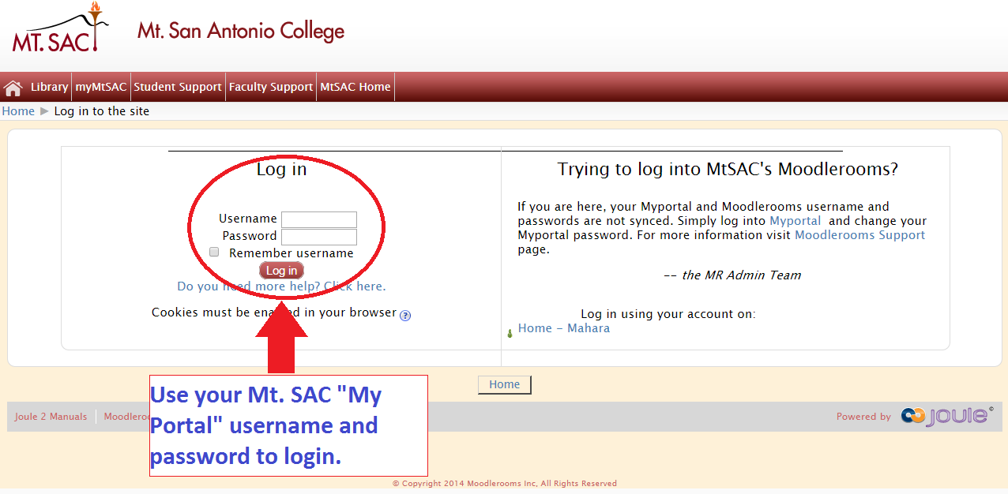](https://mtsac.mrooms.net/mod/lti/view.php?id=396760)

1. You will now be logged into World Wide Whiteboard.
   1. If it is the first time you are using online tutoring this semester, you will be asked to accept the agreement conditions. Click **"Accept and Continue to WorldWideWhiteboard."**

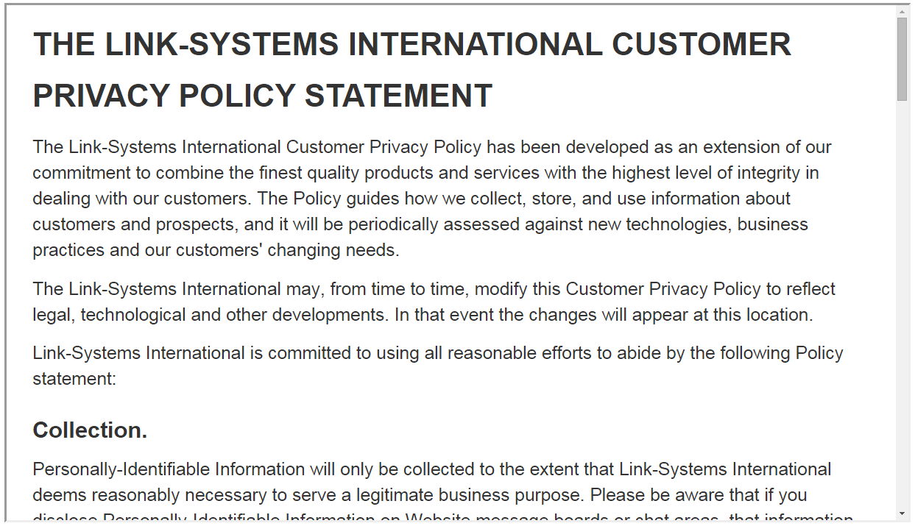

* 1. If it is NOT the first time you used online tutoring this semester, simply click the first option to enter a live tutorial session.



1. Once you are in the “**Whiteboard / Room,**” you have three options.

*** All files must be in PDF format ***

* 1. Copy and paste text into the whiteboard using  .

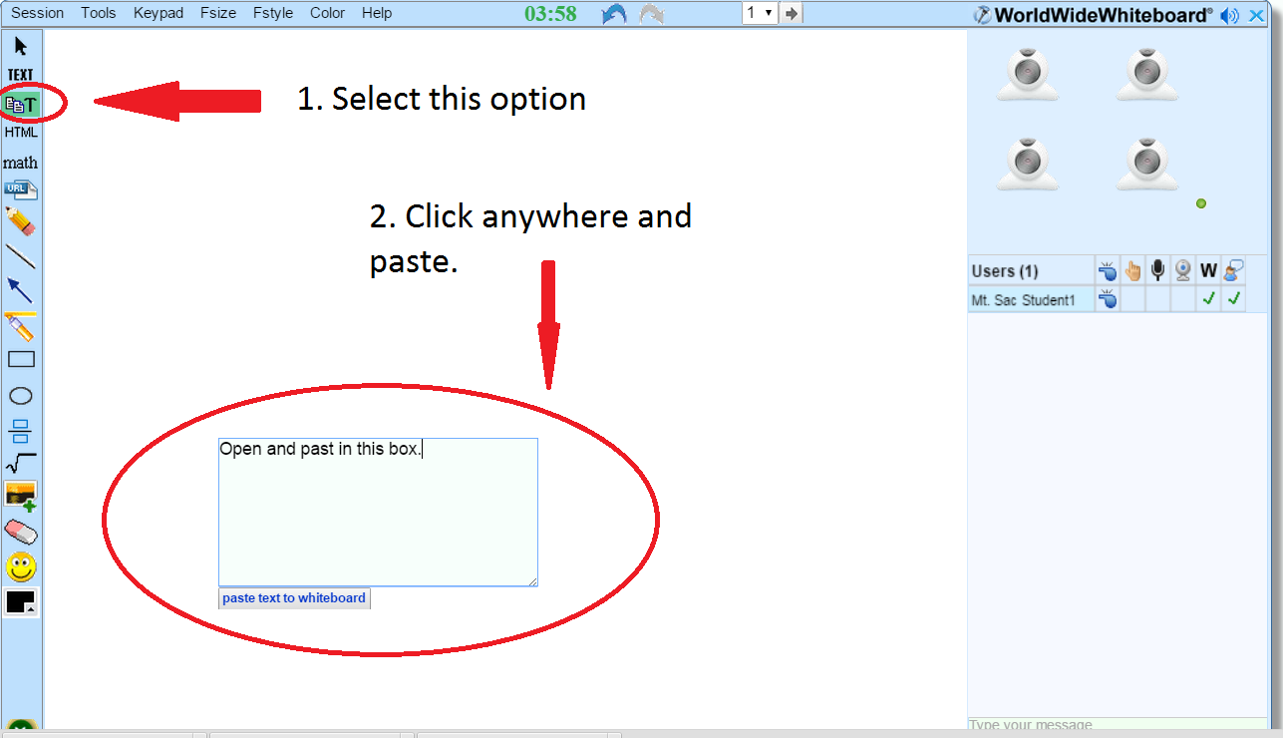

* 1. Drag and drop the essay (in PDF format) into the whiteboard area.

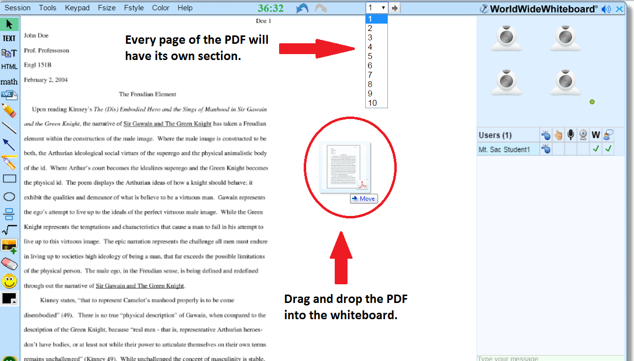

* 1. Upload (in PDF format) your paper into the **“Paper Center”** for the tutor to see.

