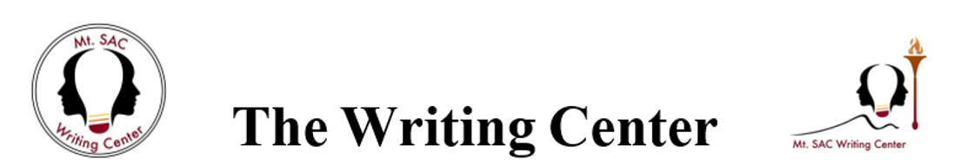

“Paramedic Method: ”How to Make Sentences Clear and Concise

Richard Lanham, a professor of English at UCLA, invented an easy-to-use method for making your writing clearer and more concise. Here's how to do it:

# 1a. Circle the Prepositions.

Too many prepositions can drain all the action out of a sentence. Get rid of the prepositions and find a strong active verb to make the sentence direct:

*Original:* In this passage is an example of the use of the rule of justice in argumentation.

*Revised:* This passage exemplifies argumentation using the rule of justice.

**1b. Circle the forms of “to be.”** Using any form of “to be” in a sentence gets it off to a slow start and makes the sentence weak. Replace as many “to be” verbs with action verbs as you can and change all passive voice (“is defended by”) to an active voice (“defends”).

*Original:* The point I wish to make is that fish sleep with their eyes open.

*Revised:* Fish sleep with their eyes open.

1. **Ask, “Where's the action?” “Who's kicking who?”** (using Lanham's own terminology here—to be precise, it would be “Who kicks whom?”). If you get stuck in a passive sentence always ask the question: “Who does what to whom?” If you use that formula, you will always write active sentences.

*Original:* Burning books is considered censorship by some people.

*Revised:* Some people consider burning books censorship.

Note how the passive voice can “hide” the true actor of the sentence. The active voice restores the actor to the sentence’s subject position.

# Put this “kicking” action in a simple active verb.

*Original:* The theory of relativity isn't demonstrated by this experiment.

*Revised:* This experiment does not demonstrate the theory of relativity.

1. **Start fast—no slow windups.** Stick to the action and **avoid** opening sentences with phrases like these:

My opinion is that....

The point I wish to make is that ... The fact of the matter is that...

# Want more information? Lanham's *Revising Prose,* a concise and witty guide to style in writing, should be on your bookshelf.

Mt. SAC Writing Center <http://www.mtsac.edu/writingcenter/> Building 26B, Room 1561 (909) 274-5325