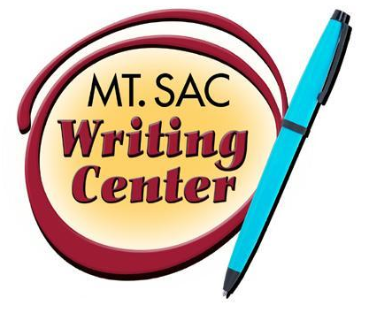

Writing Mythbusters
The Writing Center
RealWriting™ Handouts

MYTH: There is a comma at every pause.

This is false. Commas should only be used:
- between items in a series
- after an introductory expression
- around non-essential (non-restrictive) material
- before a conjunction when joining two complete sentences.
- when a sentence directly addresses someone by name

MYTH: You cannot end a sentence with a preposition.

This is false. English grammar derived from Latin grammar. Latin grammar cannot end in a preposition; however, modern English can. The purpose of the preposition is to add spacial detail and phrasal verbs to the sentence and can be used at the end of a sentence.

CORRECT use:
- He is cleaning up.
- What is this table made of?
- Where are you coming from?
- This is the sort of nonsense that I will not put up with.

MYTH: I’m no good in English – never have been, never will be and only people with natural talent for writing can succeed in a composition class.

This is false. Effective writing is a skill that can be learned.

MYTH: I write for myself, not for anyone else, so I don’t need tutoring or additional instruction in writing.

This is false. We need to write effectively to communicate with others.

MYTH: My composition teacher is a picky, comma-hunting old fogey/radical, who will insist I write just like him or her.

This is false. Writing well enables us to see and know ourselves—our feelings, ideas, and opinions—better.

