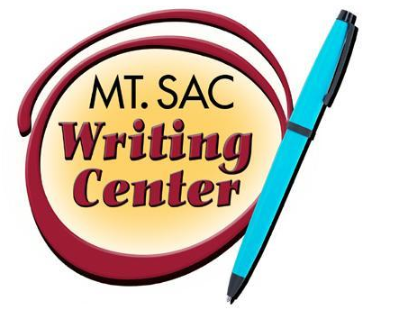

What Does My Professor Really Want?:
The Writing Center
RealWriting™ Handouts

Some General Guidelines

DO
- Read over the instructor’s prompt carefully. If your instructor doesn’t provide a prompt, try to arrange to meet with him/her to ask questions about the assignment.
- Start EARLY on your assignment and try to get the instructor’s feedback on a draft. You can also see one of the tutors in the Writing Center.
- Provide a title that tells your reader something about your stance on your topic and that helps to draw them into your paper: “Why I Love Curling” or “Banning Second Hand Smoke: The New Puritanism.”
- Follow the instructor’s format instruction for font and spacing. If none are given, use an easily readable font, such as Times New Roman, and 12 point font.
- Use signal phrases and/or colons to introduce quotations, such as According to George Will, “Obama has become the standard bearer for a new socialism.” (For further information, ask for a copy of the Writing Center’s handout on “Integrating Quotations.”)
- Always meet at least the minimum requirements of an assignment: page length, number of sources, etc.
- Read your essay out loud before turning it in—you will catch many errors and missing words when you do this.
DON’T
- Give your essay a generic title such as “Essay One” or “Research Paper” or “Stem Cell Research”
- Use second person in your papers. Circle all of the areas where you have used “you” or “your.”
- If you use first person (the pronouns “I” or “we”), make sure you have the professor’s permission to do so.
- Use slang unless it is from quoted material.
- Use conversational language. Use the dictionary and thesaurus to build your vocabulary.
- Use too many rhetorical questions (if you choose to use any at all!). It’s your job to answer the questions you ask—not assume the audience already knows the answer.
- Overuse semicolons. A semicolon is a “California stop” and should only be used when the meaning of one sentence should “roll into” the next. Otherwise, use a period, subordination, or coordination.
- Try to make your paper look longer than it is by changing the font or the spacing. Professors see through this trick immediately, and it annoys them!

