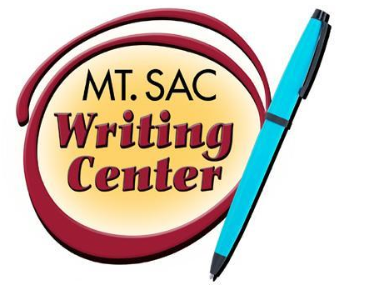

Revision as a Reader
The Writing Center
RealWriting™ Handouts

What do many students do when they finish writing an essay? Print it and turn it in, or course! However, skipping the revision process, either because of lack of time or that it can be difficult, is not a great idea. It can lead to unclear writing and lower scores. In fact, the revision process is one of the most important steps in writing.

If you typically avoid revision because it is difficult, try to revise from a different perspective other than the writer. Revising from a different perspective is helpful because it gives the distance we need to thoroughly “fix” and edit. Essentially, you should imagine that you are a reader and that someone else wrote your paper. It can be tricky, however, so it is best for us to follow a process:

- Part one: Spend time away from the essay.
If time allows for it, pull away and focus on other tasks, such as chores or other classes. A day or two would be best, but several hours can work as well. The goal is to see it as another writer's work.

- Part two: Return in a format that is comfortable.
Revision and writing can be difficult, so make it as comfortable as possible. If you work best on the computer, then do so. If you enjoy working in bed, print the essay and work on it using a bright colored pen. Make revising enjoyable so it is easier to return to.

- Part three: View the work as if not your own, focusing on the global issues first.
Treat it as if it is another student’s writing. What are they trying to say in their thesis? Is their introduction interesting, catching your attention? How strong is their argument and use of examples along with structure? It is best to have an outline handy to keep the structure easy to work with as this can take some time.

- Part four: Work towards editing sentence level issues.
Once ready, focus on the grammar, punctuation, sentence structure, and spelling errors. What is the best way to communicate your thoughts? Are your ideas conflicting due to run-ons, comma-splices, and fragments? Also, omit any repetitive or empty words and phrases. These simply clutter stronger ideas.

- Part five: Take another break; then print out the essay and proofread using a pen.
In this final step, do not be afraid to get messy and write on the printed essay. By printing it, the work will feel different and allow for even deeper revision and editing.

At this stage, do not feel bad for any major or minor edits that happen. Revision is where a piece really grows stronger, and it takes time and effort. If it helps, have someone read the essay at the end of the revision process to see what is left behind. However, it is best if you are the first person to critique your own work.

