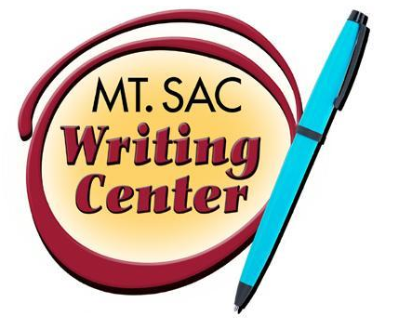

MLA Works Cited Page
The Writing Center
RealCitation™ Handouts

On the backside of this handout is an example of what an MLA-style works cited page typically looks like. Using standard formats for your entries enhances your credibility with academic readers, and alphabetizing your list helps fellow researchers quickly locate the sources that you refer to in the body of your text.

Keep in mind a few more formatting rules:

- Begin your works cited page on a new page; it will be the last page of your essay.
- The page must have one inch margins on each side.
- Double space the works cited page and use hanging indents.
- Alphabetize the entries based on the first segment of information in the entry. (i.e. If you don’t have the author’s name, begin the entry with the work’s title)
- All titles that would have previously been underlined are now italicized. No titles are underlined in the newest edition of MLA.
- Each source must include either “print” or “web” to indicate whether to source was found online or not.
- Please see the 7th Edition MLA Rule Changes handout for more detailed explanations of changes to MLA.

To view the entire MLA Handbook for Writers of Research Papers online, please go to www.mlahandbook.org. You will need the following login information (top right corner of the website): the email address etyson@mtsac.edu; the password is mtsac.
For more formats and source types, visit http://www.dianahacker.com/resdoc/.

Please note that the highlighted information in parenthesis on the following page IS NOT PART OF THE CITATION! We have listed in parenthesis the type of source; you will not need to do this when you create your works cited page.

Works Cited
“Hourly News Summary.” National Public Radio. Natl. Public Radio, 20 July 2007. Web. 20 July 2007. (Online news broadcast)
“Japan.” The Encyclopedia Americana. 2004 ed. Print. (Article in a reference book)
Leitch, Vincent B., ed. The Norton Anthology of Theory and Criticism. New York: Norton, 2001. Print. (Anthology or compilation)
Lopez, Robert. “Protestors Rally in Hermosa Beach against Tax Hikes.” Los Angeles Times. Los Angeles Times, 12 Apr. 2009. Web. Apr. 2009. (Website entry)
National Research Council. Graduate Education in the Chemical Sciences—Issues for the 21st Century. Washington: National Academy, 2000. Web. 25 May 2012. (eBook by a corporate author)
Pollack, William S., and Todd Shuster. “The Sting of Divorce.” Elements of Argument. Ed. Annette Rottenberg and Donna Haisty Winchell. 8th ed. Boston: Bedford, 2006. 567-68. Print. (A work in an anthology [usually a textbook])
Star Wars: A New Hope. Dir. George Lucas. Perf. Harrison Ford, Carrie Fisher and Mark Hamill. 20th Century Fox, 2008. DVD. (DVD)
United States. Dept. of Labor. America’s Dynamic Workforce. Washington: US Dept. of Labor, 2004. (Government publication)
---. Dept. of Transportation. Natl. Highway Traffic Safety Administration. An Investigation of the Safety Implications of Wireless Communications in Vehicles. Nov. 1999. Web. 20 May 2006 (Government publication online)
Williams, Dave. “Animal Testing Gives False Reassurance of Human Safety.” Nursing Standard 23.22 (2009): 32-35. Academic Onefile. Web. 22 July 2009. (Journal article in a database)

