****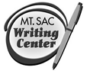

**The Writing Center**

**RealWriting™ Handouts**

**Peer Reviewed Articles: How to Read Them & Why You Should**

***What is a peer reviewed article?***

A peer-reviewed article is one that has been reviewed by experts in the field before publication. This is a rigorous process and one that is quite competitive. You can find peer reviewed articles (also known as “academic journal articles”) in library databases.**

**For help on how to use the library databases, check out the library’s [tutorial](http://www.mtsac.edu/library/14module3.html).

***Why do I have to use peer reviewed articles in my papers and projects?***

* As a result of this rigorous process, academic journal articles are considered to be credible (trustworthy) sources.
* These sources can help you formulate your ideas or support your claims about a topic.

***Why are they so hard to read?***

* + *The vocabulary*: Peer reviewed articles are often written in the language of the field or discipline. This means writers of these articles often use lots of jargon that is specific to that field, and they assume readers already know the basics of the topic.
  + *The length*: Many articles are between 30 and 50 pages long. Although they are almost always broken down into sections, some of these sections can be quite technical.

***So how should I approach reading peer reviewed articles?***

***2 Rules of Thumb:***

1. **Never read them straight through**

(It takes too much time; even experienced researchers don't read the entire article.)

1. **Develop a method for previewing and making choices about what you read.**

(Read the next section for tips on how to preview, skim, and efficiently read peer reviewed articles.)

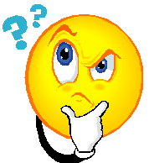



*-------------------------------------------------------------------------------------------------------------------------------*

**Time Saving Steps for Reading Peer Reviewed Articles**

1. ***Preview the article.***

Why start with a preview? This will help you decide whether or not the article will be useful for your paper and help you develop a reading strategy. To preview an article, look at the following sections and ask yourself the following questions:

|  |  |
| --- | --- |
| **Read the title:** | Does it seem related to your topic? Is the focus too broad or too specific? |
| **Read the abstract:**  (This is an overview of the article.*) | As you read, ask yourself…  What topic is the author studying? What are the findings or the argument? Does this seem related to my topic? |
| **No abstract? Read the intro:** | As you read, ask yourself…  What topic is the author studying? What are the findings or the argument? Does this seem related to my topic? How is this article different from other research papers or studies done on this topic? |
| **Skim the sections:** | If the article seems promising, flip or scroll through the entire article and read the headings. Sometimes these will have titles that help you learn more about the content. This will also help you decide what you’ll need to read and budget your time. |

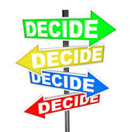\***T*he abstract*** *is usually visible from the library databases before you even open the article. Sometimes it can also be found on the first page of the article.*

1. ***Choose what sections to read.***

Although the article might be long, it is well-organized and broken down into sections. Depending on the type of paper you’re writing, some of these sections may be more useful or less useful to you.

|  |  |
| --- | --- |
| *If you are writing….* | *Focus on reading the….* |
| * A literature review, annotated bibliography, or research paper | * Literature Review, Introduction, Discussion, Conclusion |
| * Original research or your own study | * Methodology, Results, Findings |

**This chart provides a breakdown of all the sections you may find in peer reviewed articles.**

|  |  |
| --- | --- |
| **Function of The Section** | **Questions to Read For** |
| **Abstract** – provides a summary of the  article.  ***Read this first****.* | * What topic are the authors studying? * What was their most important finding(s)? |
| **Introduction/Literature Review** – provides a brief review of related research on the topics, and an in-depth description of what the article is about.  ***Read this next.*** | * What other research has been done on this topic? * What gap in research is the author addressing? In other words, how is this article different from other studies and research that has been done on this topic? * What are the main points and arguments of this article? |
| **Methodology** – describes how the research was done.  ***For most papers, you will not need to understand the methods used.*** | * Who were the participants in this sample? * How was the study conducted? * What types of data was collected? |
| **Results/Findings** – provides and analyzes the data collected.  ***For most papers, you will not need to interpret the data in this section.***  ***Instead, focus on what the findings were and how they were discovered.*** | * What data was collected? * What does this data show or suggest? |
| **Conclusion/Discussion** – provides a summary of the research, explains why it’s important, and makes recommendations for future research or policy changes.  ***Read this last.*** | * What were the authors’ overall findings? * Why are these findings important? * What are the limitations of the study? * What suggestions for future research or policy changes do the author(s) make? |

1. ***Choose how to read the sections you need.***

* *Do you only need a general understanding of the article?*

Try skimming the sections and taking notes or highlighting only the main points. To skim, read the first paragraph of each section. Then, for each following paragraph, read just the first sentence to get a sense of what the section is about.

* *Do you have a specific research question or specific topics you’re interested in?*

Before you start working on a research paper, it’s important to develop questions you have about the topic you’re researching and write these down in a notebook or in [NoodleBib](http://www.mtsac.edu/writingcenter/NoodleBib.html). As you begin selecting and reading sources, you can focus on finding the answers to your research questions. When you’re skimming your sources, these research questions can also help you identify the most important passages. If a passage directly discusses your research question, slow down and read it more closely.

* D*o you need an in-depth understanding of the article?*

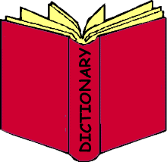Start by reading the entire introduction or literature review and take notes. Then read the entire conclusion or discussion and take notes. Finally, decide if you need to read any other sections.

* *Is there a lot of difficult vocabulary?*

Read on or near a computer so you can quickly look up the words you don’t understand as you read. Make notes of any technical words or jargon that are used frequently throughout the article.

1. ***Use the reference page to find more sources.***

As you read, did you come across any quotes or references (citations) that seemed useful to your topic? You can use the works cited or reference page to find these sources. Also read over the list of titles in the reference or works cited page and see if any sound useful to your topic. You can use the library website to find these sources to use in your own paper.

1. ***Stay organized.***

* 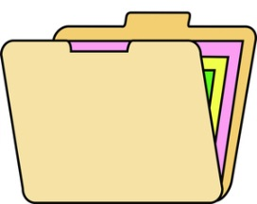Save articles when you can, email articles to yourself and bookmark websites. This will help you keep track of all your sources in case you need to find them again.
* Keep track of your notes and write down important points/ quotes with the page number you found them on. Consider using one notebook or making one file on your computer to keep track of your notes.
* 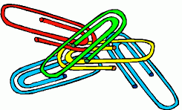Create your “Works Cited” or “Reference” page before you start researching and add the citations to it as you find sources. This only takes a few minutes and will save you from scrambling to find all your sources right before your paper is due.
* Consider using [NoodleBib](http://www.mtsac.edu/writingcenter/NoodleBib.html), an online research organizing service that is free for Mt. SAC students through the Writing Center website. [NoodleBib](http://www.mtsac.edu/writingcenter/NoodleBib.html) can help you organize your notes, keep track of your sources, and create a works cited page. Try it today at our Writing Center website (look under “Online Resources for Students).

Handout adapted from “Using Peer Reviewed Journal Articles for Your Research” by Rebecca Gronvold Hatch, Ph.D.

and “[How to Read a Peer Reviewed Article](http://www2.smumn.edu/deptpages/tclibrary/tutorials/il/read/index.htm)” from St. Mary’s University of Minnesota