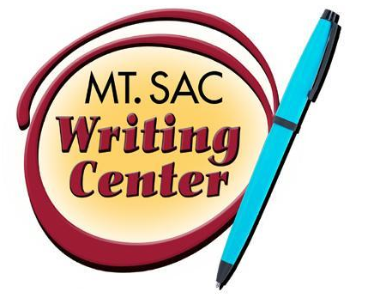

The Conclusion Paragraph
The Writing Center
RealWriting™ Handouts

Your conclusion is your opportunity to wrap up you essay in a tidy package and bring it home for your reader. After transitioning from your final body paragraph, it is a good idea to echo what you have said in your thesis statement in order to suggest to your reader that you have accomplished what you set out to accomplish. Take a moment to judge this for yourself. Reread your thesis. If you find that your thesis statement now sounds hollow or irrelevant—that you haven’t done what you set out to do—then you need either to revise your argument or to redefine your thesis statement. Do not, in any case, simply restate your thesis statement in your final paragraph, as that would be redundant. Having read your essay, we should understand this main thought with fresh and deeper understanding, and your conclusion wants to reflect what we have learned.

When writing your conclusion, keep this in mind:
- The conclusion should contain a definite, positive statement or call to action, but the statement needs to be based on what has been provided in the essay.
- The conclusion is no place to bring up new ideas. If you come up with something brilliant, find a place for it in the body of your essay. If it doesn’t fit, leave it out.
- Never apologize for or otherwise undercut the argument you’ve made or leave your readers with the sense that “this is just little ol’ me talking.”
- Avoid beginning the conclusion with “In conclusion.”

Conclusion Techniques:
Here is a brief list of techniques you can use to close your essay. Do not use all techniques in the conclusion. It is recommended that you use one or two that are closely related.

- Include a brief summary of the paper’s main points
- Ask a provocative question
- Use a quotation
- Evoke a vivid image
- Call for some sort of action
- End with a warning
- Universalize (compare to other situations)
- Suggest results or consequences
- Projection of the future

Conclusion Tasks:
- The conclusion is your last chance to say something important to your readers, and can be used for some, or all, of the following tasks. Emphasizing the purpose and importance of your essay
- Explaining the significance or consequences of your findings
- Indicating the wider applications of the method developed in your essay
- Establishing your essay as the basis for further investigation
- To show other directions of inquiry
An Outline of a Conclusion:
- Transition sentence from last body paragraph
- Sentences explaining how the paper has fit together and leads to a stronger, more emphatic and more detailed version of your thesis
- Discussion of implications for further research (or another technique)
  - Other areas that can use the same method
  - How your findings change the readers’ understanding of the topic
  - Discussion of areas in need of more detailed investigation
- Final words
  - Why the essay was important or interesting
  - Any other areas in which your essay has significance: ethics, practical applications, politics, etc

Sample Conclusions:
Technique: Projection of the Future
Task: Explain the Significance of Your Findings
They say nothing lives forever. They say that what goes up must come down. They say that all empires come to an end. For centuries boxing ruled supreme as the king of combat sports, but now it’s time to pass the torch. Whether fans like it or not, mixed martial arts is here to stay. Every day the sport gains more and more popularity, and every day the sport gains more criticism. We can only assume that at the fast pace it is growing, within a couple of year this sport will be mainstream and accepted like any other sport out there.

Technique: Quotation and an Interesting Fact
Task: Explain the Significance of Your Findings
Living in a country where the only Muslim images we are subjected to are those of gun-toting terrorists in movies and on the news, Control Room comes as a long awaited breath of fresh air. But what really clenched this film’s position in the repertoire of my favorite documentaries doesn’t happen in the film at all. After Control Room was released, Lt. Rushing quit a fourteen year run with the Marines after being reprimanded by them for portraying Al Jazeera in a positive light. After leaving, remarkably, Lt. Rushing took a position with Al Jazeera and “became one of the new faces of Al Jazeera International” (Shulman). Ultimately, this film (both on the screen and behind the scenes) has left me with an uplifted feeling and a restored faith in humanity.

Technique: Interesting Fact and a Provocative Question
Task: Emphasize the Purpose and Importance of Your Essay
Although fast food may seem convenient for all the busy-goers, the side effects of frequent fast food consumption are harmful to our bodies in the long-run. It may seem worth the minimal money that was spent because it saved time shopping for groceries and time spent cooking, but, as Washington Post broke it down, for every dollar that McDonald large fries cost, we are paying one dollar to disintegrate our body with 228 calories, and for every dollar that Burger King Double Whopper with cheese, we are paying one dollar to deteriorate our body with 207 calories. It’s good to question yourself now. Why are we paying fast food restaurants for obesity, heart disease, and diabetes?

