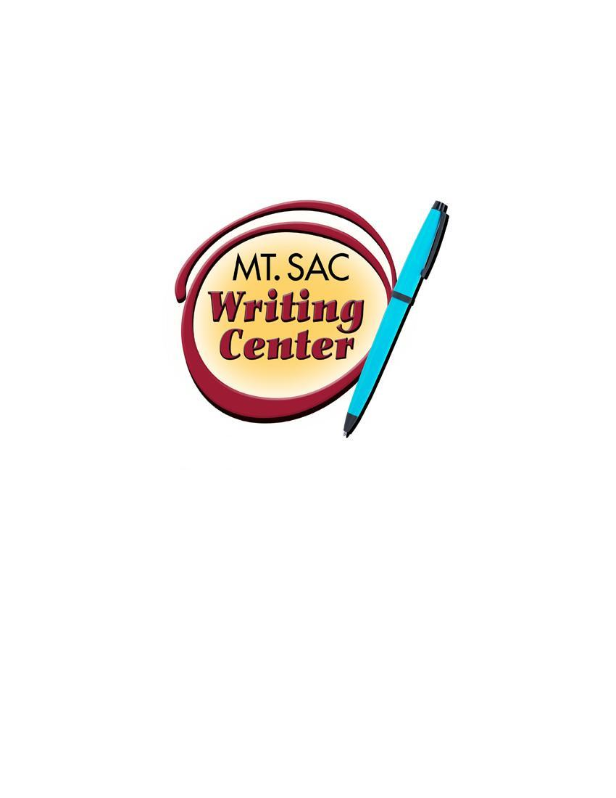

Annotated Bibliography
The Writing Center
RealCitation™ Handouts

An annotated bibliography is a combination of a list of sources (books, journals, websites, periodicals, etc.) and a summary and/or evaluation of each source used in the research. The purpose of an annotated bibliography is to learn more about the topic being researched and to help readers or other researchers find more information about the topic. There are many different types of annotation*:

- Descriptive annotations typically answer the question, “What is the point of this source?” They are generally very short and simply describe a source’s main argument.
- Summary annotations usually answer the question, “What is the source discussing?” These annotations give a more detailed summary of the source compared to the descriptive annotation. They typically include a summary of the main and supporting points of a source.
- Evaluative annotations often answer the question, “How can I use this source in my research?” These annotations discuss your thoughts on the source and how you may use the source in your essay.
- A mixed approach annotation combines two or three annotation approaches above.

*Different instructors will require different criteria, so make sure to carefully review your professor’s assignment.
MLA Annotation Sample—Summary and Evaluation

Lamott, Anne. Bird by Bird: Some Instructions on Writing and Life. New York: Anchor Books, 1995. Print.
Lamott's book offers honest advice on the nature of a writing life, complete with its insecurities and failures. Taking a humorous approach to the realities of being a writer, the chapters in Lamott's book are wry and anecdotal and offer advice on everything from plot development to jealousy, from perfectionism to struggling with one's own internal critic. Lamott presents sane advice for those struggling with the anxieties of writing, but her main project seems to be offering the reader a reality check regarding writing, publishing, and struggling with one's own imperfect humanity in the process. Several of the chapters in Part 1 address the writing process and would serve to generate discussion on students' own drafting and revising processes. Some of the writing exercises would also be appropriate for generating classroom writing exercises. Students should find Lamott's style both engaging and enjoyable.

APA Annotation Sample—Assessment and Reflection

Ehrenreich, B. (2001). Nickel and dimed: On (not) getting by in America. New York: Henry Holt and Company.
In this book of nonfiction based on the journalist's experiential research, Ehrenreich attempts to ascertain whether it is currently possible for an individual to live on a minimum-wage in America. The author is forthcoming about her methods and supplements her experiences with scholarly research on her places of employment, the economy, and the rising cost of living in America. Ehrenreich’s project is timely, descriptive, and well-researched.

Chicago Style Annotation Sample—Description and Summary

Davidson, Hilda Ellis. Roles of the Northern Goddess. London: Routledge, 1998.

Davidson's book describes the major roles filled by the numerous pagan goddesses of Northern Europe in everyday life, including their roles in hunting, agriculture, domestic arts like weaving, the household, and death. The author discusses relevant archaeological evidence, patterns of symbol and ritual, and previous research. The book includes a number of black and white photographs of relevant artifacts.

The Annotated Bibliography Map

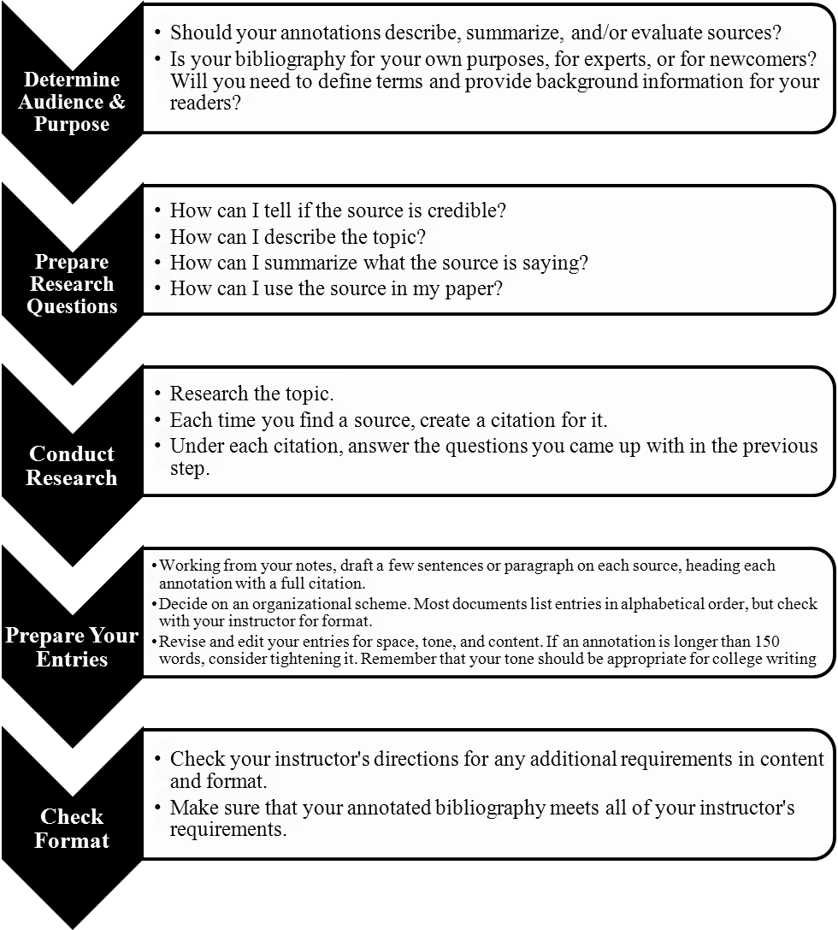
“Annotated Bibliography Samples.” OWL: Purdue Online Writing Lab. Purdue University, 2012. Web. 22 October 2012.
“Annotated Bibliographies and Literature Reviews.” The St. Martin’s Guide to Writing. Ed. Rise B. Axelrod and Charles R. Cooper. 9th ed. Boston: Bedford/St. Martin’s, 2012. Print.

