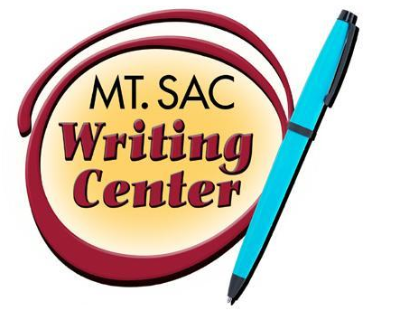

APA Style: General Guidelines for Formatting
The Writing Center
RealCitation™ Handouts

APA stands for American Psychological Association. Who should use APA? APA style describes rules for the preparation of manuscripts for writers and students in: Social Sciences like Psychology, Linguistics, Sociology, Economics, and Criminology. APA style is also used in Business and Nursing.

General APA Guidelines
Your essay should be typed, double-spaced on standard-sized paper (8.5” x 11”) with 1” margins on all sides. You should use 10-12 pt. Times New Roman font or a similar font.

Include a page header at the top of every page. To create a page header, insert page numbers flush right. Then type “TITLE OF YOUR PAPER” in the header flush left.

Major Paper Sections
Your essay should include four major sections: the Title Page, Abstract, Main Body, and References.

Title Page
The title page should contain the title of the paper, the author’s name, and the institutional affiliation. Include the page header (described above) flush left with the page number flush right at the top of the page. Please note that on the title page, your page header should look like this:

Running head: TITLE OF YOUR PAPER

Pages after the title page should have a running head that looks like this:

TITLE OF YOUR PAPER

Type your title in upper and lowercase letters centered in the upper half of the page. APA recommends that your title be no more than 12 words in length and it should not contain abbreviations or words that serve no purpose. Your title may take up one or two lines. All text on the title page, and throughout your paper, should be double-spaced.

Beneath the title, type the author’s name: first name, middle initial(s), and last name. Do not use titles (Dr.) or degrees (Ph.D.).

Beneath the author’s name, type the institutional affiliation, which should indicate the location where the author(s) conducted the research.

Please see the backside of this handout for a sample title page.

Does Online Tutoring Work?
Erin Tyson
Mt. San Antonio College

