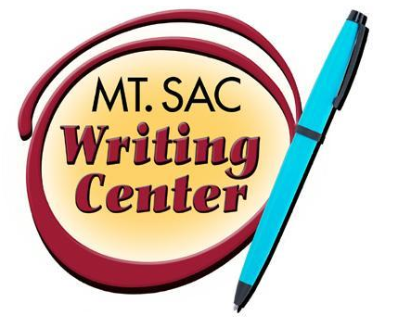

APA In-text Citation
The Writing Center
RealCitation™ Handouts

Below you will find examples of how to cite your sources in-text according to the 6th edition of the APA Publication Manual. Please note that the examples below are single spaced to conserve space; however, APA format requires that your essay be double-spaced throughout the entire document, including citations. APA also dictates that you use past or present perfect to introduce your source.
- Paraphrase/summary with Author and Date Cited in Text (no parenthetical citation necessary)
In her 2002 book In Cold Fear, Steinle explored some of the controversy surrounding Catcher in the Rye.
- Paraphrase/summary with Author Not Cited in Text
Writers need to bounce their ideas off friends or family members to get an idea of how their work will be received (Lamott, 1994).
- Paraphrase/summary with Author Cited in Text
Lamott (1994) attributed her success as a writer to the fact that she knows and recognizes that her writing needs several drafts and revisions before it is close to a “good” draft.
- Direct Quotation with Name of Author Cited in Text
Steinle’s (2002) study of the 1982 Calhoun County book banning found “that of those involved in the Calhoun County incident, only the librarian had actually read the majority of the books cited and some of the ‘censors’ had not read one of those books in question” (p. 1).
- Direct Quotation without Name of Author Cited in Text
Writers don’t often realize that “knowledge of your characters also emerges the way a Polaroid develops: it takes time for you to know them” (Lamott, 2002, p. 44).
- Long (Block) Quotations: Quotations longer than 40 words need to be put into a block. After you introduce the quotation, begin the block quotation on the following line and indent ten spaces from the left margin. Do not use quotation marks around the block. The entire block quotation will be indented ten spaces, and the end punctuation will come before the parenthesis.

Block Quotation Example:
Steinle (2002) has explained that when looking at censorship,
The question quickly becomes whether or not one has the right to read a ‘filthy’ or ‘un-American’ book such as The Catcher in the Rye, not why the book is believed to be filthy or un-American in the first place. (p. 2)
- Electronic and Multimedia Sources without Page Numbers: Electronic sources are cited in the typical author-page number style with one difference: when an Internet site does not have page numbers, offer other location information such as screen, section (sec.), paragraph (para.), track, or time frame (minute).
Because of Greece's physical characteristics-its jagged coast made almost all settlements within 40 miles of the sea-the ancient Greeks relied on the sea for most long-distance traveling (Martin, 2002, sec. 2.4).
Hoppin and Taveras (2004) pointed out that several other medications were classified by the Drug Enforcement Administration as having the “potential for abuse” (Weight-Loss Drug sec., para. 6)
Students wonder “what to do when there is no page number” (Hall, 2001, para. 5).
According to Smith (1997), “Everyone can move objects with their mind” (Mind over Matter sec., para. 6).
- Unknown Author and Unknown Date (i.e. articles on websites): If no author or date is given, use the title in your signal phrase or the first word or two of the title in the parentheses and use the abbreviation “n.d.” (for “no date”).
Another study of students and research decisions discovered that students succeeded more often with tutoring than without (“Tutoring and APA,” n.d.).

*If the date is given, replace “n.d” with the date: (“Tutoring and APA,” 2003).

For a complete explanation of APA style citation, please visit:
http://apastyle.apa.org/
OR
Visit the Online Resources section of the Writing Center’s website:
http://www.mtsac.edu/instruction/humanities/writingcenter/online-resources.html

