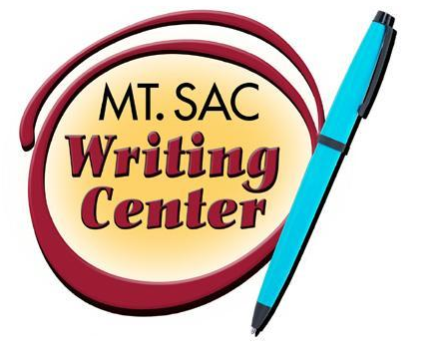

11 Tips for Making Your Writing Better Right Now
The Writing Center
RealWriting™ Handouts

(While You Wait for a Tutor)!

- UNDERSTAND THE PROMPT: “Prompt” is a fancy word for writing assignment. Be sure you understand what you are being asked to write. If you do not understand, ask your professor.

- PLAN TIME TO WRITE IN “CHUNKS”: Use your planner or smart phone to schedule 15-20 minute segments of writing on a regular basis so you can work through prewriting, organizing, drafting, revising, and editing in small chunks of time. This way, you will not get overwhelmed by your writing assignments.

- DO A PREWRITING ACTIVITY: Prewriting activities are useful for coming up with topics, thesis statements, and outlines. Clustering, freewriting, diagramming, brainstorming, outlining, and listing are some prewriting activities you can do. For specific ideas, sign up for the “Overcoming Writer’s Block” workshop today!

- CREATE A STRONG THESIS: The thesis is the main point of your essay. Creating an organized thesis that clearly states your point will help you to focus your writing and stay on topic. Use the yellow “Thesis Generator” handout to get started. Handouts are located next to the lobby in the black literature racks.

- USE TRANSITIONS BETWEEN PHRASES AND PARAGRAPHS: Transitions are words, phrases, or even sentences between ideas or paragraphs that connect them. Transitions are the glue that hold your paper together and bridge ideas so your reader knows when you are moving from point to point. Grab a yellow transitions handout and plug them into your paper while you wait!

- USE SPECIFIC EXAMPLES AND ILLUSTRATIONS: Specific details are descriptive words, clear examples, and in-depth analysis. For example, instead of mentioning just a truck, you could mention the brown beat-up Tacoma pick-up.

- VARY YOUR SENTENCES: Use short and long sentences as well as simple and complex sentences throughout your essay. Be sure you alternate how you begin your sentences.

- EXPAND YOUR VOCABULARY: Become familiar with using a dictionary and sign up for “The Word of the Day” podcast @ http://www.merriam-webster.com/word-of-the-day/

- DON’T STOP BEFORE REVISION: Students sometimes get tired of working with their paper and want to “give up” before revising. Be sure to read it over for clarity, organization, and development.

- USE THESE WEBSITES TO IMPROVE YOUR GRAMMAR:
  - http://owl.english.purdue.edu/owl/
  - http://writing.wisc.edu/
  - http://www.eslcafe.com/

- THE SUPER DUPER SECRET WAY TO START WRITING BETTER WITHOUT EVEN TRYING: READ, READ, READ! Read novels, read the newspaper, read articles in magazines of interests. You will start to write like what you read, so read good stuff!

Now that you are inspired, use the space below to write:

