Toulmin Argument Part I: Claim, Reason, and Warrant
Student Name:
Instructor:
Date:
Course:

About This DLA

Important Note
All the activities (4) in this DLA must be completed in their entirety before meeting with a tutor and receiving credit. Where indicated, complete your work on this sheet. If your instructor wants evidence of this completed DLA, return this form to him or her with the tutor’s signature included.

Learning Outcomes
Through computer and other independent work, you will be able to define Toulmin argumentation, identify its key components, and perform a Toulmin analysis of an argument.

Activities (approximately 1 hour)
Read the information, complete the activities that follow, and be prepared to discuss your answers when you meet with a tutor.

Understanding Toulmin Argument
Toulmin Argument is a mode of both constructing and analyzing arguments. While it is not the only way to examine or build an argument, it is certainly a useful tool for students and professionals alike. The Toulmin argument has five main components: the claim, the reason, the warrant, the grounds and the backing. This DLA will concentrate on the first three elements: the claim, the reason, and the warrant. Let’s look at a very small argument and examine it using the Toulmin method:
It’s raining outside, so you should take your umbrella.
The claim: You should take your umbrella.
The reason: It is raining.
The warrant: You don’t want to get wet.
The claim in the argument is what you are saying someone should think or do, for example, “Capital punishment should be illegal,” or “Mt. SAC should have a spring break.” The claim is the purpose or goal of the argument: take your umbrella!
The reason, which can be stated or unstated, addresses why someone should agree with your claim. It’s the because of the argument, as in when a parent says to a child who asks “Why?” too many times: “Because I said so!” Examples of this would include: “Capital punishment should be outlawed because sometimes the innocent are executed.” And “Mt. SAC should have a spring break so that students can rest and recover before their finals.” (This combination of the claim plus a reason is called an enthymeme.)

The warrant is the underlying assumption of the Claim + Reason. It’s the connection, often unstated, between the claim and the reason. It’s the glue that holds them together. In essence, the warrant is the shared understanding that makes the reader feel a compelling connection between the claim and the reason. It’s helpful to understand this as a kind of inverted triangle:
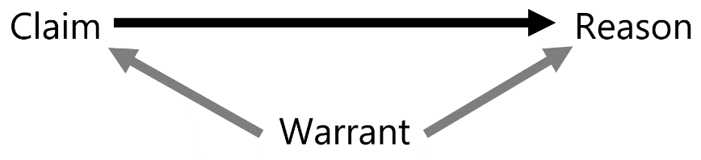
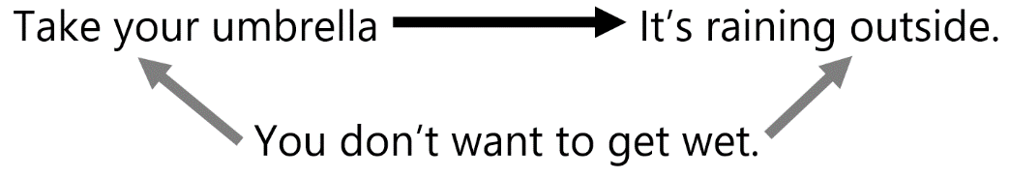
*Since warrants are often unstated, there are a number of similar ways any particular warrant might be phrased. We could also say here that the warrant is “people ought not to get wet,” or “people should avoid getting wet.”

Understanding Warrants
It’s important to understand that the connection between a claim and a reason is only as strong as the shared acceptance of the underlying warrant. If you are a carefree person who enjoys, as the Jewel song says, “feeling the rain on your skin,” then you would not find this argument persuasive, not because you disagree with the reason—you can see that it is indeed raining—but because you don’t accept the warrant that “you don’t want to get wet.” You might think people should sometimes get wet in order to feel alive or connected to nature. This would be a counterargument (or rebuttal) to the original warrant.
If we look at the earlier argument regarding capital punishment, we can also deduce the underlying warrant:
Claim: Capital punishment should be illegal.
Reason: Sometimes innocent people are executed.
Warrant: Anything that can lead to the execution of the innocent should be illegal.
This warrant relies on a shared assumption that the innocent are entitled to an absolute legal protection from punishment for a crime they didn’t commit. This is a strong value in many cultures around the world. Among liberals in the US, this warrant would find a great deal of agreement. While conservatives would also agree that the innocent should not be executed, some of them might counter-argue that just because mistakes sometimes occur, that does not justify ending capital punishment. They might argue that while these errors are very regrettable and everything should be done to avoid them, the deterrence factor justifies the use of capital punishment even if sometimes mistakes are made. After all, deterrence may save more innocent lives than capital punishment ends. The point here is that you should try to use warrants that your readers are likely to share, or be prepared to support your warrant.
In order to support a warrant your audience might not immediately accept, you need to provide backing. Backing is the evidence you offer to support a warrant. Here is an example of backing for the warrant above: If the American Justice system is premised on the idea of “innocent until proven guilty,” then protection of the innocent is of paramount value in our legal system. If we, for the sake of capital punishment’s deterrence, accept that some innocent people will be executed, then we undermine the fundamental values of our own system.
Both backing and grounds will be covered in depth in the DLA “Toulmin Argumentation, Part II.”

Activities
Check off each box once you have completed the activity.

☐ 1. Toulmin Method
Define the Toulmin Argument in your own words.

☐ 2. Identifying Claims and Reasons
Identify whether each of the following is a claim (C) or a reason (R), then draw a line to indicate which claims are connected to which reasons:
C or R | Sentence |  |  | C or R | Sentence
 | Taxes must be lowered. |  |  |  | Parking should not be an obstacle
 |  |  |  |  | to an education.
 | Mt. SAC needs to build a parking |  |  |  | These high rates are bankrupting
 | structure. |  |  |  | businesses.
 | The president should be |  |  |  | Harmful UV rays can give you.
 | impeached. |  |  |  | cancer
 | College should be free for all. |  |  |  | He has committed high crimes
 |  |  |  |  | and misdemeanors.
 | You should wear sunblock. |  |  |  | More people would be able to
 |  |  |  |  | attend college.

☐ 3. Identifying Warrants
In the space below, write each of the enthymemes listed above (remember, an enthymeme is a sentence that expresses a claim and a reason for that claim.) Then, in your own words, identify the warrant of the argument. The first one has been done for you as an example.
Enthymeme and Warrant | Your answer
Enthymeme: | Taxes must be lowered because these high rates are bankrupting businesses.
answer
Warrant: | Anything that bankrupts business should be reduced.
answer
Enthymeme: | Mt. SAC needs to build a parking structure because parking should not be an
 | obstacle to an education.
Warrant:
answer
Enthymeme:
answer
Warrant:
answer
Enthymeme:
answer
Warrant:
answer
Enthymeme:
answer
Warrant:
answer

Chose 4a or 4b below.

☐ 4a. Work with Your Own Writing
Identify a topic you have been asked to write on in any class. State your claim about this topic, your reason for this claim, and one or more warrants that support the argument.
Write your answers.
Claim:
answer
Reason:
answer
Warrant(s):
warrant
warrant

If you do not have your own writing, complete 4b below.

☐ 4b. Developing Claims, Reasons, and Warrants.
Develop a Claim, a Reason, and a Warrant for FIVE of the following topics:
absences
climate change
Dreamers
e-cigarettes
the electoral college
Kanye West
late adds
parking at Mt. SAC
scooters or skateboards

 | Write your answers.
Claim: | Students should not need to complete paperwork for late adds.
Reason: | Extra paperwork makes it more difficult for students to get the classes they need.
Warrant: | Anything that makes it more difficult for students to add classes should be
 | eliminated.
Claim: | Flavored e-cigarettes should be banned.
Reason: | The flavor of e-cigarette attracts children and leads to nicotine addiction.
Warrant:
answer
Claim: | The government needs to pass stricter emission laws to combat climate change.
Reason:
Warrant:
answer
Claim:
Reason:
Warrant:
answer
Claim:
Reason:
Warrant:
answer
Claim:
Reason:
Warrant:
answer

☐ 5. Review
Go to https://mtsac2.mywconline.com and use the Mt. SAC Writing Center Appointment System to make a DLA appointment, or sign-up to see a tutor on the “DLA Walk-in” list in the Writing Center. During your session with a tutor, explain Toulmin Argument and your answers to the exercises. How will knowledge of these concepts improve your writing?
Student’s Signature
Tutor’s Signature:
Date:
Date:

If you are an individual with a disability and need a greater level of accessibility for any document in The Writing Center or on The Writing Center’s website, please contact the Mt. SAC Accessible Resource Centers for Students, access@mtsac.edu, (909) 274-4290.
Revised 09/24/2019

