Thesaurus Skills

Student Name:
Instructor:
Date:
Course:

About This DLA

Important Note
All the activities (4) in the DLA must be completed in their entirety before meeting with a tutor and receiving credit. Where indicated, complete your work on this sheet. If your instructor wants evidence of this completed DLA, return this form to him or her with the tutor’s signature included.

Learning Outcome
Through computer and other independent work, this activity will familiarize you with skills needed for the effective use of thesauruses, which will increase your vocabulary and help you choose correct words for different contexts.

Activities (approximately 1 hour)
Read the information, complete the activities that follow, and be prepared to discuss your answers when you meet with a tutor.

Thesaurus Basics
Pronounced: [THəˈsôrəs]

What is a thesaurus and how is it different from a dictionary?
- A thesaurus, like a dictionary, uses alphabetical order to list words. Although most thesauruses provide a brief definition of each word, they are different from dictionaries in that they are focused on synonyms (words that have the same meaning) and antonyms (words that have the opposite meaning).
- If you would like to avoid repeating words, or you would like to replace some of your words with more precise or more academic words, you can look up your word in a thesaurus and find a list of synonyms.
- If you want to find an antonym for a word you have used, you can look up your word in a thesaurus and find a list of antonyms.
- Thesauruses can help you expand your vocabulary since you are able to learn a variety of synonyms and antonyms for different contexts.
- Important note: You should always keep in mind that synonyms are usually not used in the same contexts, and their connotations* may vary greatly. See the next section.
Thesaurus.com at http://www.thesaurus.com/ is a good online thesaurus.
Longman Dictionary of Contemporary English Online at http://www.ldoceonline.com is a good online dictionary for English learners.
Here is a picture of an entry on Thesaurus.com:
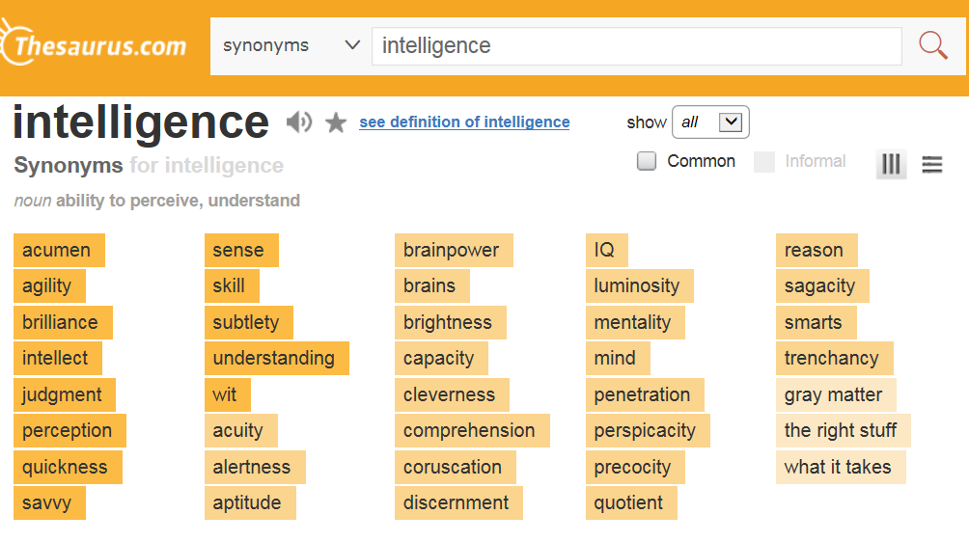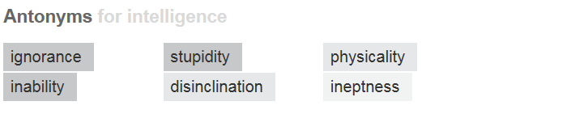

Microsoft Word© also has a feature that helps you find synonyms and sometimes even antonyms. To find this feature, simply type a word, right click, select “Synonyms,” and then you can see a list of similar words. To see more options, click on the “Thesaurus” field. A box with synonyms will appear to the right of your screen.

Choosing the Right Synonym
When you find synonyms in a thesaurus, the next step is to look at the definitions of each word so that you can understand the slight differences between each one. You can also look for examples of how the word is used in sentences in similar contexts to the one you are using it in. See how others have used it in sentences they wrote so that you understand whether the word generally carries either a negative, neutral, or positive connotation and whether or not it has the exact meaning you want to express. If you find that the word has the right definition but not the correct connotation you want, then search for a new synonym in your thesaurus and follow the above process again to find out if your new word has the correct meaning and connotation.
(*For more information on connotations of words, please refer to our “Connotation and Denotation” DLA.)
For example, which word would be the best synonym for middle in the following sentence?
Do not eat the middle of an apple.
middle² /ˈmɪdl/ noun ▼ middle
the part of something that is farthest from all the edges of an area or object. You use middle especially about the part that is halfway between two sides:
• Gary swam toward the middle of the lake.
• She placed the flowers in the middle of the table.➔ You can also use middle to talk about the part of something that is halfway between the beginning and the end: I fell asleep in the middle of the movie.
▼ center
center means the same as middle. You use center especially about the part that is exactly in the middle:
• Draw a line through the center of the circle.
• She placed the flowers in the center of the table.
▼ heart
the middle of an area, town, or city:
• The hotel is located in the heart of Manhattan.
▼ core AWL
the central part of the Earth, an object, such as a fruit:
• The Earth has a solid inner core which is 2,500 kilometers in diameter.
For the previous sentence, a better synonym for middle would be the word core because this word is related to the central part of a fruit. Make sure you look at the difference in meaning before choosing a synonym.

Activities
Check off each box once you have completed the activity.

☐ 1. Thesaurus Skills Review
Write the answers.
What are the benefits of using a thesaurus?
What is similar and what is different between a thesaurus and a dictionary?
Similar:
Different:

☐ 2. Online Quiz
Go to http://tinyurl.com/ThesaurusSkillsDLAQuiz and take the Thesaurus Skills DLA Quiz. You must score at least 80% on the exercises before seeing a tutor. After you complete the task, PLEASE ASK A LAB TUTOR OR FRONT DESK ATTENDANT TO PRINT THE PAGE THAT HAS YOUR SCORE. DO NOT EXIT THE PROGRAM UNTIL THIS PAGE HAS BEEN PRINTED (FREE OF CHARGE). If you have any other questions, do not hesitate to ask a lab tutor.

☐ 3. Thesaurus Word-Level Practice
Go to www.thesaurus.com for Thesaurus.com find and write down 3 synonyms and 1 antonym for the word flexible.
Answer | Answer | Answer
Synonyms: | 1. | 2. | 3.
Antonym | 1.
Using a thesaurus from the Writing Center (located on the shelves by the couches in our tutoring area), find and write down 3 synonyms for the word yell.
 | Answer | Answer | Answer
Synonyms: | 1. | 2. | 3.
Using Microsoft Word©, find and write down 3 synonyms for the word party.
 | Answer | Answer | Answer
Synonyms: | 1. | 2. | 3.

Choose 4a or 4b Below

☐ 4a. Review Your Own Writing
Collect some of your written work. Find 3 words that you would like to replace with more precise words. Then, use one of the Writing Center’s thesauruses or the following links to choose the appropriate replacement and write your sentences below.
Thesaurus.com at http://www.thesaurus.com/
Longman Dictionary of Contemporary English Online at http://www.ldoceonline.com/
Write sentences
1a. Original Sentence
1b. New Sentence
2a. Original Sentence
2b. New Sentence
3a. Original Sentence
3b. New Sentence
If you do not have sentences from your own writing to work with, please complete the supplemental activity below (4b).

4b. Thesaurus Sentence-Level Practice
Using a thesaurus, find the best synonym for the bolded word in each sentence.
Choose a synonym and explain your choice.
- At summer camp, Laura felt sad, for she had been away from her family and friends for two weeks.
Best synonym:
Explain your choice:
- I have a major problem; I can’t decide whether I should keep my terrible job and have money or quit and be unemployed with no money.
Best synonym:
Explain your choice:
- Grace has this silly idea that chewing gum will help her hair grow longer!
Best synonym:
Explain your choice:
- Jim was so shocked when he heard the news that he stayed silent for a whole minute.
Best synonym:
Explain your choice:
- Kim jumped across the big puddle of water so that she wouldn’t get her new shoes dirty.
Best synonym:
Explain your choice:
- We immediately knew that something was wrong when we saw the look on her face.
Best synonym:
Explain your choice:
- Michael quickly ran out the door and down the street to catch the ice cream truck.
Best synonym:
Explain your choice:

☐ 5. Review the DLA
Go to https://mtsac2.mywconline.com and use the Mt. SAC Writing Center Appointment System to make a DLA appointment, or sign-up to see a tutor on the “DLA Walk-in” list in the Writing Center.. During your session with a tutor, explain your work to demonstrate your understanding of thesaurus skills. Refer to your own graded writing (or the completed activity) and explain to the tutor the strategies that you used to improve your diction (choice of words) in your writing.
Student’s Signature:
Tutor’s Signature
Date:
Date:
If you are an individual with a disability and need a greater level of accessibility for any document in The Writing Center or on The Writing Center’s website, please contact the Mt. SAC Accessible Resource Centers for Students, access@mtsac.edu, (909) 274-4290.
Revised 06/12/2018

