Pronoun-Antecedent Agreement
Student Name:
Instructor:
Date:
Course:

About This DLA

Important Note
All the activities (5) in the DLA must be completed in their entirety before meeting with a tutor and receiving credit. Where indicated, complete your work on this sheet. If your instructor wants evidence of this completed DLA, return this form to him or her with the tutor’s signature included.

Learning Outcomes
Through computer and other independent work, this activity will familiarize you with the rules for pronoun-antecedent agreement and help you create sentences in which pronouns agree with their antecedents.

Activities (approximately 1 hour)
Read the information, complete the activities that follow, and be prepared to discuss your answers when you meet with a tutor.

Understanding Pronoun-Antecedent Agreement

Terms to know or review:
- Pronoun: a word that substitutes a noun
- Antecedent: the word or words that a pronoun replaces
Examples of pronouns and their antecedents:
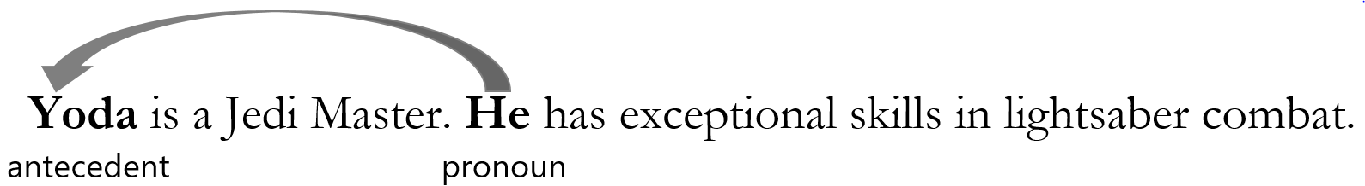
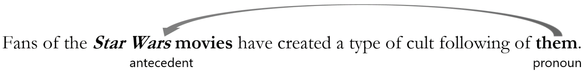

Why do we have problems with pronoun agreement?
Language evolves and it has been proposed that usage may change pronouns like everyone from singular to plural in the near future. We run into problems with pronoun agreement because we hear this error all of the time on the radio and in live news broadcasts; however, pronoun agreement has quite a simple concept:
A pronoun agrees with its antecedent in person, number, and gender.

Activities
Check off each box once you have completed the activity.

☐ 1. Pronoun Agreement PowerPoint
Go to http://www.mtsac.edu/writingcenter/ for Mt. SAC’s Writing Center website. At the top, select the DLA link for Directed Learning Activities. Scroll down, select, and watch the Pronoun Agreement PowerPoint presentation.

☐ 2. Online Quiz
Go to http://tinyurl.com/PronounAgreementDLAQuiz and take the Pronoun Agreement DLA Quiz. You must score at least 80% on the exercises before seeing a tutor. After you complete the task, PLEASE ASK A LAB TUTOR OR FRONT DESK ATTENDANT TO PRINT THE PAGE THAT HAS YOUR SCORE. DO NOT EXIT THE PROGRAM UNTIL THIS PAGE HAS BEEN PRINTED (FREE OF CHARGE). If you have any other questions, do not hesitate to ask a lab tutor.

☐ 3. Pronoun Agreement Review
Review the information above on pronoun agreement. Then answer the following questions.
Write the answers.
What is a pronoun?
What is an antecedent?

☐ 4. Find Pronoun Antecedent Agreement
Go to http://starwars.wikia.com/wiki/Yoda and read the blog entry about Star Wars’ character Yoda. Note: Because this site is used for entertainment, it may contain grammatical and mechanical errors. Locate five sentences that demonstrate correct or incorrect pronoun agreement, and write the sentences below. Make sure the antecedent and its pronoun are in the same sentence. Next identify the pronoun and antecedent in each sentence.
Write the sentences.
1.
2.
3.
4.
5.

Choose 5a or 5b Below

☐ 5a. Review Your Own Writing
Collect some of your graded work that identifies faulty pronoun antecedent agreement. Correct all marked errors and look for others to correct as well. Bring this revised work with you to the DLA tutoring session.
If you do not have your own essay to work with, please complete the supplemental activity below (5b).

☐ 5b. Choose the Correct Pronoun
Read the following sentences and circle the pronoun that agrees with its antecedent.
Each commanding member of the Trade Federation had a droid army given to (him or her, them).
When a traveler passes the Mos Eisley Cantina, (you, he or she, they) should ignore the strange characters within.
The pod racer or one of our droids has lost both of (its, their) power thrusters.
As the Gungan Bongo Submarine crossed Lake Paonga, one of the passengers lost (his, their) lightsaber.
Every fan at the Boonta Classic was rooting for (his or her, their) racer pilot.
When a racer has lost, (he or she, they) can become rather frustrated.
The Rebel Alliance gathered at (their, its) secret command center.
Anyone in the Jedi order can use (their, his or her) lightsaber as a quiet threat.
The Trade Federation formed (its, their) own private military.
Neither Luke Skywalker nor Princess Leia knew (his, her, his or her, their) father was Darth Vader.

☐ 6. Review the DLA
Go to https://mtsac2.mywconline.com and use the Mt. SAC Writing Center Appointment System to make a DLA appointment, or sign-up to see a tutor on the “DLA Walk-in” list in the Writing Center. During your session with a tutor, explain the corrections you made to demonstrate your understanding of pronoun-antecedent agreement. Refer to your own graded writing (or the completed activity) and explain to the tutor strategies that you used to identify and correct this error. Consider and discuss techniques you will use to avoid this error in your writing.
Student’s Signature:
Tutor’s Signature
Date:
Date:
If you are an individual with a disability and need a greater level of accessibility for any document in The Writing Center or on The Writing Center’s website, please contact the Mt. SAC Accessible Resource Centers for Students, access@mtsac.edu, (909) 274-4290.
Revised 05/07/2018

