The Present Tenses:

Simple Present & Present Progressive
Type your information in the space below.
Student Name: | Date:
Instructor: | Course:

About This DLA

Important Note
All the activities (3) in the DLA must be completed in their entirety before meeting with a tutor and receiving credit. Where indicated, complete your work on this sheet. If your instructor wants evidence of this completed DLA, return this form to him or her with the tutor’s signature included.

Learning Outcomes
Through computer and other independent work, this activity will familiarize you with the simple present and present progressive tenses and help you create sentences with correct use of these tenses.

Activities (approximately 1 hour)
Read the information, complete the activities that follow, and be prepared to discuss your answers when you meet with a tutor.

The Simple Present Tense
Use the simple present tense to express:

1. Repeated Actions
The simple present expresses repeated actions, such as habits, routines, hobbies, or scheduled events. It can also be things that people do not do.
Example: I drive to school every day. I collect old cars. I never eat after 8:00 p.m.
Often, we use adverbs of frequency for routines or habits. Here are some examples:

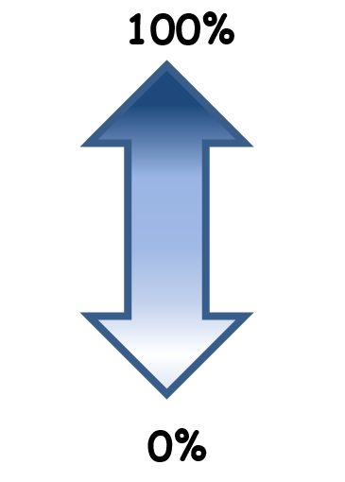
-Always/Every day
-Usually
-Often/Frequently
-Sometimes
-Occasionally
-Rarely/Seldom
-Never

2. General Information/Scientific Facts
The simple present also expresses general information, such as personal information, likes, dislikes, and things that are true.
Example: I work in Walnut. I don’t like milk. I come from Bolivia. Water boils at 100°C.

How to Form the Simple Present
There are three forms of be: am/is/are

I am
he/she/it/singular subjects is
you/we/they/plural subjects are

We use the –s form when the subject is he, she, it, or a singular noun:
We use the base form of the verb when the subject is I, you, we, they or a plural noun:
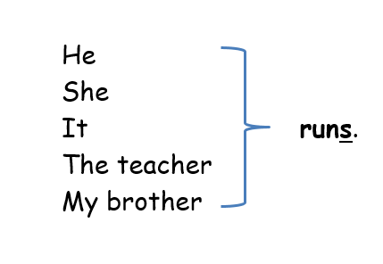
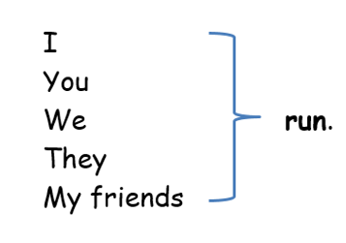

Many times, you only add –s to verbs for he/she/it, but sometimes you need more than –s. Here are some spelling rules for the –s form:
Rule | Base Form | -s Form
Add –s to most verbs to make the –s form | hope  eat | hopes  eats
When the base form ends in ss, sh, ch, or x, add –es and pronounce an extra syllable | miss  wash  catch  mix | misses  washes  catches  mixes
When the base form ends in a consonant + y, change the y to i and add –es | carry  worry | carries  worries
When the base form ends in a vowel + y, add –s but do not change the y | pay  enjoy | pays  enjoys
Add –es to go and do | go  do | goes  does

The Present Progressive Tense
We use the present progressive tense to express:

1. Actions that are happening right now
The present progressive expresses on-going actions in the present.
Example: You are reading this page. The student is typing on the computer.

2. Actions that are happening for a temporary time
The present progressive also expresses actions that are happening for a temporary time only. Sometimes, they will use expressions like this week, this month, this semester, this year, etc.
Example: I am taking English 67 this semester.

How to Form the Present Progressive
{ am/is/are + verb-ing }
Examples: I am driving on the freeway. The teacher is talking to a student. We are taking this class.
*Non-action verbs (mental states, emotional states, possession, be, etc.) are usually not in a progressive form.

How to Make Questions and Negative Statements
Simple Present and Present Progressive

Negative Statements
All verbs (except be since it never needs a helper) that have only one part to them (one-word verbs) need the helper do or does and not to become negative. Start with the subject, then be/do/does not, and then the base form of the verb. Verbs that have two or more parts already have a helper, so you just add not between the helper and the main verb.
Examples:

I live in Brea.
I do not live in Brea.

He likes chocolate.
He doesn’t like chocolate.

I am sad.
I am not sad.

We are studying.
We aren’t studying.

Questions
All verbs (except be since it never needs a helper) that have only one part to them (one-word verbs) need the helper do or does. The helper is first, then the subject, and then the base form of the verb. Verbs that have two or more parts already have a helper—the first part of the verb is the helper. You can add a wh- word at the beginning if you need it.
Examples:

She lives in New York.
You are tired.
They are making a cake.
Does she live in New York?
Are you tired?
Are they making a cake?
Where does she live?
Why are you tired?
What are they making?

Activities
Check off each box once you have completed the activity.

☐ 1. Review the Simple Present and the Present Progressive Tenses
Review the information on this sheet. Then, answer the following questions.
a. In what situations do we use the simple present tense?
Write Answer Here
b. In what situations do we use the present progressive tense?
Write Answer Here

☐ 2. Online Quiz
Go to http://tinyurl.com/PresentTensesDLAQuiz and take the Present Tenses DLA Quiz. You must score at least 80% on the exercises before seeing a tutor. After you complete the task, PLEASE ASK A LAB TUTOR OR FRONT DESK ATTENDANT TO PRINT THE PAGE THAT HAS YOUR SCORE. DO NOT EXIT THE PROGRAM UNTIL THIS PAGE HAS BEEN PRINTED (FREE OF CHARGE). If you have any other questions, do not hesitate to ask a lab tutor.

Choose 3a or 3b Below

☐ 3a. Practice with Your Own Writing
Collect some of your graded work. Find examples of sentences that contain the following:
Repeated Action:
Write Answer Here
General Information or Fact:
Write Answer Here
Non-Action Verb:
Write Answer Here
Action happening right now or for a temporary time:
Write Answer Here
If you do not have your own essay to work with, please complete the supplemental activity below (3b).

☐ 3b. Create Sentences
Get the envelope that reads “The Present Tenses—Activity 3b Word Cards” in the DLA file. In it, you will find word cards. Form the following statements or questions. You must use a different subject and verb every time. Make a sentence using the word cards, write it down below, and then form another sentence. You will do this four times. (Not online)
A negative statement in the simple present tense:
Write Answer Here
An affirmative statement in the present progressive tense:
Write Answer Here
A question in the simple present tense:
Write Answer Here
A question in the present progressive tense:
Write Answer Here

☐ 4. Review the DLA
Go to https://mtsac2.mywconline.com and use the Mt. SAC Writing Center Appointment System to make a DLA appointment, or sign-up to see a tutor on the “DLA Walk-in” list in the Writing Center. During your session with a tutor, explain your work to demonstrate your understanding of the present tenses. Refer to your own graded writing (or the completed activity) and explain to the tutor strategies that you used to create sentences with simple present and present progressive.
Sign and date in the space below.
Student’s signature: | Date:
Tutor’s Signature: | Date:
If you are an individual with a disability and need a greater level of accessibility for any document in The Writing Center or on The Writing Center’s website, please contact the Mt. SAC Accessible Resource Centers for Students, access@mtsac.edu, (909) 274-4290.
Revised 05/10/2018

