Parts of Speech

Student Name:
Instructor:
Date:
Course:

About This DLA

Important Note
All the activities (3) in the DLA must be completed in their entirety before receiving credit for completion. Students are welcome to meet with a tutor if they need help, but please be aware that students might need a second appointment for review and signature in that case. If your instructor wants evidence of this completed DLA, return this form to him or her with the tutor’s signature included.

Learning Outcomes
Through computer and other independent work, this activity will familiarize you with the various parts of speech and help you select the appropriate part of speech for different parts of sentences.

Activities (approximately 1 hour)
Read the information, complete the activities that follow, and be prepared to discuss your answers when you meet with a tutor.

Understanding Parts of Speech
All words in sentences in the English language comprise one of the eight categories: nouns, verbs, pronouns, adjectives, adverbs, prepositions, conjunctions, and interjections.
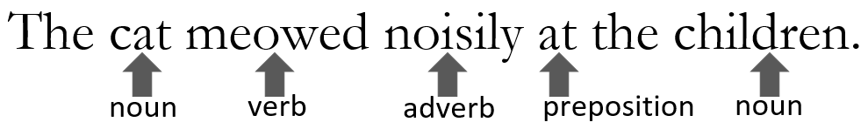
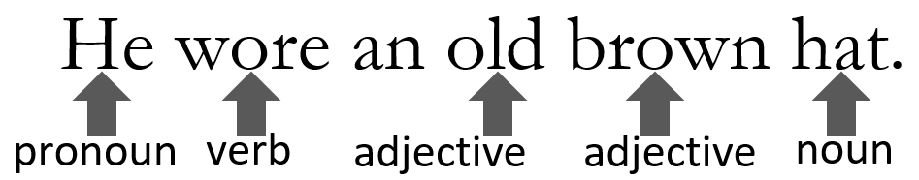
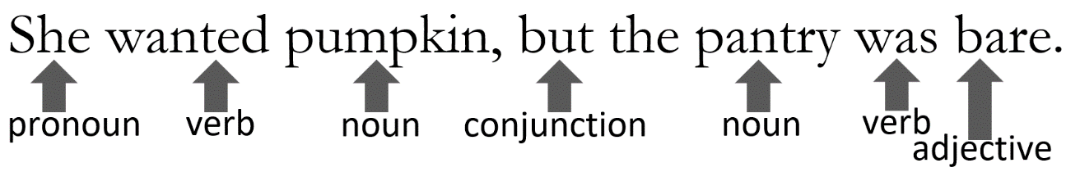
Here are a few examples of the eight parts of speech:
Part of Speech | Definition | Examples
Nouns | -person, place, thing, or quality | Bob, America, coffee, kindness
 | -the subject of the action being expressed in a sentence | Starbucks has many types of coffees.
 | - the object of the action being expressed in a sentence | He asked Enrique to buy him a cup of coffee.
 | -the object of a preposition | Henry gave the coffee to Enrique.
 | Proper nouns are used to denote individuals and personifications and are always capitalized. Common nouns are not. | Amy (proper noun) wants to buy a new mug (common noun).
 | -gerunds (verb + -ing) | Eating fast food can be harmful to one’s health.
 | -infinitives (to + verb) | Maria wanted to eat out for dinner.
Verbs | - words that show action | run, hide, sing
 | -words that show a state of being or non-action | be, seem, know, have
 | -a single-word verb or verb plus helpers | run, is running, has been running, should run, must have been running
Pronouns | -words that are used in place of a noun  -subject pronouns | I, you, he, she, it, they, we, their, this, these, that, those, who, which, each, either, neither
 | -object pronouns | me, you, her, him, it, them, us
 | -possessive pronouns | mine, his, hers, its, theirs
 | -indefinite pronouns | one, anyone, everybody, something
 | -demonstrative pronouns | this, these, that, those
 | -relative pronouns | who[m], whose, that, which
 | -reflexive pronouns | myself, herself, themselves
Adjectives | -words that provide description for nouns and pronouns | scared, scary, smart, difficult, proper
 | -determiners | a[n], the
 | -quantifiers/numbers | many, half, three, second
Adjectives | -possessive adjectives | my, your, her, his, its, our, their
 | -nouns that act like adjectives | delicious coffee
 | -comparative | more intelligent, stronger
 | -superlative | the most intelligent, the strongest
Adverbs | -modify a verb | Erica eats quickly.
 | -modify an adjective | a very loud party
 | -modify another adverb | very quickly
 | -indicate place or direction | here, there
 | -indicate time | ever, immediately
 | -indicate degree | very, almost
 | -indicate manner | thus, and words ending in -/ly
 | -indicate belief or doubt | perhaps, no
 | -indicate frequency | always, often, never, daily
 | -can be comparative/superlative | more highly, the most highly
 | -conjunctive adverbs | therefore, however, thus, as a result
Prepositions | -link nouns, pronouns and phrases to other words; describe time, space, or logic | in, on, at, through, by, for, to, after, up, down, of, out, over, above, next to, below, with, about, beside, until, & many more!
Conjunctions | -connect sentences, clauses, phrases and words  coordinating conjunctions | for, and, nor, but, or, yet, so
 | -subordinating conjunctions | because, if, when, although, before, since, after
 | -correlative conjunctions | either/or, neither/nor, not only/but also
Interjections | -words used for emphasis or to  convey an emotion; not needed to complete a sentence | ugh, oh, whoa, well, sure, holy smokes, ouch, stop, aha, phew, yikes, ah, hey, duh, wow, uh oh, whoops, bingo, yuck, yo, huh

Parts of Speech and Changing Functions
Some words can have different functions. To understand what part of speech a word is, it is important to pay attention to how it is functioning in a sentence.
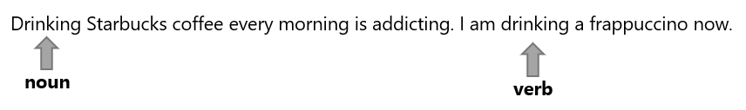
In the above example sentences, “drinking” functions as a noun and as a verb.
“Drinking” functions as a noun in the first sentence, “Drinking Starbucks coffee every morning is addicting” because “drinking” is the subject of sentence and is a gerund, which is a type of noun.
In the second sentence, “I am drinking a frappuccino now,” “drinking” functions as verb since it follows the present progressive form (am/is/are + verb -ing).
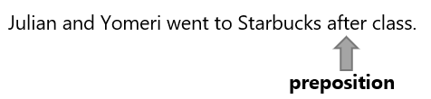
In the above example, “after” functions as a preposition because it is followed by a noun, “class.”
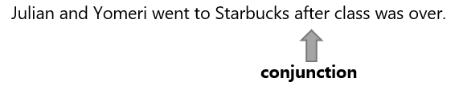
In the above example, “after” functions as a subordinating conjunction because it is followed by a clause, “class was over.”

Activities
Check off each box once you have completed the activity.

☐ 1. Online Quiz
Go to http://tinyurl.com/PartsofSpeechDLAQuiz and take the Parts of Speech DLA Quiz. You must score at least 80% on the exercises before seeing a tutor. After you complete the task, PLEASE ASK A LAB TUTOR OR FRONT DESK ATTENDANT TO PRINT THE PAGE THAT HAS YOUR SCORE. DO NOT EXIT THE PROGRAM UNTIL THIS PAGE HAS BEEN PRINTED (FREE OF CHARGE). If you have any other questions, do not hesitate to ask a lab tutor.

☐ 2. Parts of Speech Practice
Fill in the blanks with the correct part of speech. (Try to do it without reading the text first.)
Starbucks is (adverb_______________) (adjective_______________) around the world. They have sold (adjective_______________) coffee and are located in (adjective_______________) US states. The Starbucks Corporation has net earnings of 4.7 billion dollars for their first quarter in 2021. Americans (verb_______________) Starbucks coffee, (noun_______________), and mugs, but the corporation is not as popular in the other countries. Starbucks is (adverb_______________) popular in California, (conjunction_______________) (pronoun_______________) have sold millions of coffees. (adverb_______________), what is really popular now are Starbucks’s tumblers and coffee mugs. Many Americans even collect their (adjective_______________) mugs and tumblers. In fact, (pronoun_______________) tumblers have been so beloved by (noun_______________) that people (verb_______________) to multiple Starbucks locations to find the latest special edition, limited release cups. Ashley Spaulding, a collector in Fort Worth, Texas, (verb_______________) her first tumbler (preposition_______________) 2017. The matte-black tumbler attracted her, and she has been collecting tumblers (adverb_______________). Many people are so (adjective_______________) with their cups that they are willing to buy them from eBay or Poshmark for double or more than the original price. The (noun_______________) to collect all of the latest editions of their cups have led to some Starbucks baristas being harassed and assaulted by (adjective_______________) consumers. (interjection_______________)! It is (adjective_______________) to see the lengths some individuals go to get what they want. If you have not gotten a drink at Starbucks, today is the day to try something new!

Choose 3a or 3b Below

☐ 3a. Correct Your Own Writing
Collect some of your graded work that identifies errors in parts of speech usage. Correct all marked errors and look for others to correct as well. Bring this revised work with you to the DLA tutoring session.
If you do not have your own essay to work with, please complete the supplemental activity below (3b).

☐ 3b. Parts of Speech Sentences
Review the above information on parts of speech. Write eight different sentences and underline its part of speech.
Write your sentences.
Noun
Verb
Pronoun
Adjective
Adverb
Preposition
Conjunction
Interjection

☐ 4. Review the DLA
Go to https://mtsac2.mywconline.com and use the Mt. SAC Writing Center Appointment System to make a DLA appointment, or sign-up to see a tutor on the “Walk-in” list in the Writing Center. During your session with a tutor, explain the different parts of speech. Refer to your own graded writing (or the completed activity) and explain to the tutor strategies that you used to identify these various forms and how knowledge of this can help improve your writing style.
Student’s Signature:
Tutor’s Signature
Date:
Date:
If you are an individual with a disability and need a greater level of accessibility for any document in The Writing Center or on The Writing Center’s website, please contact the Mt. SAC Accessible Resource Centers for Students, access@mtsac.edu, (909) 274-4290.
Revised 04/12/2022

