Dictionary Skills
Student Name:
Instructor:
Date:
Course:

About This DLA

Important Note
All the activities (3) in the DLA must be completed in their entirety before receiving credit for completion. Students are welcome to meet with a tutor if they need help, but please be aware that students might need a second appointment for review and signature in that case. If your instructor wants evidence of this completed DLA, return this form to him or her with the tutor’s signature included.

Learning Outcome
Through computer and other independent work, this activity will familiarize you with skills needed for the effective use of dictionaries, which will increase your vocabulary and help you choose correct words for different contexts.

Activities (approximately 1 hour)
Read the information, complete the activities that follow, and be prepared to discuss your answers when you meet with a tutor.

Dictionary Basics

Alphabetical Order
Words in a dictionary are listed in alphabetical order, which is true for each letter in a word.
This is the order of the alphabet:
A, B, C, D, E, F, G, H, I, J, K, L, M, N, O, P, Q, R, S, T, U, V, W, X, Y, Z
For example, if you are looking for the word intelligence, you will start by going to the “i" section of the dictionary since “i” is the first letter of this word. Many dictionaries use tabs or colors to mark where a new letter of the alphabet starts. Look for the tab with the letter you need.
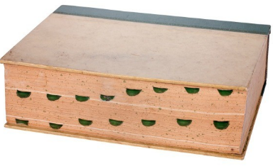
Tabs marking the start of each letter of the alphabet
Once you find the letter “i,” you will need to look for the second letter in the word, which in the case of the word intelligence is the letter “n.” The second letter of each word, like all other letters in the word, will follow the alphabetical order. Therefore, within the “i” section, you will need to look for the section that has words beginning with “in.” To do this, you can look at the first word at the top of each page to see its letters. You will then follow the same procedure for each letter in the word until you find the word you are looking for.
Go to http://tinyurl.com/DictionaryBasics if you would like to watch a dictionary basics video that demonstrates the above steps.

Symbols and Parts of Speech
Once you find the word you need, you will see many different symbols next to the word. Here are a few symbols from the Longman Advanced American Dictionary:
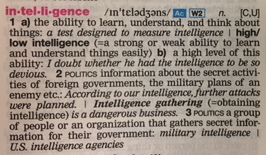
Symbol | Meaning
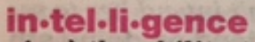 | The dots (.) between the letters of a word separate the syllables. As you can see, this word has four syllables.
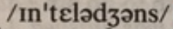 | These are the sound symbols for this word to help you pronounce it accurately. To know which sound a symbol stands for, look for the “Pronunciation Table” of your dictionary, which is usually within the first or last pages of dictionaries.
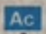 | Dictionaries will often use abbreviations to mark academic words. In this case, Ac indicates that this word is included in the Academic Word List, which means you will probably see it in many academic texts and you will likely need to use it in writing assignments.
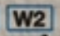 | Dictionaries will often use symbols to mark most frequently used words. In this case, W2 indicates that this word is among the top 2,000 words most frequently used in writing. The W stands for writing and 2 stands for 2,000.
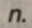 | This n. indicates the part of speech of this word: noun. Some words can be used as different parts of speech without changing the form or spelling, so you might see more than one part of speech indicated within the dictionary entry.
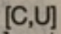 | The C stands for “count” and the “U” stands for “uncount,” which means that this word can be used both as a count and an uncount noun, depending on the context.
To find out what each of the symbols in your dictionary mean, look for the “key” in the table of contents. Below is an example of part of the “key” found in a dictionary.
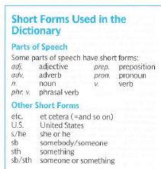

Word Definition Information
Word Definition Images | Meaning
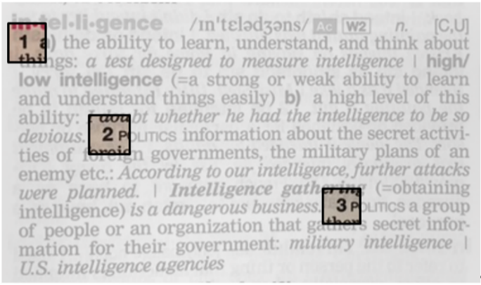 | If a word has more than one meaning, each meaning is numbered.  The first meaning of the word intelligence has to do with learning, understanding, and thinking.
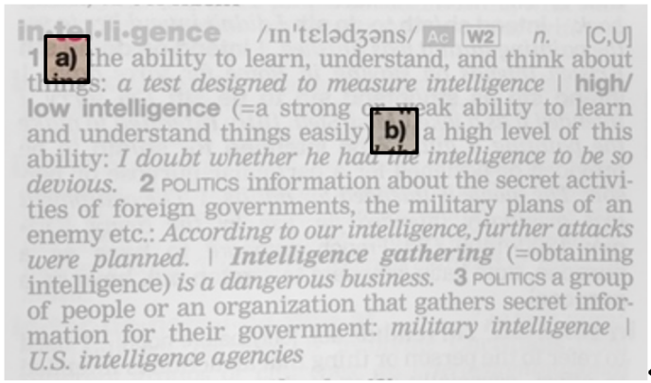 | Notice that the first meaning is divided into a) and b) because there are two different contexts in which the word can be used with the first meaning.
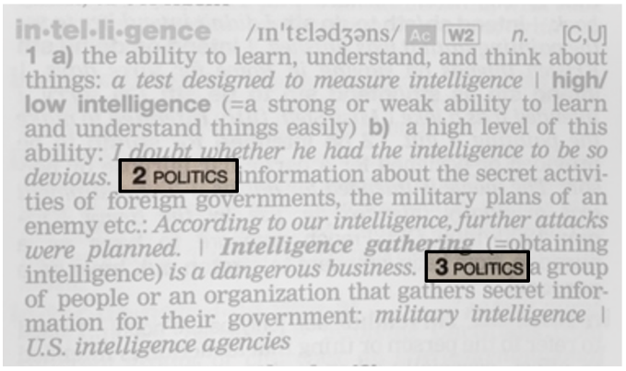 | The second and third meanings are related to a specific field—politics, and this is made clear because the definition starts with the word politics written in small caps.
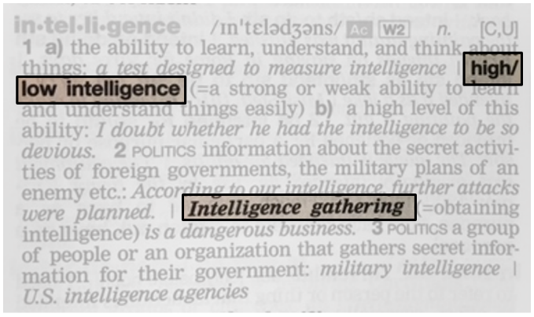 | This dictionary uses bold letters to mark collocations. In the above entry, there are three collocations: high/low intelligence and intelligence gathering.
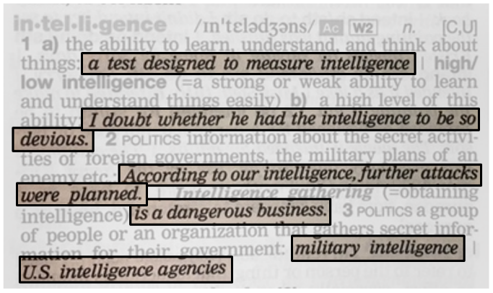 | Examples of how the word is used with each specific meaning are marked by italics

Choosing the Correct Meaning
As the above images show, there are different definitions given for each word in a dictionary, and writers must be careful to choose the correct meaning.
Let’s say you are reading an article and there is an important word in the article that you are not familiar with, and you look it up in the dictionary only to find that it has different meanings.
How do you decide which meaning is the correct one for the context in which you found the word?
For instance, say you read the following sentence, and you are not sure what the word coherent means.
“The candidate’s business proposal was not coherent.”
Let’s take a look at the entry taken from the online version of Merriam Webster’s Learner’s dictionary:
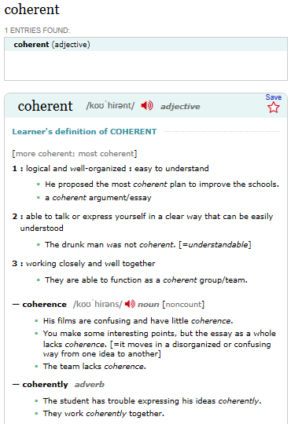
As you can see, the part of speech of the word is labeled at the very beginning of the entry.
There are three definitions for the adjective form of this word. Each meaning is used in a different context, as you can see in the examples provided under each definition.
This entry also provides the other forms of this word (noun and adverb forms), followed by examples of how they are used in sentences.
Since the sentence is about a business proposal, you can automatically eliminate definition #3 in the above entry and focus on #s 1 and 2. From there, you would narrow it down to #1 since the sentence is about the proposal itself, and not the candidate’s ability to talk.
Source: Learners Dictionary entry for coherent at http://www.learnersdictionary.com/definition/coherent

Keep in mind that all of the above examples include only a few of the many pieces of information provided in dictionaries.

Dictionary Usage Notes
The good part of using online dictionaries is that you can click on different parts of the entry in order to find out additional information about the word. In the above entry, for example, you can click on the in order to hear the pronunciation of this word. Some entries will also have links to the other parts of speech of a word, further examples, etc.
These are some good online dictionaries. The first two are designed for English language learners.
- Learners Dictionary at http://www.learnersdictionary.com/
- Longman Dictionary of Contemporary English Online at https://www.ldoceonline.com/
- Merriam Webster at https://www.merriam-webster.com/
You can download a dictionary app to your phone to make it easier to look up words. Also, to learn about finding and selecting correct synonyms for a word, refer to our Thesaurus Skills DLA.
Remember, some words can look the same in different parts of speech, so make sure you select the correct definiton. For example, in the following sentence, the word fish is a verb, so the correct definition for this part of speech and the context of this sentence would be #2 under fish².
Sentence: The thief was fishing for my wallet.
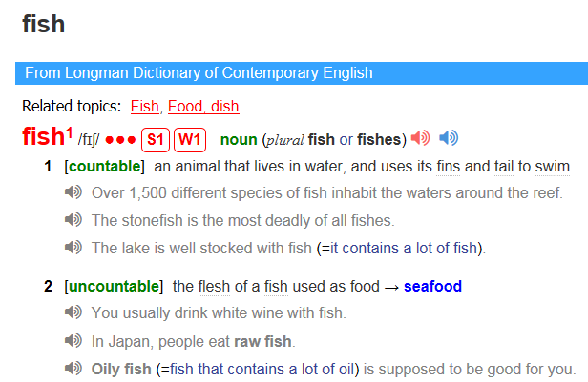

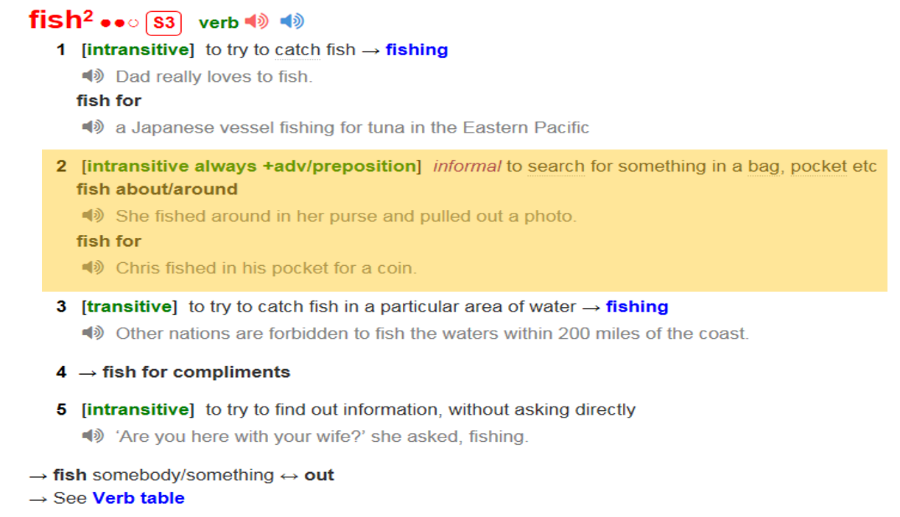
Something else to keep in mind is that once you find the word you want to use, you will need to use the correct form of that word in your sentence. For help with word forms, refer to our Word Forms DLA, our Parts of Speech DLA, and/or our Understanding Parts of Speech and Word Forms workshop.

Activities
Check off each box once you have completed the activity.

☐ 1. Dictionary Skills Review
Write the answers.
- How are words in a dictionary organized?
- What types of information can you find in a dictionary entry?

☐ 2. Online Quiz
Go to http://tinyurl.com/DictionarySkillsDLAQuiz. and take the Dictionary Skills DLA Quiz. You must score at least 80% on the exercises before seeing a tutor. After you complete the task, PLEASE ASK A LAB TUTOR OR FRONT DESK ATTENDANT TO PRINT THE PAGE THAT HAS YOUR SCORE. DO NOT EXIT THE PROGRAM UNTIL THIS PAGE HAS BEEN PRINTED (FREE OF CHARGE). If you have any other questions, do not hesitate to ask a lab tutor.

Choose 3a or 3b below

☐ 3a. Dictionary Practice with Your Own Writing
Collect some of your written work. On the lines below, write four of your own sentences and underline a word of your choice. Then look up your word in a dictionary, find the correct definition of your word (according to the part of speech and the context in which it is used in your sentence), and write the definition on the lines provided.
*You can use one of the Writing Center’s dictionaries or an online version such as the ones listed at the top of page 6.
Write your answers.
- Your Sentence
Part of Speech
Definition
- Your Sentence
Part of Speech
Definition
- Your Sentence
Part of Speech
Definition
- Your Sentence
Part of Speech
Definition
If you do not have sentences from your own writing to work with, please complete the supplemental activity below (3b).

☐ 3b. Dictionary Practice
Use the Longman Dictionary of Contemporary English Online at https://www.ldoceonline.com/ to look up the words bolded in the sentences below. Then choose the correct definition for the bolded word (according to the part of speech and the context in which it is used in each sentence) and write the correct definition on the lines provided.
Write the answers.
- The judge made a fair decision.
Part of Speech
Definition
- His performance was only fair.
Part of speech
Definition
- Her skin is very fair.
Part of Speech
Definition
- They had a lot of fun at the fair.
Part of Speech
Definition
- Netflix has a free trial period, so you don’t have to pay anything for the first month.
Part of Speech
Definition
- Thomas Edison invented the light bulb after much trial and error.
Part of Speech
Definition
- The criminal is on trial for the crime he committed.
Part of Speech
Definition
- The medicine is undergoing clinical trials, so we can’t buy it yet.
Part of Speech
Definition

☐ 4. Review the DLA
Go to https://mtsac2.mywconline.com and use the Mt. SAC Writing Center Appointment System to make a DLA appointment, or sign-up to see a tutor on the “Walk-in” list in the Writing Center. During your session with a tutor, explain your work to demonstrate your understanding of dictionary skills. Refer to your own graded writing (or the completed activity) and explain to the tutor the strategies that you used to improve your dictionary use. ?
Student’s Signature:
Tutor’s Signature
Date:
Date:

If you are an individual with a disability and need a greater level of accessibility for any document in The Writing Center or on The Writing Center’s website, please contact the Mt. SAC Accessible Resource Centers for Students, access@mtsac.edu, (909) 274-4290.
Revised 04/12/2022

