Parts of Speech

Student Name:
Instructor:
Date:
Course:

About This DLA

Important Note
All the activities (3) in the DLA must be completed in their entirety before meeting with a tutor and receiving credit. Where indicated, complete your work on this sheet. If your instructor wants evidence of this completed DLA, return this form to him or her with the tutor’s signature included.

Learning Outcomes
Through computer and other independent work, this activity will familiarize you with the various parts of speech and help you select the appropriate part of speech for different parts of sentences.

Activities (approximately 1 hour)
Read the information, complete the activities that follow, and be prepared to discuss your answers when you meet with a tutor.

Understanding Parts of Speech
All words in sentences in the English language comprise one of the eight categories: nouns, verbs, pronouns, adjectives, adverbs, prepositions, conjunctions, and interjections.
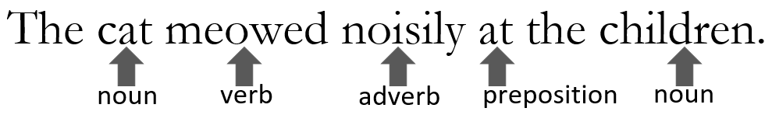
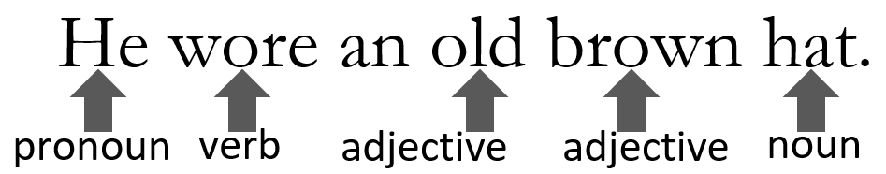
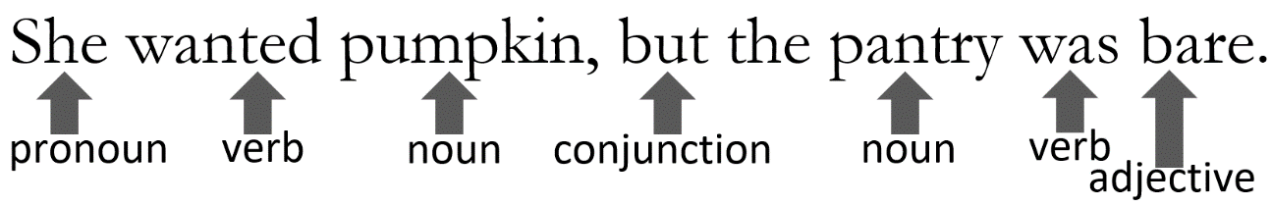
Here are a few examples of the eight parts of speech:
Part of Speech | Definition | Examples
Nouns | -person, place, thing, or quality | Harry, England, broomstick, kindness
 | -the subject of the action being expressed in a sentence | Harry ran to his room.
 | - the object of the action being expressed in a sentence | He told Ron to be quiet.
 | -the object of a preposition | Harry gave the book to Ron.
 | Proper nouns are used to denote individuals and personifications and are always capitalized. Common nouns are not. | Harry wants to buy a new wand and broomstick.
 | -gerunds (verb + -ing) | Reading Harry Potter is fun for children.
 | -infinitives (to + verb) | Hermione wanted to study.
Verbs | - words that show action | run, hide, sing
 | -words that show a state of being or non-action | be, seem, know, have
 | -a single-word verb or verb plus helpers | run, is running, has been running, should run, must have been running
Pronouns | -words that are used in place of a noun  -subject pronouns | I, you, he, she, it, they, we, their, this, these, that, those, who, which, each, either, neither
 | -object pronouns | me, you, her, him, it, them, us
 | -possessive pronouns | mine, his, hers, its, theirs
 | -indefinite pronouns | one, anyone, everybody, something
 | -demonstrative pronouns | this, these, that, those
 | -relative pronouns | who[m], whose, that, which
 | -reflexive pronouns | myself, herself, themselves
Adjectives | -words that provide description for nouns and pronouns | scared, scary, smart, difficult, proper
 | -determiners | a[n], the
 | -quantifiers/numbers | many, half, three, second
Adjectives | -possessive adjectives | my, your, her, his, its, our, their
 | -nouns that act like adjectives | magic potion
 | -comparative | more intelligent, stronger
 | -superlative | the most intelligent, the strongest
Adverbs | -modify a verb | Harry runs quickly.
 | -modify an adjective | a very loud party
 | -modify another adverb | very quickly
 | -indicate place or direction | here, there
 | -indicate time | ever, immediately
 | -indicate degree | very, almost
 | -indicate manner | thus, and words ending in -/ly
 | -indicate belief or doubt | perhaps, no
 | -indicate frequency | always, often, never, daily
 | -can be comparative/superlative | more highly, the most highly
 | -conjunctive adverbs | therefore, however, thus, as a result
Prepositions | -link nouns, pronouns and phrases to other words; describe time, space, or logic | in, on, at, through, by, for, to, after, up, down, of, out, over, above, next to, below, with, about, beside, until, & many more!
Conjunctions | -connect sentences, clauses, phrases and words  coordinating conjunctions | for, and, nor, but, or, yet, so
 | -subordinating conjunctions | because, if, when, although, before, since, after
 | -correlative conjunctions | either/or, neither/nor, not only/but also
Interjections | -words used for emphasis or to  convey an emotion; not needed to complete a sentence | ugh, oh, whoa, well, sure, holy smokes, ouch, stop, aha, phew, yikes, ah, hey, duh, wow, uh oh, whoops, bingo, yuck, yo, huh

Parts of Speech and Changing Functions
Some words can have different functions. To understand what part of speech a word is, it is important to pay attention to how it is functioning in a sentence.
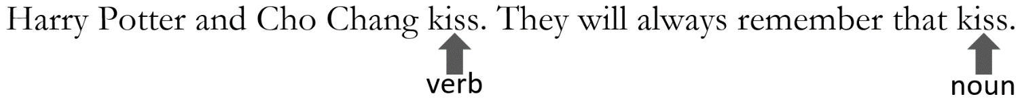
In the above example sentences, “kiss” functions as a verb and as a noun.
“Kiss” functions as a verb in the first sentence, “Harry Potter and Cho Chang kiss” because “kiss” is the action that Harry Potter and Cho Chang perform.
In the second sentence, “They will always remember that kiss,” “kiss” functions as noun since it is the object of the verb “remember.”
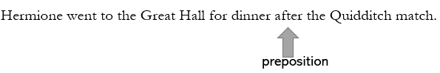
In the above example, “after” functions as a preposition because it is followed by a noun phrase, “the Quidditch match.”
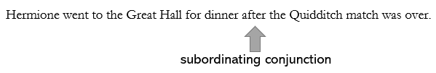
In the above example, “after” functions as a subordinating conjunction because it is followed by a clause, “the Quidditch match is over.”

Activities
Check off each box once you have completed the activity.

☐ 1. Online Quiz
Go to http://tinyurl.com/PartsofSpeechDLAQuiz and take the Parts of Speech DLA Quiz. You must score at least 80% on the exercises before seeing a tutor. After you complete the task, PLEASE ASK A LAB TUTOR OR FRONT DESK ATTENDANT TO PRINT THE PAGE THAT HAS YOUR SCORE. DO NOT EXIT THE PROGRAM UNTIL THIS PAGE HAS BEEN PRINTED (FREE OF CHARGE). If you have any other questions, do not hesitate to ask a lab tutor.

☐ 2. Parts of Speech Practice
Fill in the blanks with the correct part of speech. (Try to do it without reading the text first.)
The Harry Potter series of books is (adverb_______________) (adjective_______________) around the world. The books have sold (adjective_______________) copies and are available in (adjective_______________) languages, (conjunction_______________) the Harry Potter movies have grossed 7.7 billion dollars worldwide. Children and adults alike (verb_______________) the characters, (noun_______________), and excitement, but two Harry Potter fans have taken their (noun_______________) for the series to a(n) (adjective_______________) level. Steve Petrick (adverb_______________) holds the title of World’s Biggest Harry Potter Fan. (pronoun_______________) has read each book (adverb_______________) over a hundred times, and he (verb_______________) four Harry Potter (noun_______________) on his (noun_______________). His house has three rooms full (preposition_______________) Harry Potter collectibles such as posters, (noun_______________), games, and (noun_______________). Petrick’s Harry Potter collection is (adverb_______________) large, (conjunction_______________) it is still smaller than the one held by Menahem Asher Silva Vargas. A lawyer in Mexico, Vargas has collected over three thousand (adjective_______________) pieces of Harry Potter memorabilia. (interjection_______________)! (pronoun_______________) is a(n) (adjective_______________) (noun_______________). His collection includes scarves, (noun_______________), dolls, and artwork. Vargas’ collection is so large, it is certified by the Guinness Book of World Records to be the largest Harry Potter collection (preposition_______________) the world. With more Harry Potter books and movies on the way, the number of Harry Potter fans will continue to grow (adverb_______________). In time, even more passionate fans may (verb_______________) and (verb_______________) their love (preposition_______________) Harry Potter (preposition_______________) the world.

Choose 3a or 3b Below

☐ 3a. Correct Your Own Writing
Collect some of your graded work that identifies errors in parts of speech usage. Correct all marked errors and look for others to correct as well. Bring this revised work with you to the DLA tutoring session.
If you do not have your own essay to work with, please complete the supplemental activity below (3b).

☐ 3b. Parts of Speech Sentences
Review the above information on parts of speech. Write eight different sentences and underline its part of speech.
Write your sentences.
Noun
Verb
Pronoun
Adjective
Adverb
Preposition
Conjunction
Interjection

☐ 4. Review the DLA
Go to https://mtsac2.mywconline.com and use the Mt. SAC Writing Center Appointment System to make a DLA appointment, or sign-up to see a tutor on the “DLA Walk-in” list in the Writing Center. During your session with a tutor, explain the different parts of speech. Refer to your own graded writing (or the completed activity) and explain to the tutor strategies that you used to identify these various forms and how knowledge of this can help improve your writing style.
Student’s Signature:
Tutor’s Signature
Date:
Date:
If you are an individual with a disability and need a greater level of accessibility for any document in The Writing Center or on The Writing Center’s website, please contact the Mt. SAC Accessible Resource Centers for Students, access@mtsac.edu, (909) 274-4290.
Revised 09/23/2021

