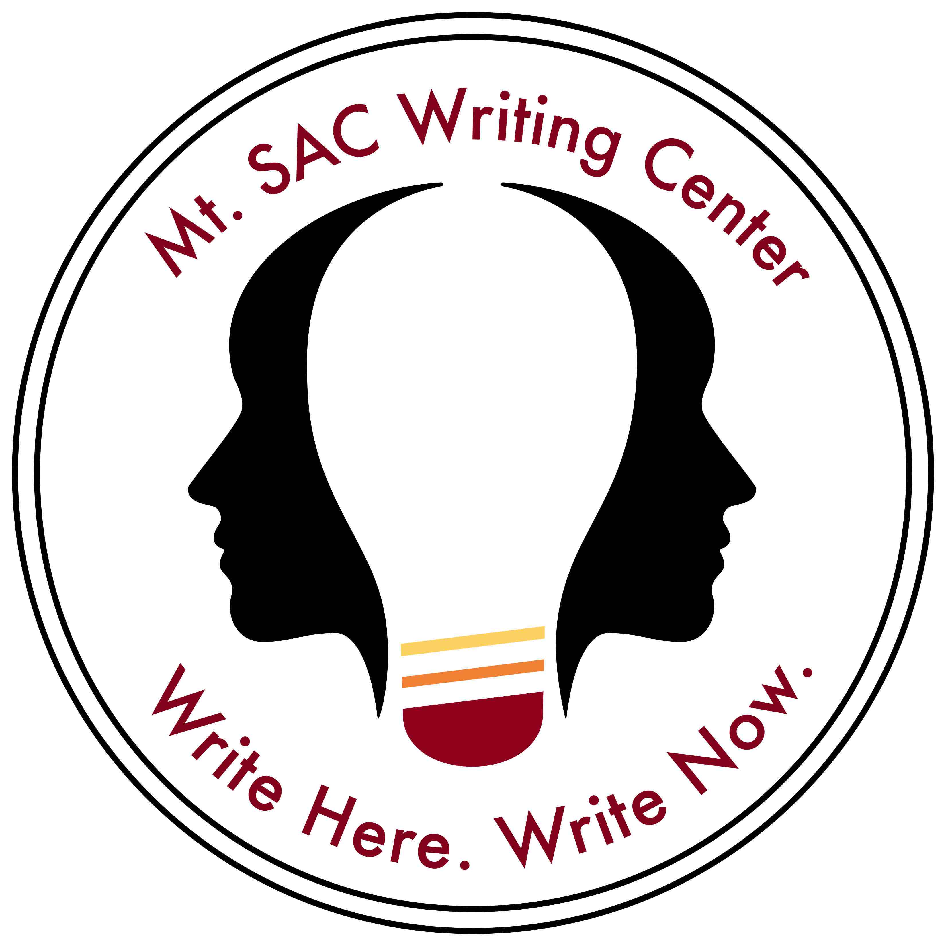
October Workshops

Monday | Tuesday | Wednesday | Thursday | Sunday
3 | 4  Finding and Evaluating Sources  2-3 pm (Mauricio)  Online | 5  Understanding and Avoiding Plagiarism  5:30-6:30 pm (Jackie)  Online | 6  Annotating and Notetaking  3-4 pm (Bianca)  In Person | 9  Conquering Commas  2-3 pm (Tara)  Online
10 | 11  Incorporating Sources Effectively  2-3 pm (Mauricio)  Online | 12  Using Quotations and Paraphrases  3-4 pm (Ivan)  Online | 13  Writing with Flow  3-4 pm (Bianca)  In Person | 16  Fixing Fragments, Run-ons, and Comma Splices  2-3 pm (Tara)  Online
17 | 18  The Research Paper Steps to Success  2-3 pm (Mauricio)  Online | 19  Analyzing Literature and Film 3-4 pm (Nicole)  Online | 20  Essay Refresh  3-4 pm (Bianca)  In Person | 23  Writing Clearer Sentences Simple and Compound Sentences  2-3 pm (Tara)  Online
24 | 25  Citations Made Easy with NoodleTools  2-3 pm (Mauricio)  Online | 26  Working in MLA Style and Format  5:30-6:30 pm (Jackie)  Online | 27  Reading Like a Writer  3-4 pm (Bianca)  In Person | Writing Clearer Sentences: Complex and Compound-Complex Sentences  2-3 pm (Tara)  Online
Note: | Writing Center Online Workshops  Thursday workshops are in person; all others will be online.  Please register on our website: https://www.mtsac.edu/writingcenter/workshops.html

