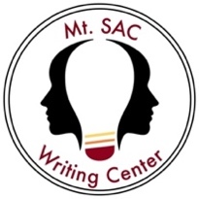
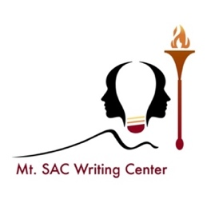
The Writing Center
List of Handouts

We have created this list to help you find a handout that will work for you. Here you will find handouts in several categories and for different parts of the writing process. Please feel free to download and print any handouts you find here.

Non-Native English Speakers (NNES)
- Article Usage
- Basic Sentence Patterns
- Restrictive Vs. Non-restrictive Clauses
- How to Put Clauses Together
- Verb Tenses
- Reporting Verbs
- Transition Words

Brainstorming & Organizing
- What Does My Professor Want?
- Decoding Assignments
- Planning an Essay
- The Five Paragraph Essay Outline
- Research Essay Worksheet

Researching
- Annotated Bibliography
- Tips for Reading Peer-reviewed Articles

Drafting
- Basic Paragraph Writing
- The Introduction Paragraph
- They Say/I Say Model
- The Meal Plan
- The Five Paragraph Essay
- The Conclusion Paragraph

Revising
- Reverse Outlining
- Revision as a Reader
- 10 Tips to Improve Your Writing

Editing & Proofreading
- Comma Splices & Run-ons
- Comma Rules You Should Know
- Fragments
- Semi-colons, Colons, and Dashes
- Punctuation Patterns
- Prepositional Phrases

Style & Reference
- Writing with Style: Parallelism
- Logos, Ethos, & Pathos
- Logical Fallacies

MLA, APA, ASA, & Chicago Documentation
- MLA: General Formatting
- MLA: Works Cited Page Example
- MLA: Integrating Sources & In-text Citations
- MLA: Practice Template
- APA: General Formatting
- APA: Reference List Example
- Chicago: General Formatting
- Chicago: Reference List Example
- ASA: Quick Tips for American Sociological Association
- Citations Made Easy with NoodleTools

