Creating New Pages and Directories
In addition to editing current pages, it may also be possible, based on permissions, to create new pages and directories.
The system is configured with templates, which are utilized to create new sections and pages. These templates allow for the pages to be configured uniformly and have a consistent look and feel.
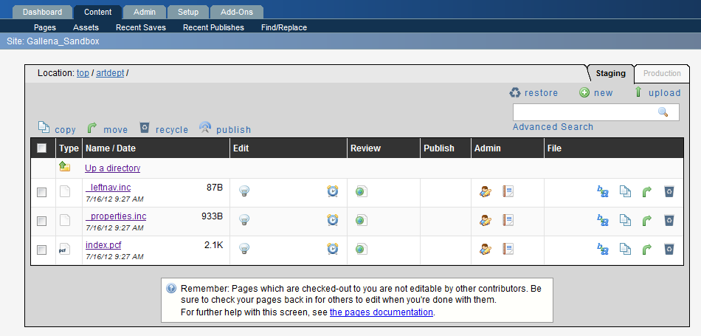
To Create a New Page
- Navigate to the correct folder.
- Click New.
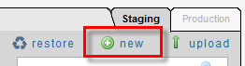
- Click New Web Page Template Design.
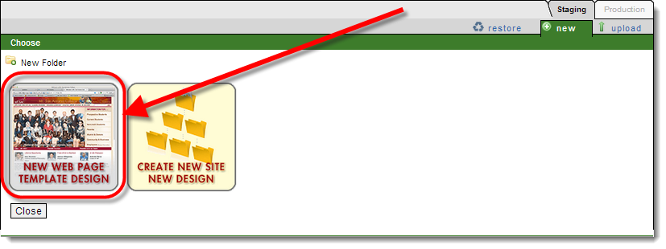
- Enter the Page Properties (there are five items to complete see below):
  - Page Title: This is the page name that appears at the top of a browser window when viewing web pages. This is also the title of the link in the navigation at the right. Keep the title simple, short, but specific to the page.
  - Keywords: This is optional. You can add keywords to help users find the content of the page using a search engine. Typically, the subjects and verbs in sentences make good keywords.
  - Short Description: This is also optional. Some people use the page title for the description, but you can add a bit more specific detail. This should still be a very short sentence, no more than 10 to 15 words.
  - Add Navigation Item: If set to “No,” the navigation on the right does not appear on the page. This could be used for content that requires more width, but you would need to add your own links on the page to get back to the previous page or the “home” page of your site.
  - Page File Name: This is the name of the HTML file that will appear in the browser. This should be short, meaningful, and you should use lower-case letters with no spaces! For example, “Campus News & Events.pcf” is not an acceptable filename. However, “campus-news.pcf” would be.
  - Overwrite Page: Check this box ONLY if you are creating a new page with the same filename as an existing page. Sometimes you may want to start over and recreate a page rather than edit an existing one. Unless you check this box to replace the old page, you will not be able to create a page with the same filename.
  - Page Access: When you create a page, you can give access to other users so they can edit the page as well. Typically, you would only want to give access to those in your workgroup.
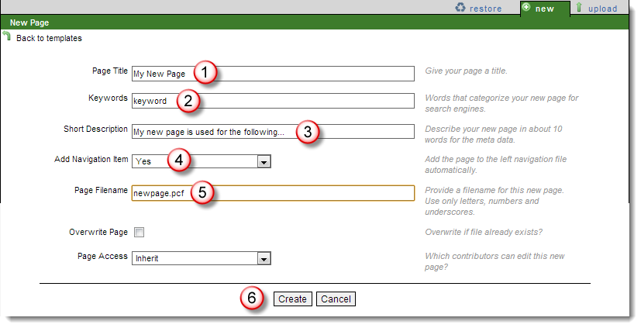
Important Note: Remember to keep the extension of .pcf when naming files. If this is extension is changed, the page will not render appropriately, including that the header, footer, and styles will not be available.
- Click Create.

To Create a New Directory
- Navigate to the directory where the new where the new directory will be created.
- Click New.
- Select Create New Site Design.
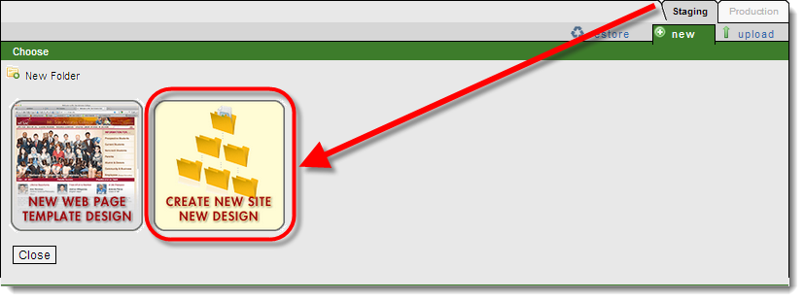
- When creating a new directory, please use only lower case letters, number, hyphens, and underscores. For example, "a-directory," "a_directory," and "1directory" are fine, however "aDirectory" and "adirectory!" are not.

