- Volume 1, Issue 4  May 27, 2022  Data Coach Team  Cara Tan  Cathy Stute  Christopher Jackson  Daniel Garcia  Laura Espinoza  Loni Nguyen  Mike Hood  Ned Weidner  Tiffany Kuo | Data Literacy for Equity  Data Dashboard Access, Part 2  This is the second of a two-part newsletter devoted to data dashboards. In part two, we will introduce you to Mt SAC dashboards.  How do I access the Mt SAC data dashboards?  The Research for Institutional Effectiveness [RIE] department at Mt SAC maintains several dashboards available to users with Mt SAC logins. As faculty, staff, and managers at Mt SAC, you can access them directly at www.bit.ly/mtsacdata. The screenshot below shows what the launch page for the Mt SAC dashboards look like:  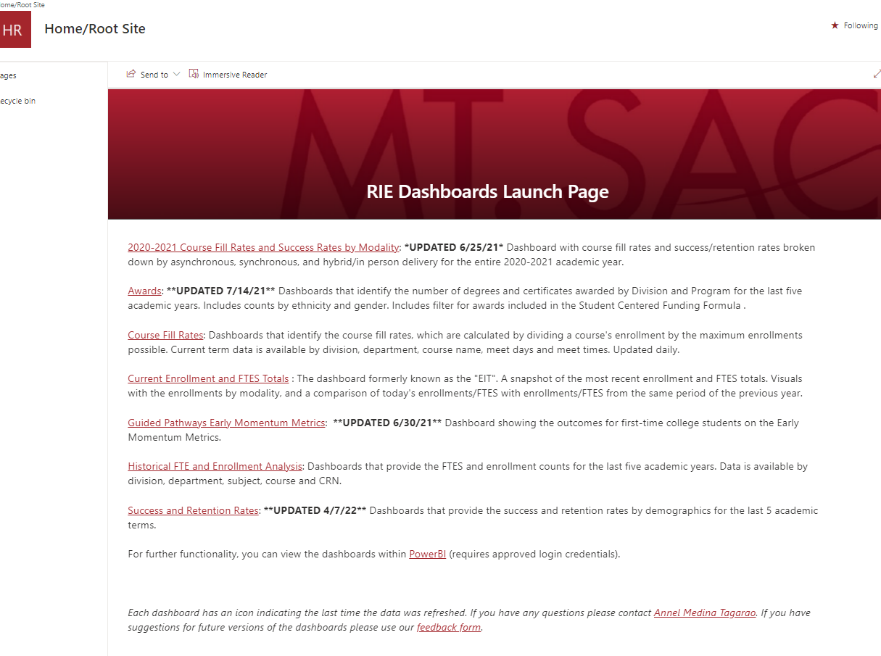  Each of the underlined categories in red contains useful information for faculty, managers, and staff. Currently, there are seven categories:  - 2020-2021 Course Fill Rates and Success Rates by Modality  - Awards  - Course Fill Rates  - Current Enrollment and FTES Totals  - Guided Pathways Early Momentum Metrics  - Historical FTE and Enrollment Analysis  - Success and Retention Rates  This newsletter will focus on the last link, titled “Success and Retention Rates.” To access the data, click on the “Success and Retention Rates” link…

What types of data are available in this dashboard?
When you click on the “Student Success and Retention Rates” link, the dashboard will load with 7 more options. Each of these links will allow you to look at data for the entire college, or separated out by division, department, or discipline.
To clarify what these dashboards show, we’ve provided basic definitions:
- Headcount: Total number of students enrolled, unduplicated.
- Enrollment: Duplicated count of students. So, a student who is taking 4 classes in a semester would be counted 4 times.
- Success Rate: Counts students who pass a class.
- Retention Rate: Counts students who complete a class, meaning they did not drop.
- Detailed View: Items listed as having a “detailed view” will show you a table with the data, in addition to the bar graphs that are always available.
- EW Version: Usually, students who received an Excused Withdrawal (EW) in a course are not included in these calculations at all. So, if a student receives an excused withdrawal, the data will show up as if they never enrolled in that course at all. During the period of Spring 2020 through Summer 2021, the use of EW replaced the standard W grade as many students opted for EW. In this EW version dashboard, students who chose to take an EW count as students who dropped the class. [Please refer to the formula in newsletter 2 for specific calculations.]

How can these dashboards help investigate equity gaps?
In addition to being able to separate the data out by division, department, and discipline, each of these dashboards has several variables that can be selected; they include gender, ethnicity, course modality (online vs. in-person vs. hybrid), age, academic goals, special populations (such as first-generation students, AB540 status, and returning students), and other identifiers.
These dashboards can be a tool for you to investigate equity gaps in your own discipline, department, division, and college wide. Even though this type of data can be daunting or disappointing, identifying and understanding the equity gaps that currently exist is the first step to improving the success rates of all Mt SAC students.

Did you say: what about a flowchart?
To assist, we created a flowchart for each website for you to understand.
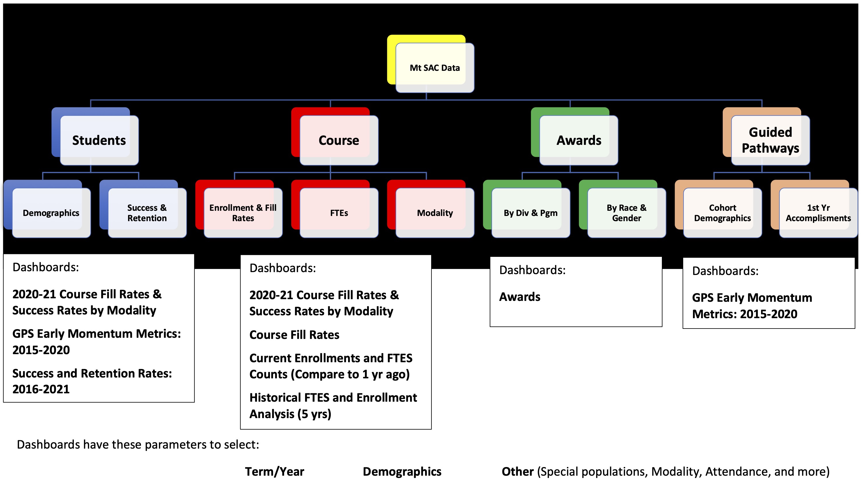

What’s next: do you know your own course-level data?
Now that you have a wealth of information, we encourage you to contact a data coach to find out your personal course-level disaggregated data. This information is private and to be shared only with the specific instructor on record. Feel free to contact the data coach in your division, or the data coach coordinator. We look forward to hearing from you!!

Arts & Data Coach Coordinator | Tiffany Kuo | tiffany.kuo@mtsac.edu
Humanities | Ned Weidner | nweidner@mtsac.edu
Social Sciences | Cara Tan | ctan51@mtsac.edu
Kinesiology, Athletics and Dance | Chris Jackson | cjackson@mtsac.edu
Natural Sciences | Mike Hood | mhood@mtsac.edu
Natural Sciences | Loni Nguyen | knguyen@mtsac.edu
Tech and Health | Dan Garcia | dgarcia@mtsac.edu
School of Continuing Education | Laura Espinoza | lespinozarodriguez@mtsac.edu

#####

