- Volume 1, Issue 3  May 27, 2022  Data Coach Team  Cara Tan  Cathy Stute  Christopher Jackson  Daniel Garcia  Laura Espinoza  Loni Nguyen  Mike Hood  Ned Weidner  Tiffany Kuo | Data Literacy for Equity  Data Dashboard Access, Part 1  This is the first of a two-part newsletter devoted to data dashboards. In part one, we will introduce you to California Community College Chancellor’s Office [CCCCO] dashboards.  What are data dashboards?  In general, a data dashboard is an information management tool, used to track, analyze, and display key performance indicators, metrics, and data points.  At the community college, a data dashboard is a series of webpages that displays information on student achievement, headcount, enrollment, and demographics.  For example, the California Community College Chancellor’s Office publishes California Community College student achievement data via two different websites.  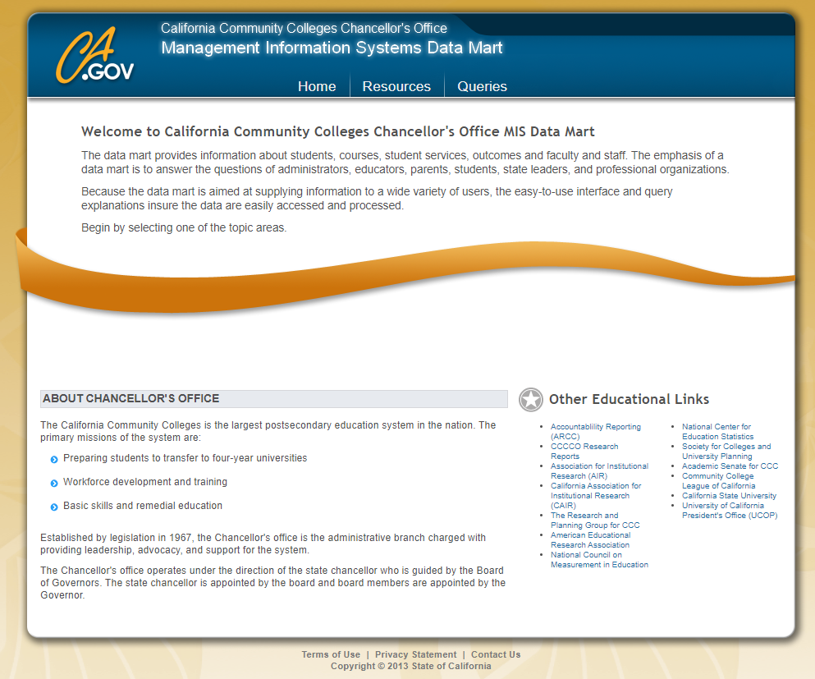  One of the websites is CCCCO’s Management Information System Data Mart. An image of its homepage is seen above.

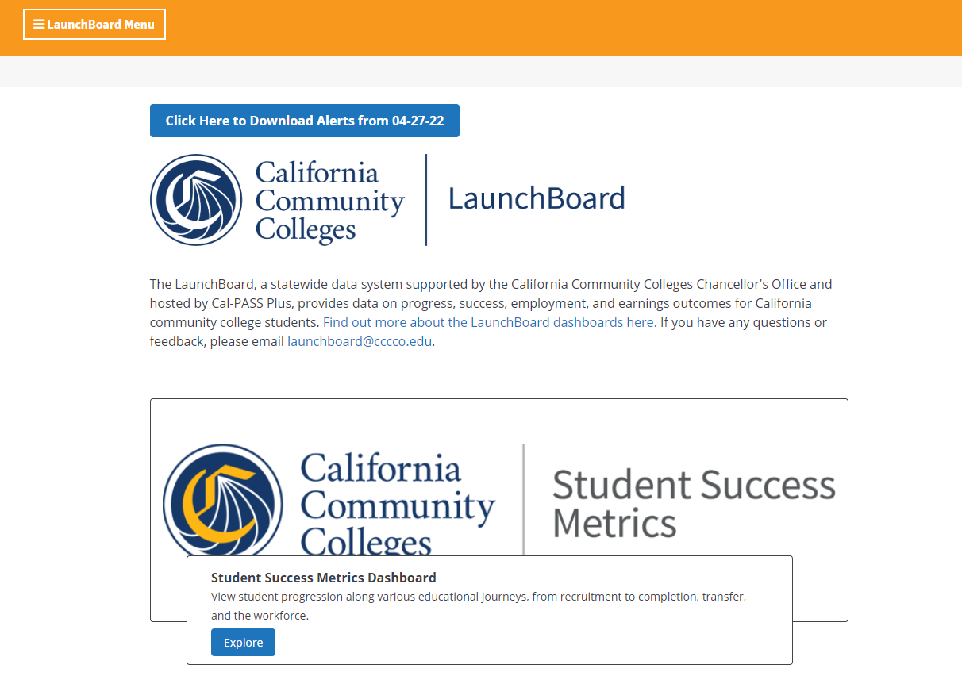

The other website is CCCCO’s LaunchBoard. The image above is its home page.

What types of information are in these dashboards?

To assist, we created a flowchart for each website for you to understand.
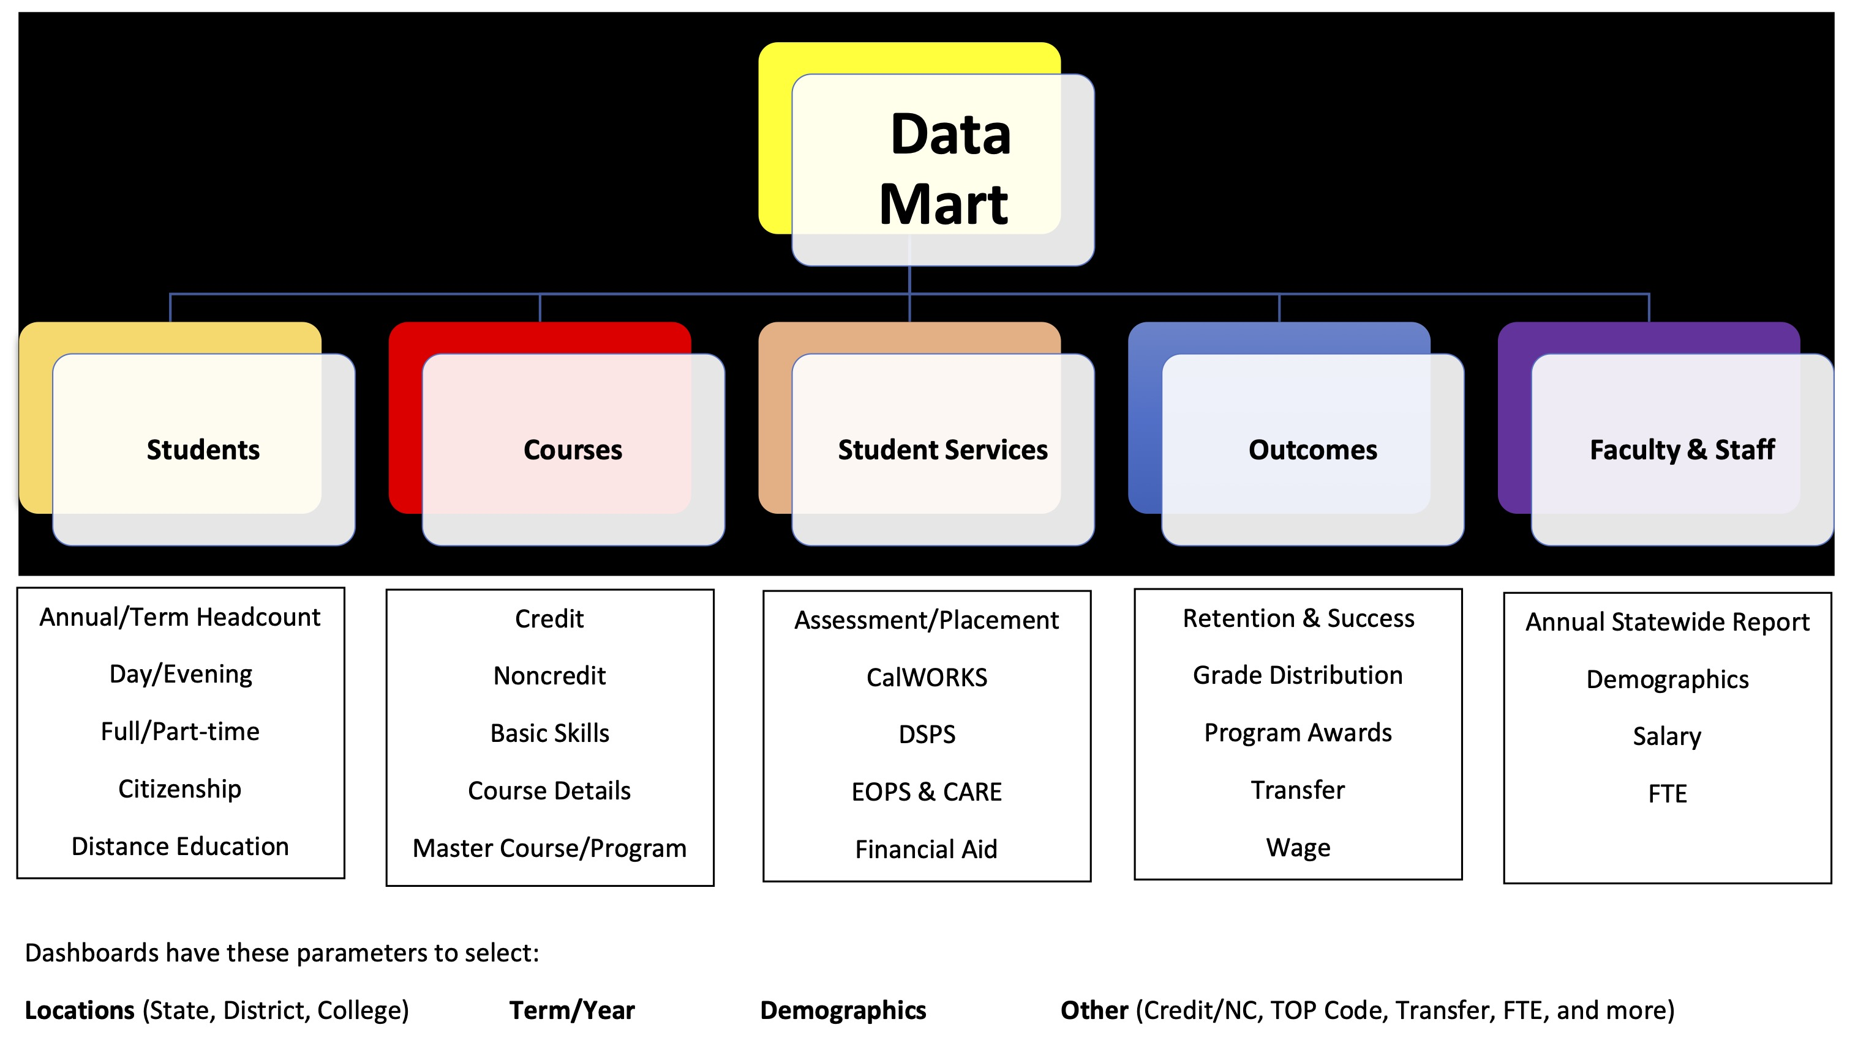

The flowchart above shows how CCCCO’s Data Mart sorts information into five categories: Students, Courses, Student Services, Outcomes, and Faculty & Staff. Under each category, you will find the type of data available. For example, in “Outcomes,” you can find a summary report of “Grades Distribution” for an array of options, including statewide, districtwide, collegewide, for individual terms, such as “Fall 2021.”

CCCCO’s LaunchBoard also provides a host of information. Specifically, we focus on the Student Success Metrics Dashboard. The flowchart below provides the categories of information you can access.

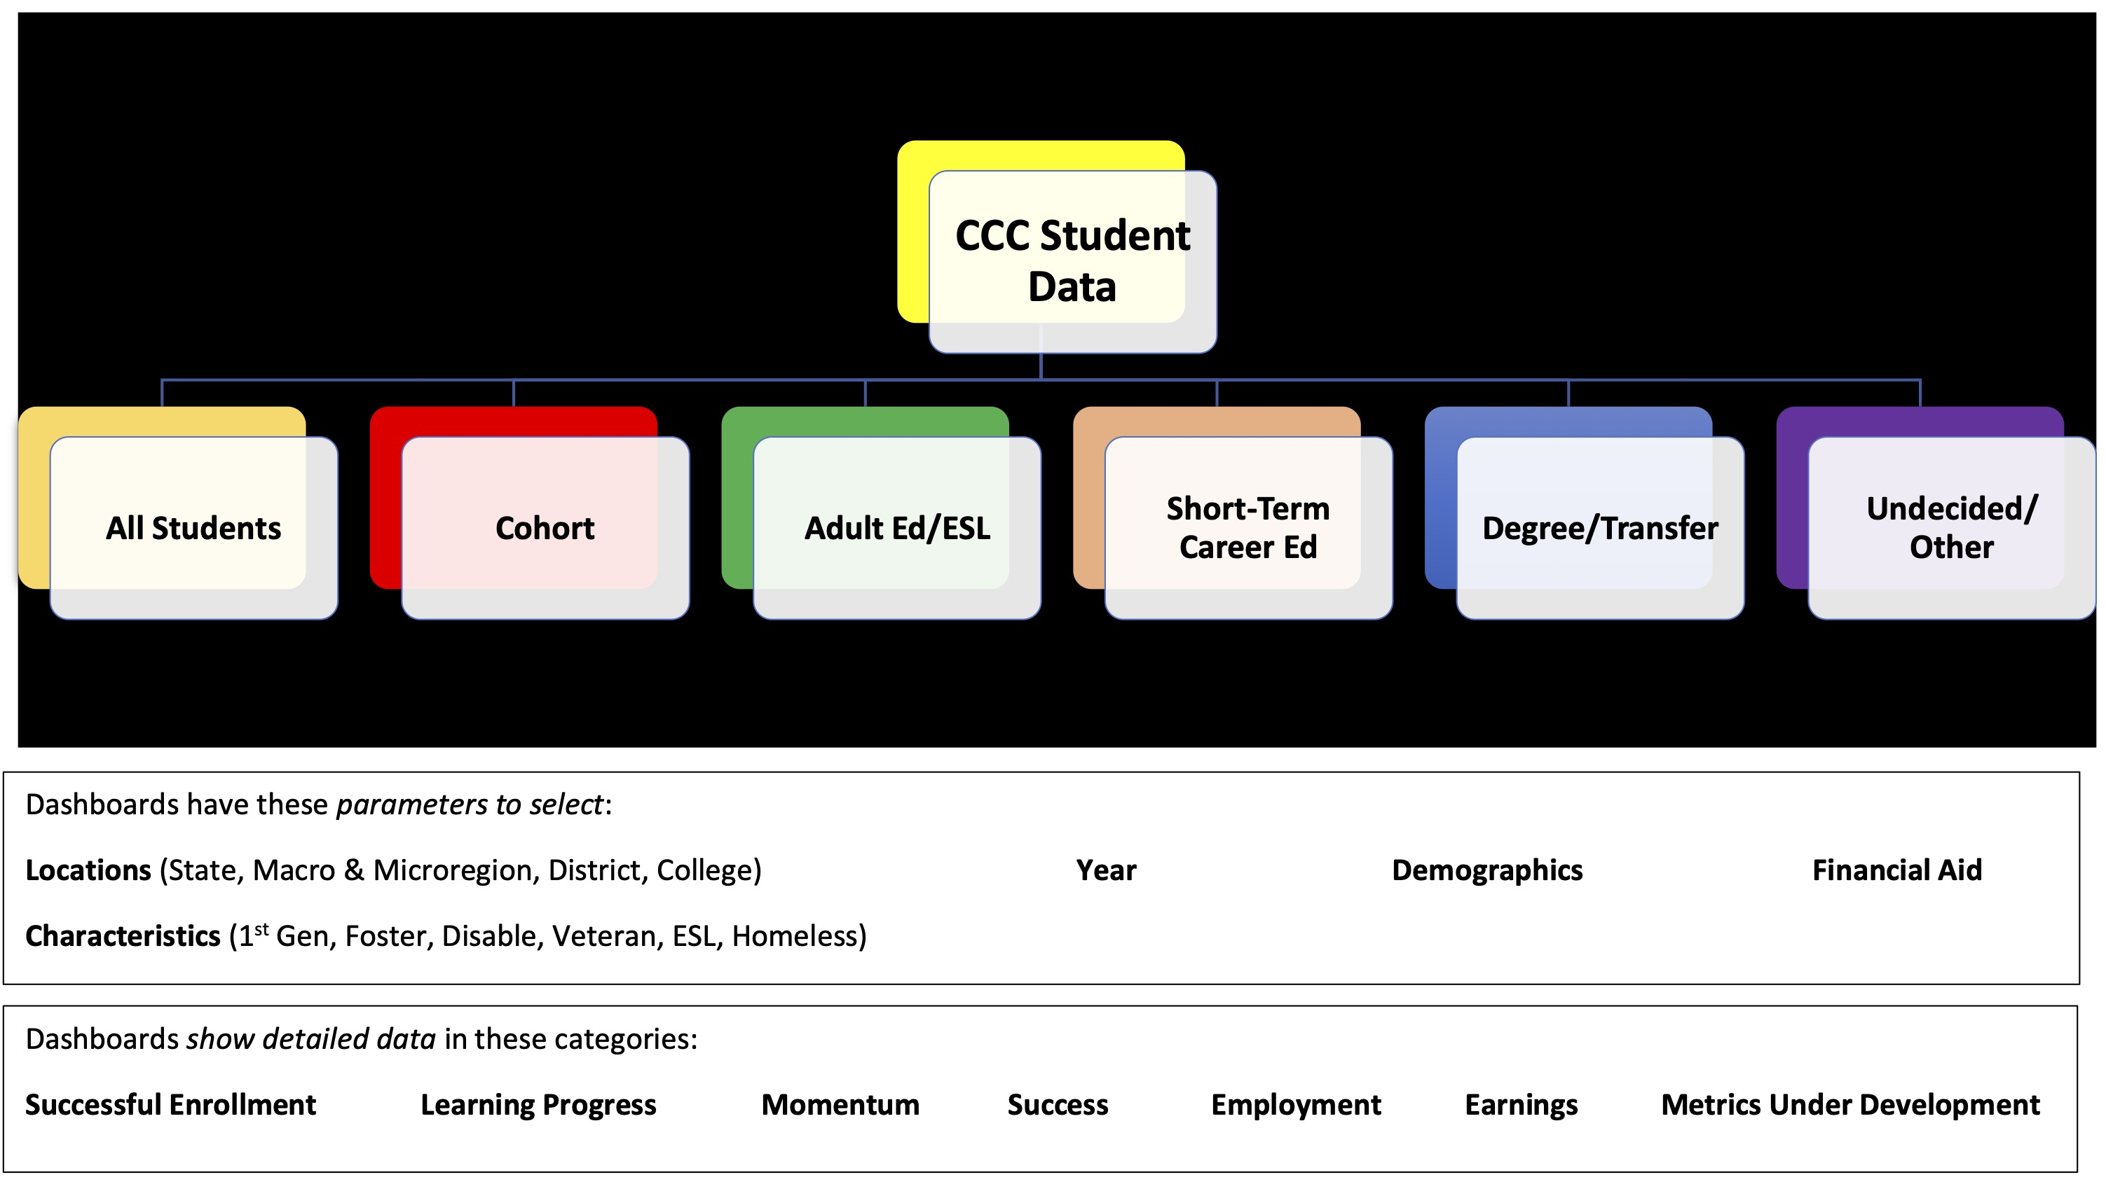

Similarly, you find the data categorized, first by the type of students, or all students. Then you can begin to select the parameters, such as location, academic year, demographics, type of financial aid received, and student characteristics, which includes first generation, DSPS, Credit ESL, etc.

What should I look at first?

We understand that there’s a lot of information contained in these dashboards. Our recommendation is to start with a simple question, like: do Mt SAC students’ demographics resemble the Mt SAC faculty’s demographics? Next, by using the flowchart, figure out which dashboard will give you the data needed. In this instance, you can answer the question in CCCCO’s Data Mart, in two categories: students, and faculty and staff.

Another question is: how do veterans compare with non-veterans, in terms of course success rate, and completion of transfer-level math and English? To answer this, check out the Student Success Metrics in the CCCCO’s LaunchBoard!

Last suggestion: don’t be afraid to start clicking, you may learn more than you can imagine!
#####

