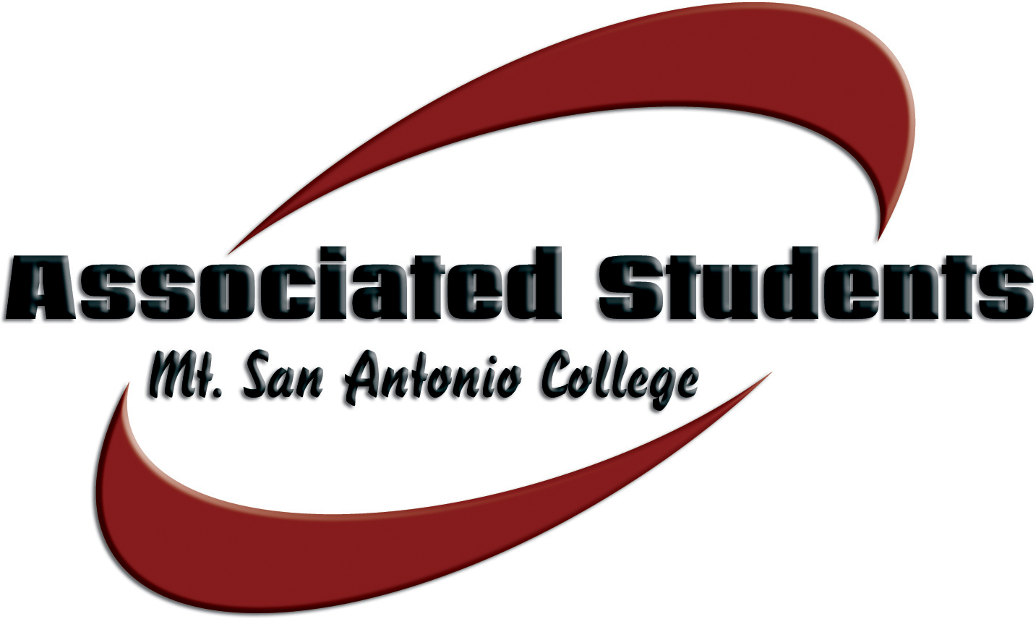 | Associated Students, Mt. San Antonio College  Date: November 17, 2015 | Time: 3-4:30 p.m. | Location: 9C Council Room

SENATE AGENDA

- CALL TO ORDER

- FLAG SALUTE

- ROLL CALL

- APPROVAL OF MINUTES

- OPEN FORUM

The public may address the board. Under provisions of the Brown Act, student government is prohibited from taking action on oral requests that are not part of the agenda. Comments are limited to three (3) minutes per person.

VI. REPORTS
- A.S. Advisor
- A.S. Secretary
B. A.S. President
C. A.S. Vice President
D. Student Trustee
E. ICC Report
F. College Committees

- INFORMATION & ANNOUNCEMENTS
Active Shooter – Bob Wren

- DISCUSSION & ACTION ITEMS
- Bill #2 – That the Associated Students approve that the A.S. President preside Senate meetings in the absence of both Senate Chairs
- Resolution #2 – That the Associated Students approve the change from Christopher Columbus day to Indigenous People’s Day
- Senator Binder Requirements
- Appropration #9 – That the Associated Students approve an amount not to exceed $1205.00 to fund Mecha’s Christmas in Mexico
- Appropriation #10 – That the Associated Students approve an amount not to exceed $160,000 to reallocate funding in the A.S. budget for 2015-2016

X. BOARD COMMUNICATION
Members of the Board will report on matters related to upcoming events, conferences, current projects, community involvement, news, and updates directly related to their functions and responsibilities as A.S. Officers. Comments are limited to two (2) minutes per person.

XI. ADJOURNMENT
NOTE: Associated Students reserves the right of the chair to modify the order of the agenda, as it deems appropriate and necessary.

