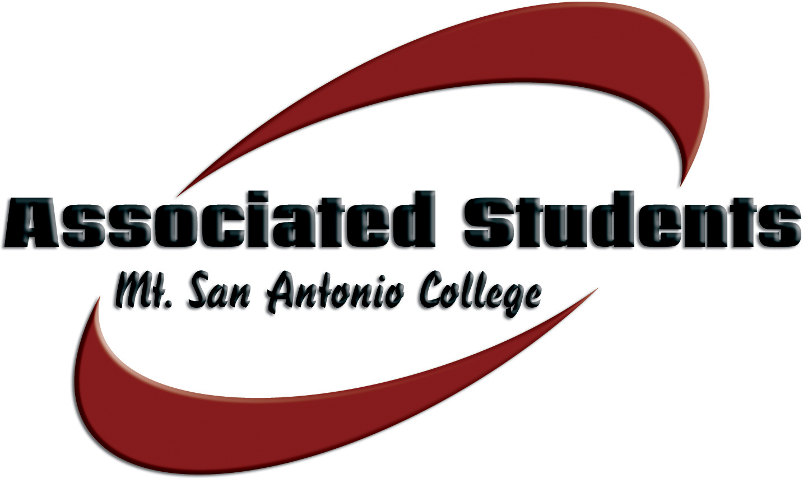 | Associated Students, Mt. San Antonio College  Date: April 1, 2014 | Time: 3-4:30 p.m. | Location: 9C-5

SENATE AGENDA

- CALL TO ORDER

- FLAG SALUTE

- ROLL CALL

- APPROVAL OF MINUTES

- OPEN FORUM

The public may address the board. Under provisions of the Brown Act, student government is prohibited from taking action on oral requests that are not part of the agenda. Comments are limited to three (3) minutes per person.

- INFORMATION & ANNOUNCEMENTS (15 minute limit)
None

- DISCUSSION & ACTION ITEMS
A. Transfer of Funds for Livestock Program – Matt Pawlak would like $600.00 transferred from Conference expenses to supplies
B. Appropriation #16 – That the Associated Students approve an amount not to exceed $2,370.00 to fund the Society of Physics club to attend conference in Colorado in June 2014
C. Appropriation #18 – That the Associated Students approve an amount not to exceed $593.20 for catering for the Earth Week event
D. Resolution #2 – That the Associated Students endorse Mary Su for Council Member
E. Bill #6 – That the Associated Students approve revisions to the Organizational Directive

VIII. BUDGET PRESENTATIONS
3:10 – Aspire
4:00 - Global Opportunities

VIIII. REPORTS
A. A.S. Advisor
B. A.S. President
C. Student Trustee
D. ICC Report
E. Committee Reports

X. BOARD COMMUNICATION
Members of the Board will report on matters related to upcoming events, conferences, current projects, community involvement, news, and updates directly related to their functions and responsibilities as A.S. Officers.

XI. ADJOURNMENT
NOTE: Associated Students reserves the right of the chair to modify the order of the agenda, as it deems appropriate and necessary.

