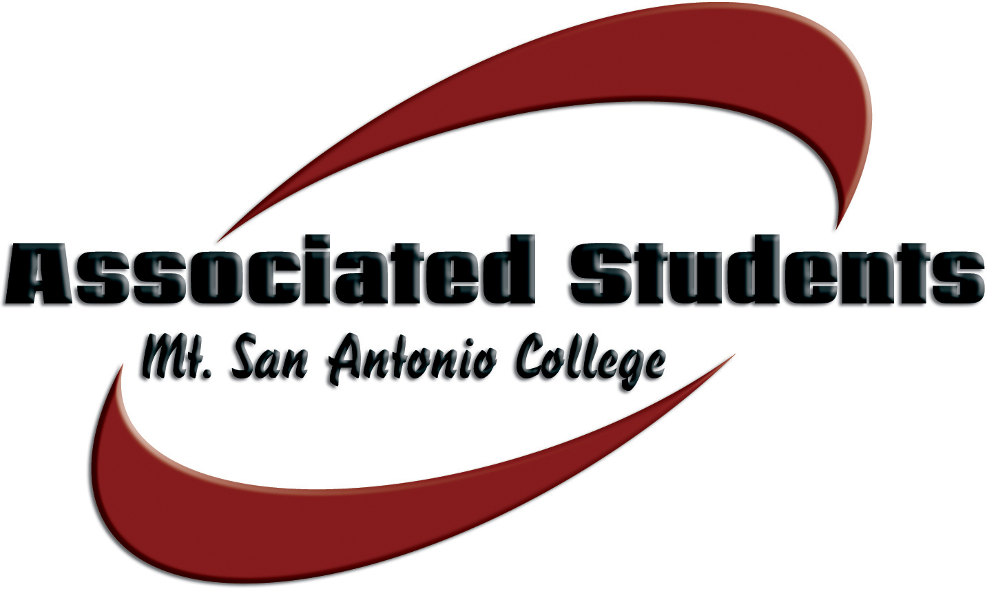 | Associated Students, Mt. San Antonio College  Date: March 18, 2014 | Time: 3-4:30 p.m. | Location: 9C-5

SENATE AGENDA

- CALL TO ORDER

- FLAG SALUTE

- ROLL CALL

- APPROVAL OF MINUTES

- OPEN FORUM

The public may address the board. Under provisions of the Brown Act, student government is prohibited from taking action on oral requests that are not part of the agenda. Comments are limited to three (3) minutes per person.

- INFORMATION & ANNOUNCEMENTS (15 minute limit)
None

- DISCUSSION & ACTION ITEMS
A. Appropriation #13 – That the Associated Students approve an amount not to exceed $2,234.65 for Skills USA to attend conference in San Diego
B. Appropriation #14 – That the Associated Students approve an amount not to exceed $1,200.49 for the VEX Competition Supplies
C. Appropriation #15 - That the Associated Students approve an amount not to exceed $2,685.00 for the VEX Competition travel expenses
D. Appropriation #17 – That the Associated Students approve an amount not to exceed $4,390.00 for AGS to attend the State Convention.
E. Resolution #2 – That the Association Students approve the endorsement of Walnut City Council member Mary Su
F. Bill #6 – That the Associated Students approve revisions to the Organizatonal Directive

- BUDGET PRESENTATIONS
3:10 – DSPS - Julie Bradley/Eloise Reyes
3:30 – Art Gallery – Cindi Orr
3:40 – Livestock Show Team – Matt Pawlak
3:50 – Turf Team – Brian Scott
4:20 – ACM – Horia Pop

- REPORTS
A. A.S. Advisor
B. A.S. President
C. Student Trustee
D. ICC Report
E. Committee Reports

XI. BOARD COMMUNICATION
Members of the Board will report on matters related to upcoming events, conferences, current projects, community involvement, news, and updates directly related to their functions and responsibilities as A.S. Officers.
XII. ADJOURNMENT
NOTE: Associated Students reserves the right of the chair to modify the order of the agenda, as it deems appropriate and necessary.

