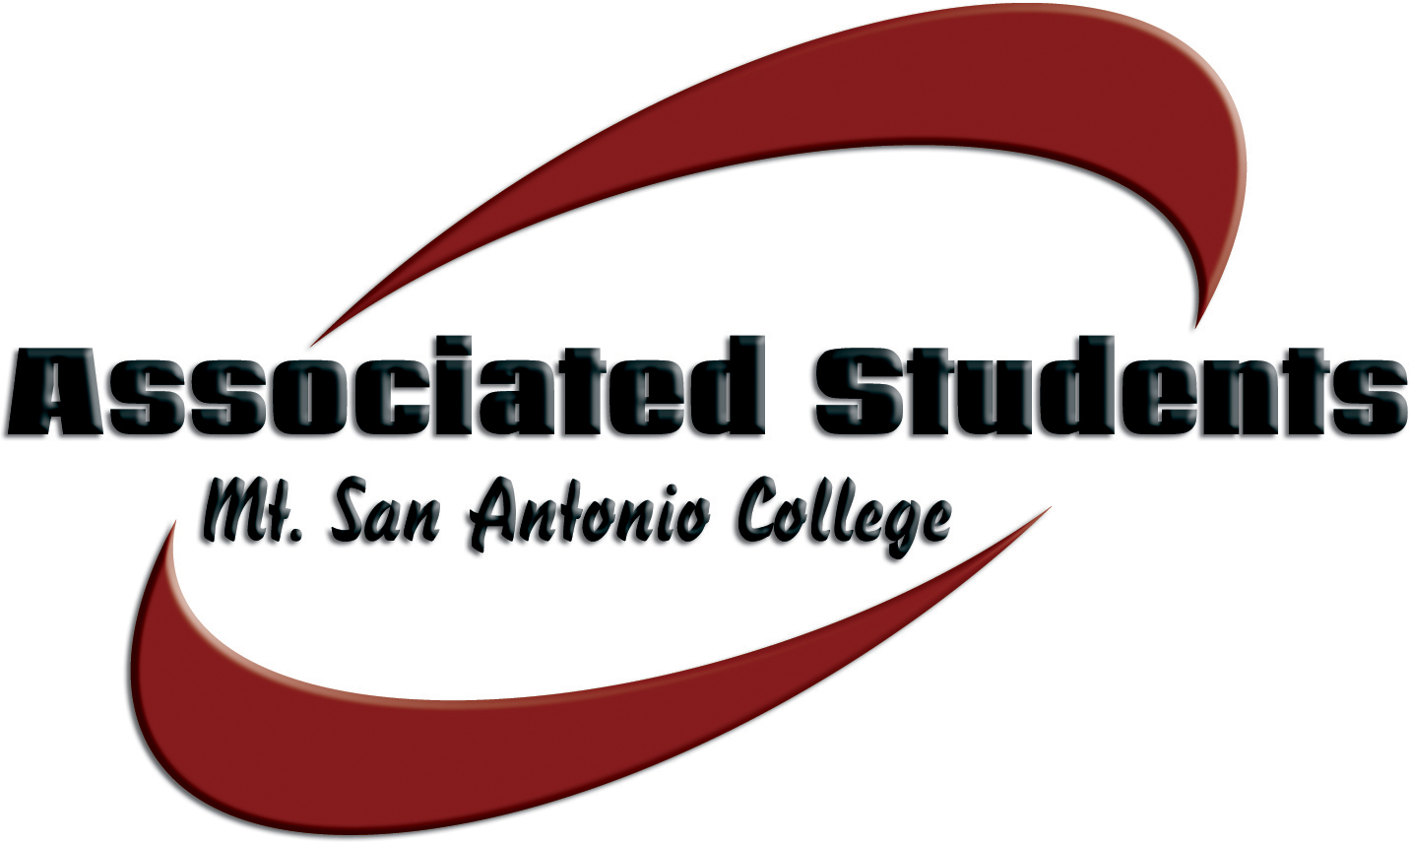 | Associated Students, Mt. San Antonio College  Date: February 25, 2014 | Time: 3-4:30 p.m. | Location: 9C-5

SENATE AGENDA

- CALL TO ORDER

- FLAG SALUTE

- ROLL CALL

- APPROVAL OF MINUTES

- OPEN FORUM

The public may address the board. Under provisions of the Brown Act, student government is prohibited from taking action on oral requests that are not part of the agenda. Comments are limited to three (3) minutes per person.

- INFORMATION & ANNOUNCEMENTS
None

- DISCUSSION & ACTION ITEMS
A. Heidi Lockhart – Request to transfer approved A.S. funds from Campus Tours to Transfer Achievement Celebration
B. Student Center Hours
C. March in March Rally
D. Appropriation #11 – That the Associated Students approve an amount not to exceed $3,876.06 for the Alcohol and Drug Student program to attend conference
E. Appropriation #12 – That the Associated Students approve an amount not to exceed $9,090.00 for the Hospitality Management Club to attend a conference

- REPORTS
A. A.S. Advisor
B. A.S. President
C. Student Trustee
D. ICC Report
E. Committee Reports

XI. BOARD COMMUNICATION
Members of the Board will report on matters related to upcoming events, conferences, current projects, community involvement, news, and updates directly related to their functions and responsibilities as A.S. Officers.

XII. ADJOURNMENT

NOTE: Associated Students reserves the right of the chair to modify the order of the agenda, as it deems appropriate and necessary.

