[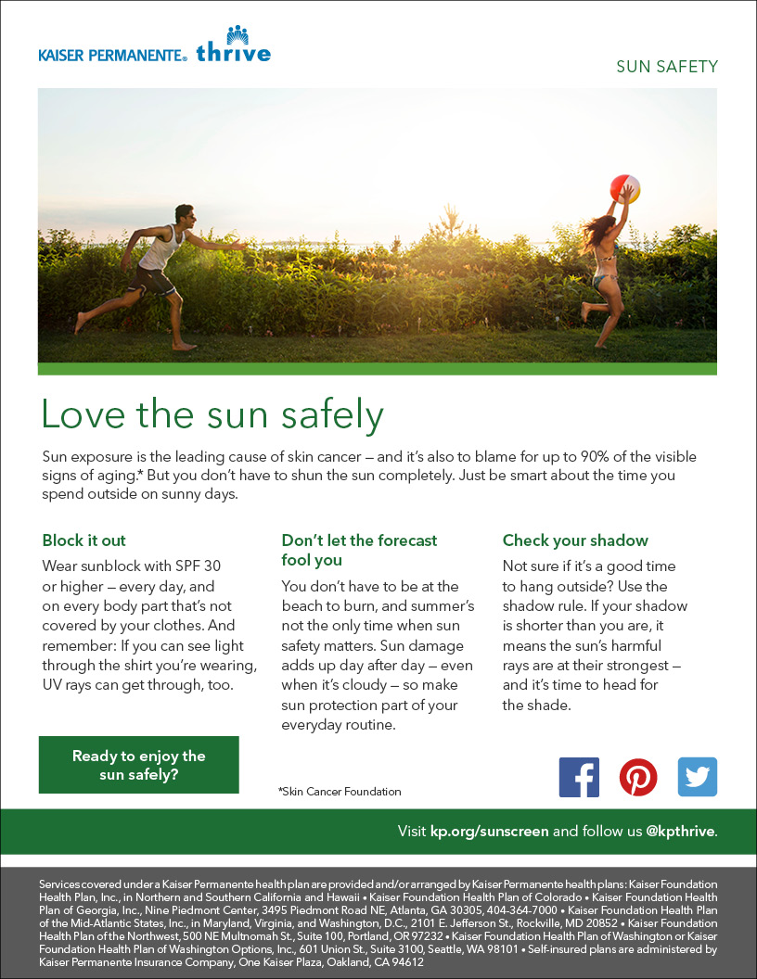](http://kp.org/sunscreen)

[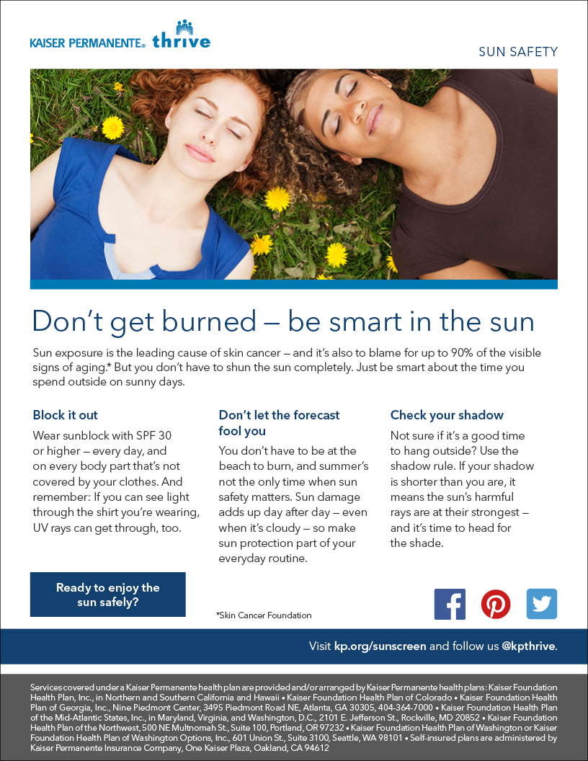](http://kp.org/sunscreen)