

**FLEX Day Zoom Registration Instructions**

Two days of each academic year are designated as FLEX (flexible) days to provide faculty time to participate in professional development activities that are related to staff, student, and instructional improvement.

### **All faculty must register first in POD Connect. An email with a Zoom link will then be sent to your Mt. SAC email inbox. The Zoom link will lead you to a Zoom Registration Page which is considered your Sign-in sheet for the session. Completing this Zoom Registration is required to gain access to the workshop** **and for your attendance to be recorded.**

# Log-In to POD Connect

To login to POD Connect please go to the POD Website <https://www.mtsac.edu/pod/> . Click on “POD Connect Calendar” in the middle of the page to log into POD Connect.

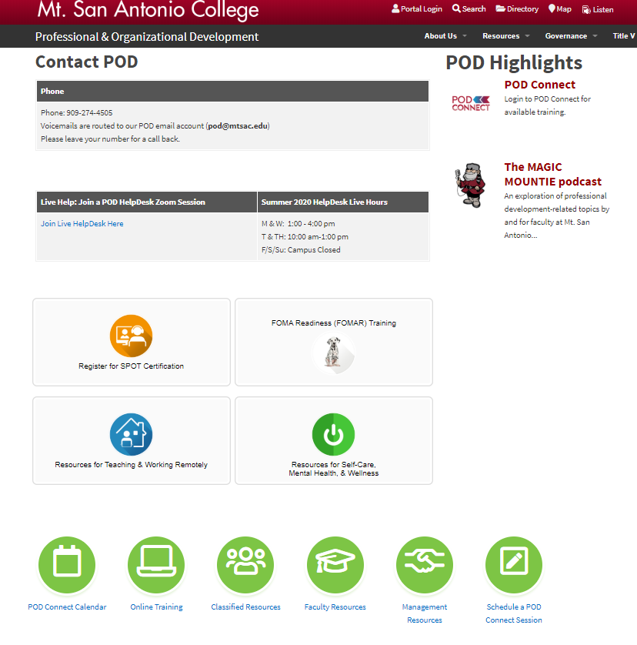

# FLEX Day Information Page

-OR- Access FLEX Sessions from the FLEX Day webpage: <https://www.mtsac.edu/pod/programs/flex-day-fall-2020.html>

Click on the name of the session you would like to attend.

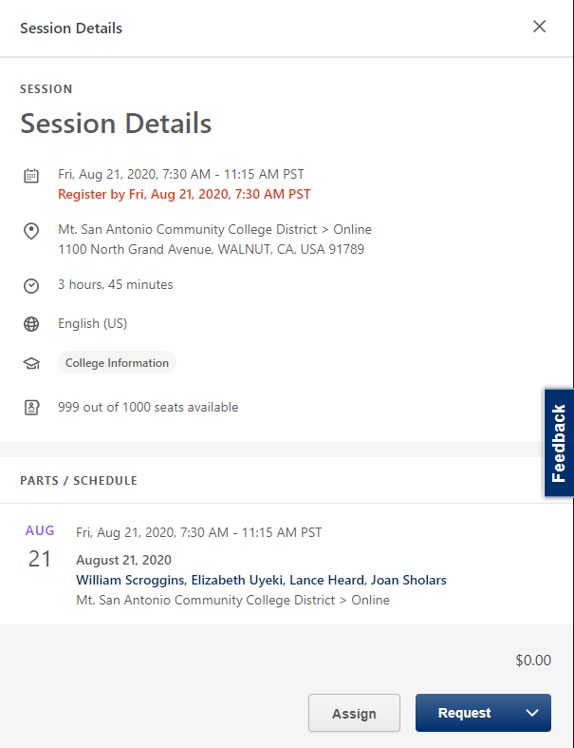

**REQUEST** your self-selected session by

clicking on the word. “Request”.

Do not click the small white arrow.

# E-mail Confirmation of Registered Session

A Zoom Registration link will be sent to your Mt. SAC email. This Zoom Link will allow you to access the Zoom Registration Page.

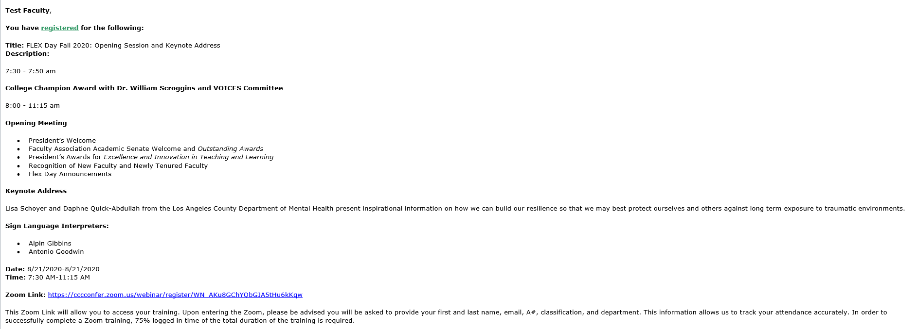

# Zoom Registration Page

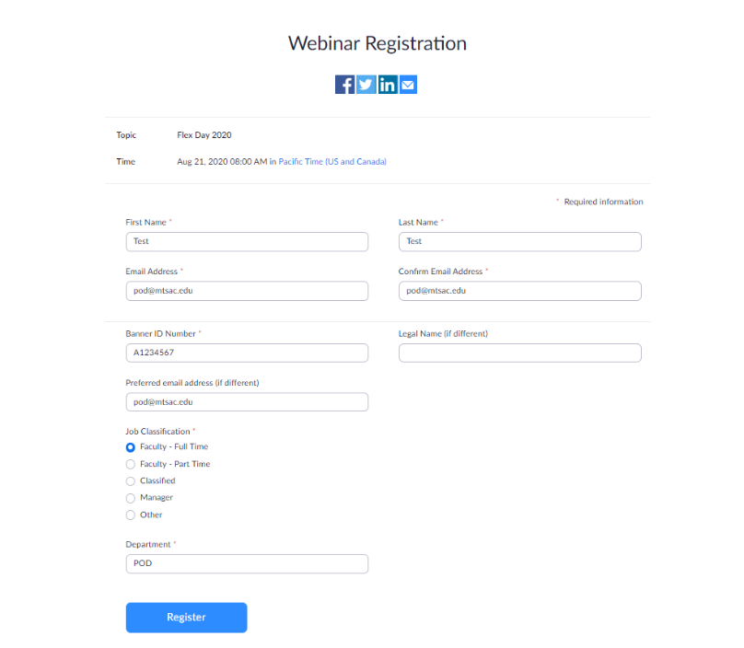Click on the Zoom registration link provided to you in the email confirmation. You will be asked to provide your first and last name, email, A#, and department. Select register when complete.

**Zoom Registration is considered your Sign-in sheet for the workshop. Completing this Zoom Registration is required to gain access to the workshop and for your attendance to be accurately recorded.**

# Approved Zoom Registration

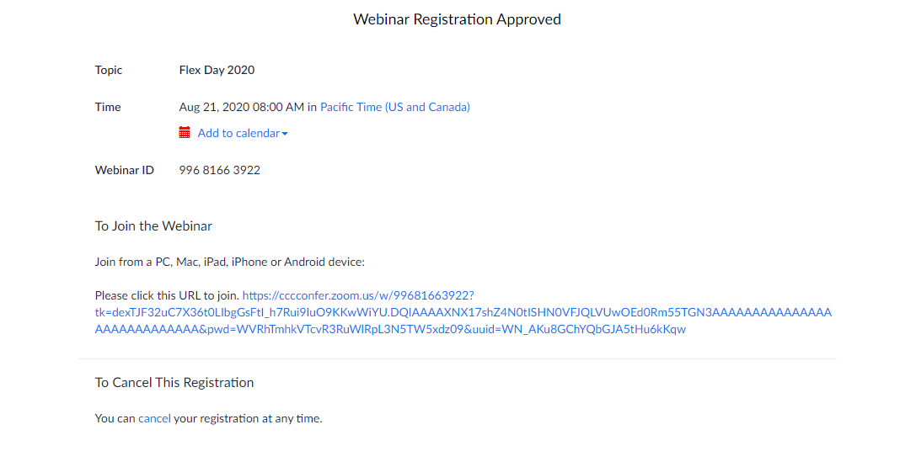Upon completion of the zoom registration, you will automatically be admitted into your workshop. If the workshop is not yet in session, you will be given a second Zoom link to gain access to your session at a later time.

**For immediate live assistance, visit the POD HelpDesk Zoom session at**[**POD HelpDesk**](https://cccconfer.zoom.us/j/96189071419)**or email POD at**[**pod@mtsac.edu**](mailto:pod@mtsac.edu)**.**