**Mt. SAC Zoom Registration Instructions**

### **Zoom registration is required to gain access to Mt. SAC Zoom trainings and sessions**.

### **Follow the Zoom registration instructions below to obtain the zoom link for your session.**

# Zoom Registration Page

# Select the Zoom registration link provided to you. You will be asked to provide your first and last name, email, A#, and department. *Please note if you are a facilitator you are only required to provide your first and last name and email address.* Select Register when this information is entered. This step does not have to be completed in advance. You can complete the Zoom registration process on the day of the training.

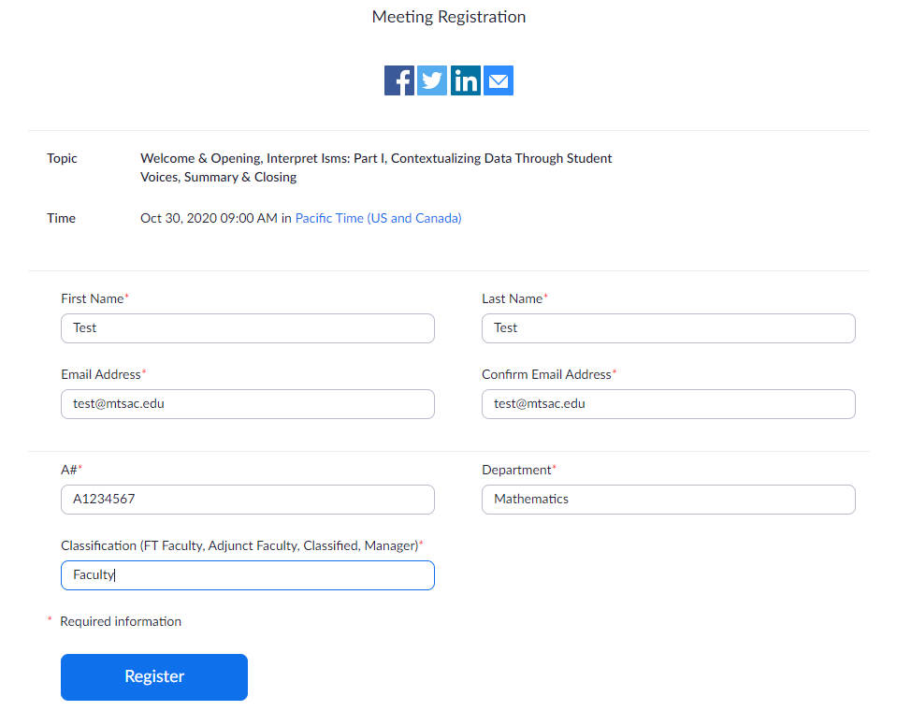

# Approved Zoom Registration

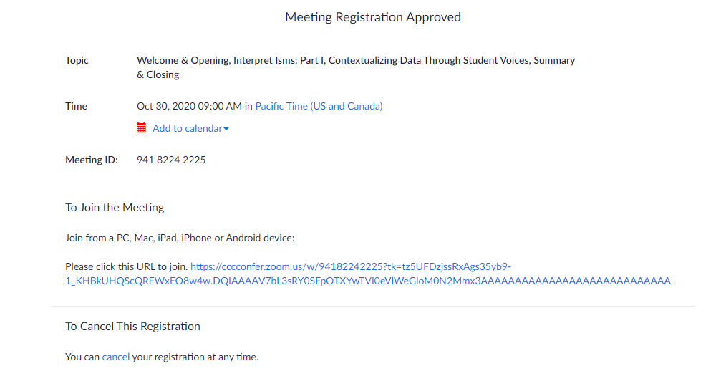Upon completion of the Zoom registration, the Zoom link to will be provided to you to gain access to your training. **Select** the link to join the session.