**POD Connect Training Registration**

### **Registration is required to gain access to Mt. SAC Zoom trainings and sessions**.

### **There are two formats to register for a training, follow the registration instructions below to register for your desired training(s).**

# Format 1: Select your desired training from the Workshop Calendar. Select *Request* from the *Session Details* banner.

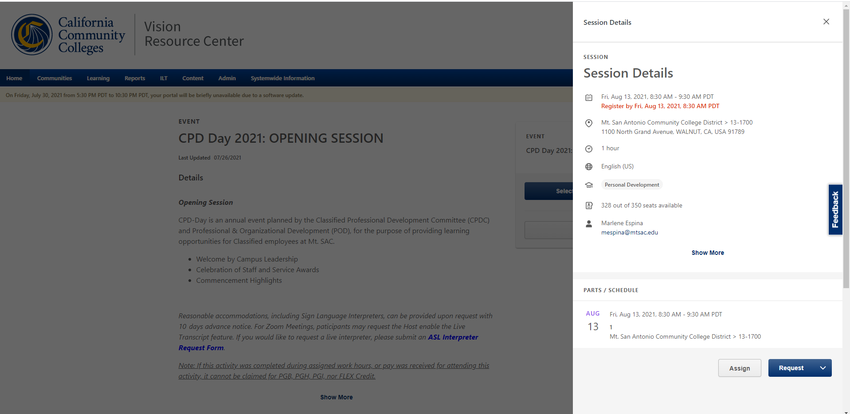

**Format 2:** To read session description, **select** the grey area and the side banner will “disappear”. To register for the session **select** the drop down arrow on the *View Details* button, then select *Request.*

