

**CPD-Day Zoom Registration Instructions**

### CPD-Day is an annual event planned by the Classified Professional Development Committee (CPDC) and Professional & Organizational Development (POD), for the purpose of providing learning opportunities for Classified employees at Mt. SAC.

### **Zoom registration is required to gain access to the day's events.**

# CPD-Day Information Page

Select your desired session from the CPD-Day webpage: <https://www.mtsac.edu/pod/programs/cpd-day-2020.html>

The following steps will be repeated for each self-selected session you are requesting to attend.

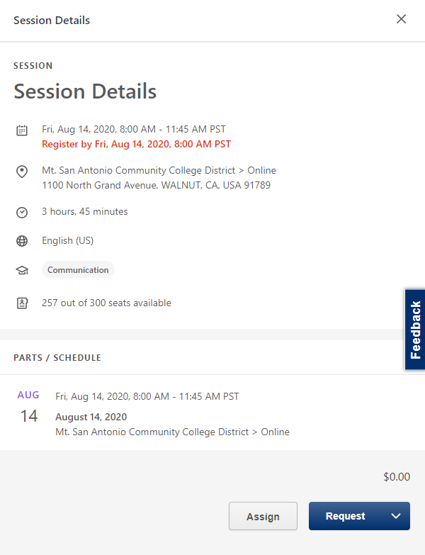**REQUEST** your self-selected session.

# E-mail Confirmation of Registered Session

The Zoom Registration link will be provided to you in the confirmation email of the registered session. This Zoom Link will allow you to access the Zoom Registration Page.

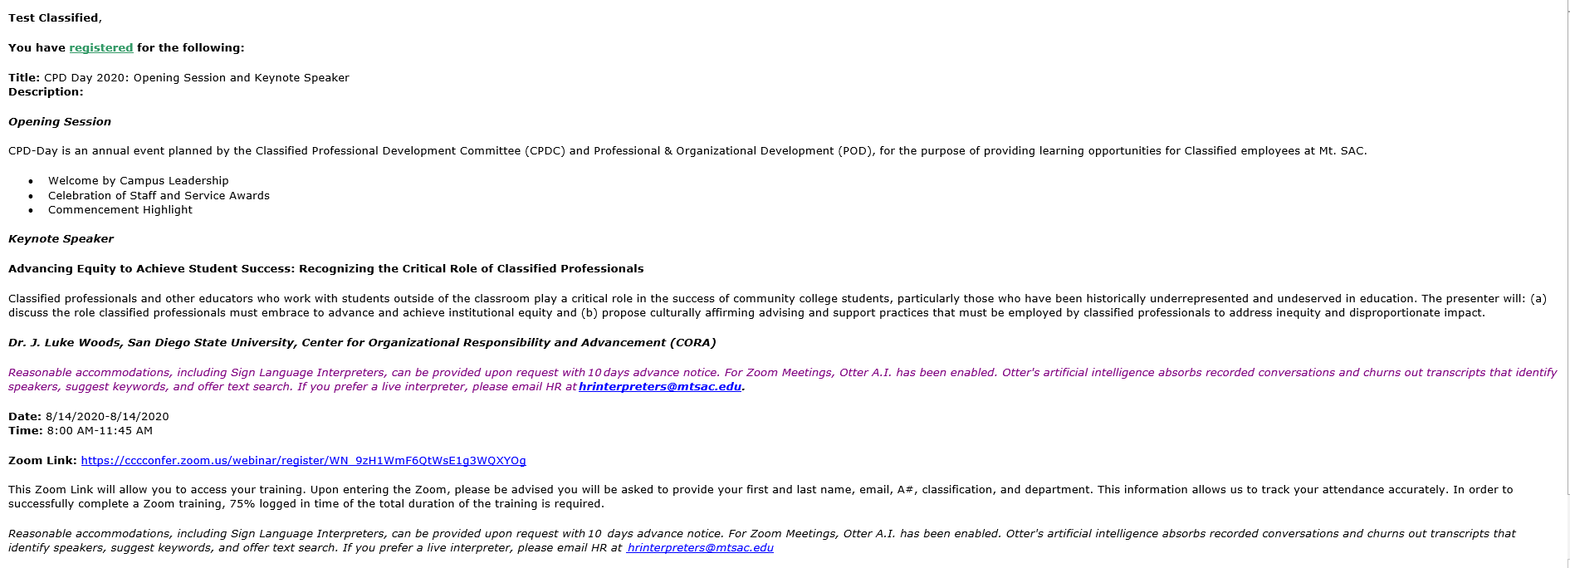

# Zoom Registration Page

Select the Zoom registration link provided to you in the email confirmation. You will be asked to provide your first and last name, email, A#, and department. Select register when complete.

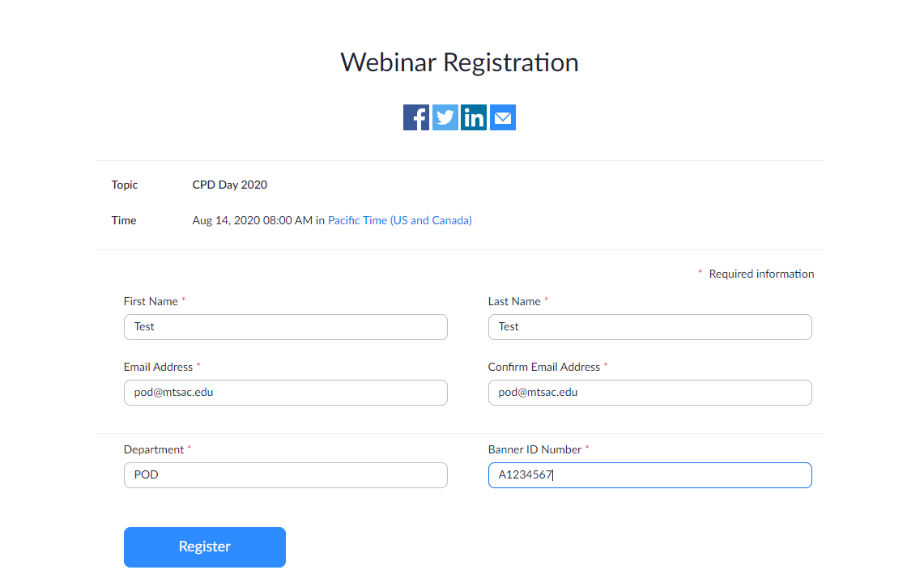

*\*This information allows us to track your attendance accurately. In order to successfully complete a Zoom training, 75% logged in time of the total duration of the training is required.*

# Approved Zoom Registration

Upon completion of the zoom registration, the Zoom link will be provided to you to gain access to your CPD-Day session.

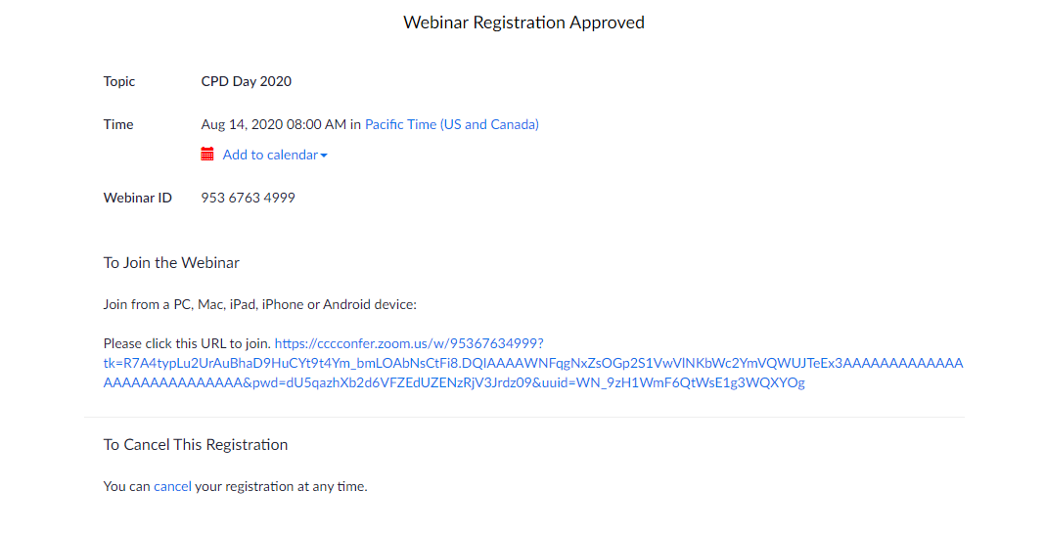

**For immediate live assistance, visit the POD HelpDesk Zoom session at**[**POD HelpDesk**](https://cccconfer.zoom.us/j/96189071419)**or email POD at**[**pod@mtsac.edu**](mailto:pod@mtsac.edu)**.**