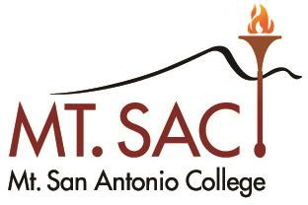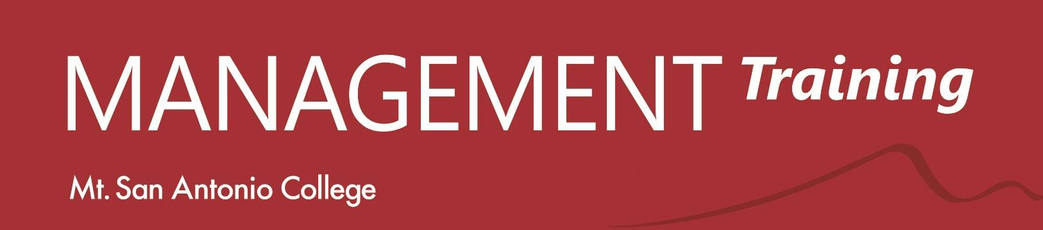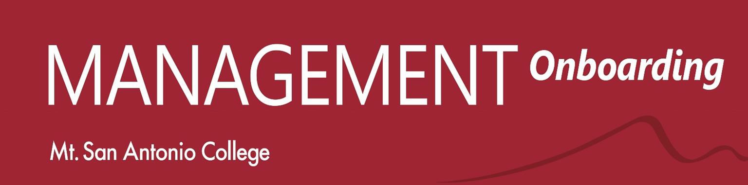
We are committed to the continued development of a healthy management culture where productivity is maximized and all managers are empowered to thrive.

Designed for new managers; open to all managers.

Management Onboarding Team
Brandin Bowman Jody Fernando Lianne Greenlee Lee Jones
Matt Judd Luke Meyer Carlos Santana Sayeed Wadud
Bianca Valle Ward Marisa Ziegenhohn

2021-22
Essentials

How to Use Your Approved Budget September 17, 2-3:30 Now that you have your approved budget, what do you do? Learn how your Mt. SAC budget is created, including explanations of your account strings and what you can and can’t actually spend your
money on!
Essentials

Sexual Harassment Awareness October 1, 2-4 This is training that must be renewed every two years. If you’re getting close or you have never had this training at Mt. SAC, join
us.

Mindfulness for Managers December 3, 2-3 Learn how to increase your clarity and focus, developing not only habits of self-care in your life but developing tools that will help you address specific issues and challenges in your workspace.

Intro to Emotional Intelligence and Diversity (2 parts)
January 14 AND January 28, 11-2 Introduction to increasing team engagement and effectiveness through techniques that merge the understanding of emotional intelligence with a commitment to diversity.

Progressive Discipline—FRISKTM January 21, 2-4 FRISKTM is a communication framework designed to help managers promote positive change in substandard employee performance through clear communication and scaffolding of appropriate outcomes.

Managing Effective Evaluations February 4 2-4:30 Learn how to effectively create substantive evaluations that reflect performance and scaffold improvement.

Handling Employees’ Time-Off February 11, 2-4 This training will explain the different types of leaves available to employees and address some of the challenges faced by managers in supervising the often-complicated requirements of leaves and absences.

(SEE OTHER SIDE FOR SPRING
2022 WORKSHOPS)

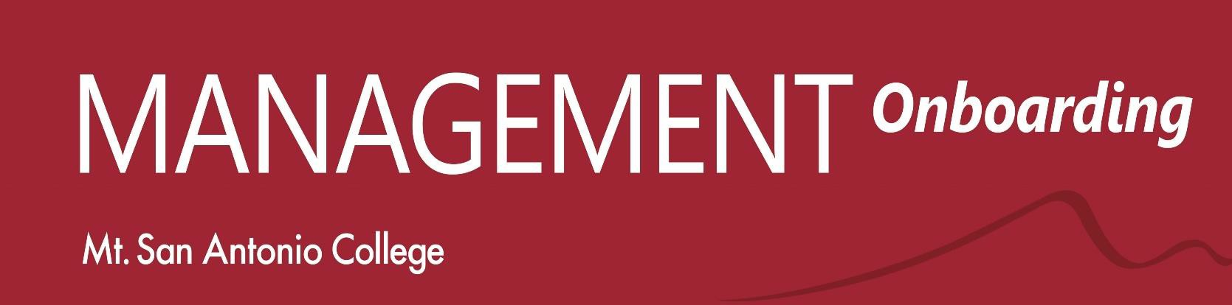
We are committed to the continued development of a healthy management culture where productivity is maximized and all managers are empowered to thrive.

Designed for new managers; open to all managers.

Management Onboarding Team
Brandin Bowman Jody Fernando Lianne Greenlee Lee Jones
Matt Judd Luke Meyer Carlos Santana Sayeed Wadud
Bianca Valle Ward Marisa Ziegenhohn

2021-22
Essentials

SPRING 2022 WORKSHOPS

Planning and Budget—Creating Your Tentative Budget
March 11, 2-3:30
As we prepare to work on the current year budget review, learn the do’s and don’ts of planning and budgeting, including how PIE and budget are integrated to create your 2021-22 tentative budget.

Creating a Satisfying and Equitable Work Environment
March 25, 2-4 The nuts and bolts of creating a thriving work environment based on trust, team building, effective communication, and how to handle challenging team members.

Essential Leadership April 22 AND April 29, 12:30-4:30 This exciting two-part workshop will provide you with foundational leadership skills to support your ability to adapt, pivot, and lead effectively within this high-pressure and often confusing environment. Learn how to be more effective in securing resources AND in building and motivating your team.

Project Management May 20, 2-4 Introduction to the essential elements and strategies of effective project management including organization, scheduling, and communication for both larger and smaller projects.

