The Real History of the Underground Railroad & How Fictionalizing the Past Might Help Change the Future

History Professor Kim Earhart will discuss ways in which the book, the Underground Railroad, departs from actual history and possible implications of this bold choice to current social justice work, including our work as educators.

I. Understanding Slavery as Integral to US History
A. John Rolfe, “20. and odd negroes,” 1619
B. John Punch, “for the time of his natural life,” 1640
II. Sources Consulted for the Underground Railroad
A. North Carolina Runaway Slave Advertisements, 1750-1840
1. “outlawed”
2. Glenn Ligon, Runaways, 1993
B. Slave Narratives
1. Harriet Jacobs, Incidents in the Life of a Slave Girl, 1861
2. WPA Interviews, 1936-1938
III. Departing from History
A. "When I was writing the book, I wouldn't stick to the facts—I'd stick to the truth." (Colson Whitehead, Boise Weekly, February 14, 2018)
B. “Well, I was finishing John Henry Days in 2000 and was pretty depleted. But I had this fanciful idea—I think I was remembering how when you're a kid and you hear about "The Underground Railroad," you think it's an actual subway. Then when you find out it's not, you think, Damn, that would've been so cool! So I just thought what if it actually was true? That was the start of the story, but there's not a lot of meat there. So I was, like, what if every state that our character goes through is a different state of American possibility?” (Colson Whitehead, Goodreads, September 2016)

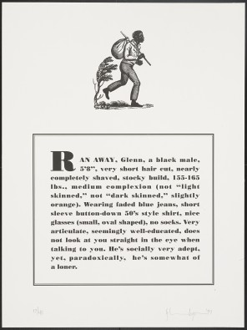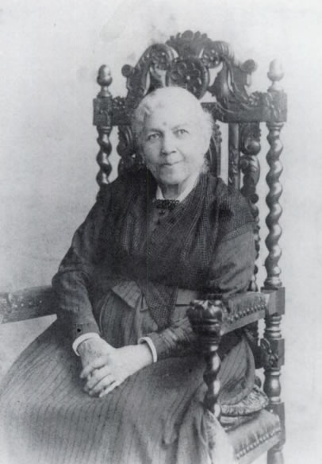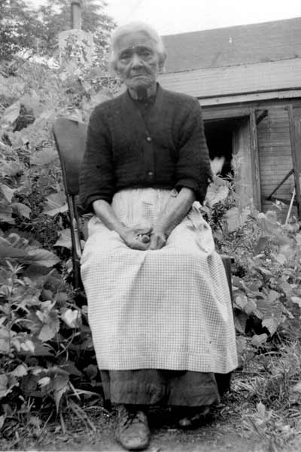

John Rolfe, “20. and odd Negroes,” Virginia, 1619
About the latter end of August, a Dutch man of Warr of the burden of a 160 tunes arrived at Point-Comfort, the Comandors name Capt Jope, his Pilott for the West Indies one Mr Marmaduke an Englishman. … He brought not any thing but 20. and odd Negroes, w[hich] the Governo[r] and Cape Merchant bought for victuall[s].

John Punch, “for the time of his natural life,” Virginia, 1640
Whereas Hugh Gwyn hath by order from this Board Brought back from Maryland three servants formerly run away from the said Gwyn, the court doth therefore order that the said three servants shall receive the punishment of whipping and to have thirty stripes apiece one called Victor, a dutchman, the other a Scotchman called James Gregory, shall first serve out their times with their master according to their Indentures, and one whole year apiece after the time of their service is Expired. By their said Indentures in recompense of his Loss sustained by their absence and after that service to their said master is Expired to serve the colony for three whole years apiece, and that the third being a negro named John Punch shall serve his said master or his assigns for the time of his natural Life here or elsewhere.

Hall’s Wilmington Gazette, Wilmington, North Carolina, February 9, 1797
Twenty Dollars Reward Will be paid to any person who will apprehend and bring to me, at the Hermitage, in New Hanover county, a negro fellow named YORK, who ran away last Tuesday, without the least provocation. He is a likely able bodied negro, about five feet 9 or 10 inches high--he speaks plain, and is extremely plausible and deceptious. I am told he has been frequently harboured at the big Bridge, and it is supposed is now gone up towards Long creek or Black river. The said fellow is outlawed, and whoever harbours him will be prosecuted with the utmost rigour. JOHN BURGWIN.

Wilmington Gazette, Wilmington, North Carolina, April 19, 1799
RANAWAY from the subscriber a negro fellow named MICHAEL, stout and well made, of a yellow complexion--did, when a lad wait on the subscriber--he is well known about Wilmington. It is supposed he will make for Brunswick Old Town, at which place he has a wife, formerly belonging to the estate of Hezekiah Davis, named Nanny, a yellow wench. He had on when he went away a white negro cloth jacket and trousers--he also took with him a pair of striped homespun overalls with an uniform coat, blue turned up with red. This fellow is outlawed agreeably to law and the subscriber will give fifty dollars reward for his head, if dead, or ten dollars to any person who will secure him so that his master can get him again. J.W. BRADLEY

Harriet Jacobs, Incidents in the Life of a Slave Girl, 1861
But I now entered on my fifteenth year—a sad epoch in the life of a slave girl. My master began to whisper foul words in my ear. (44) No pen can give an adequate description of the all-pervading corruption produced by slavery. The slave girl is reared in an atmosphere of licentiousness and fear. The lash and the foul talk of her master and his sons are her teachers. (79) You may believe what I say; for I write only that whereof I know. I was twenty-one years in that cage of obscene birds. (81) When they told me my new-born babe was a girl, my heart was heavier than it had ever been before. Slavery is terrible for men; but it is far more terrible for women. Superadded to the burden common to all, they have wrongs, and sufferings, and mortifications peculiarly their own. (119) My grandmother was much cast down. I had my secret hopes; but I must fight my battle alone. I had a woman's pride, and a mother's love for my children; and I resolved that out of the darkness of this hour a brighter dawn should rise for them. My master had power and law on his side; I had a determined will. There is might in each. (130)

Laura Smiley, “you couldn’t guess the awfulness,” WPA Interviews, 1936-1938
Them days was hell. Babies was snatched from their mothers’ breasts and sold to speculators. Children were separated from sisters and brothers and never saw each other again. 'course they cry. You think they don't cry when they was sold like cattle. I could tell you about it all day but even then, you couldn't guess the awfulness. It’s bad to belong to folks who own your soul and body and they can tie up to a tree with your face to the tree and your arms fastened tight 'round it. Would take a long cuttin' whip and cut the blood every lick. Oh trust... trusting was the only hope for the poor black critters in those days. Us just prayed for strength to endure it to the end.
Arnold Gragston, “I never saw my passengers,” WPA Interviews, 1936-1938
An old woman . . . told me she had a real pretty girl there who wanted to go across the river to Ripley, Ohio, and would I take her? I was scared, and backed out in a hurry. But then I saw the girl, and she was such a pretty little thing . . . I don’t know how I ever rowed the boat across the river; the current was strong and I was trembling. I couldn’t see a thing there in the dark, but I felt the girl’s eyes . . . Well, pretty soon I saw a tall light and when I got up to it, two men reached down and grabbed her. I started tremblin’ all over again and prayin’. Then, one of the men took my arm and I just felt down inside of me that the Lord had got ready for me. ‘You hungry, Boy?’ is what he asked me. “That was my first trip; it took me a long time to get over my scared feelin’, but I finally did, and I soon found myself goin’ back across the river, with two and three people, and sometimes a whole boatload. I got so I used to make three and four trips a month . . . I never saw my passengers. It would have to be the ‘black nights’ of the moon when I would carry them . . .

SOURCES: [Rolfe] https://www.nps.gov/jame/learn/historyculture/african-americans-at-jamestown.htm [Punch] http://www.virtualjamestown.org/practise.html [Advertisements] http://libcdm1.uncg.edu/cdm/landingpage/collection/RAS [Jacobs]http://www.docsouth.unc.edu/fpn/jacobs/jacobs.html [Smiley] https://naturalhistory.si.edu/africanvoices/voices.html [Gragston] http://content.time.com/time/classroom/unchained/pdfs/student.pdf [Jacobs Image] http://spec.lib.miamioh.edu/home/from-the-stacks-solomon-northrup-free-man/ [Ligon Image] https://www.moma.org/learn/moma_learning/glenn-ligon-untitled-from-the-runaways-1993 [Whitehead, truth] https://www.boiseweekly.com/boise/colson-whitehead-at-the-egyptian-slavery-the-truth-and-macarthur-park/Content?oid=9310602 [Whitehead, possibility] https://www.goodreads.com/interviews/show/1169.Colson_Whitehead

