




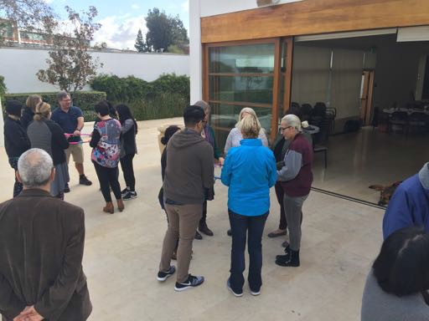

Once we figured out to open the actual door – we went outside.

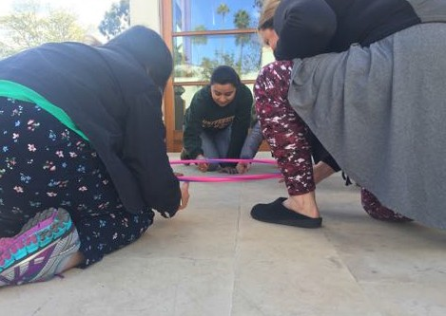

One group finally mastered the hula hoop challenge when a single member gave all the instructions.
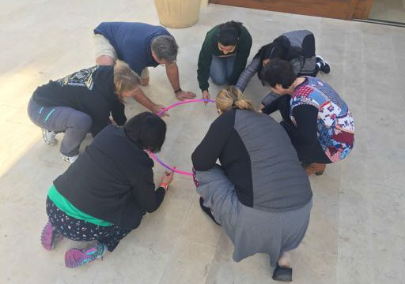

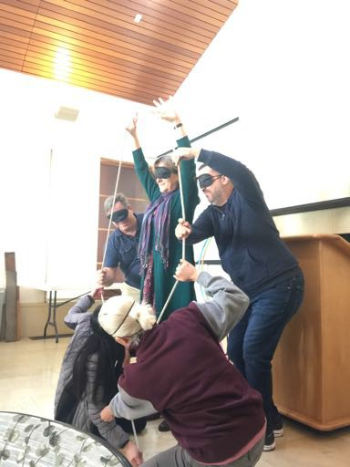

Back inside. Blindfolded and making letters out of rope.


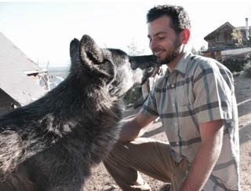
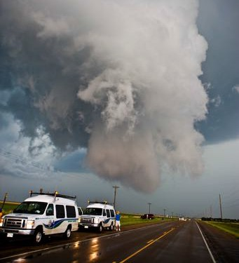
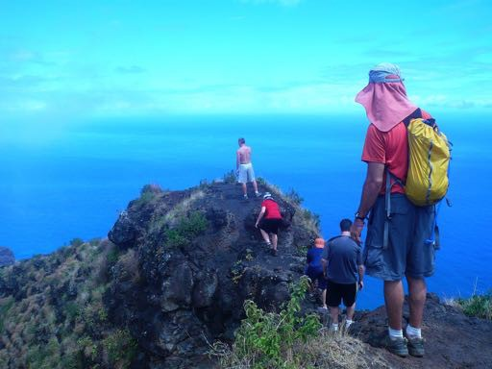
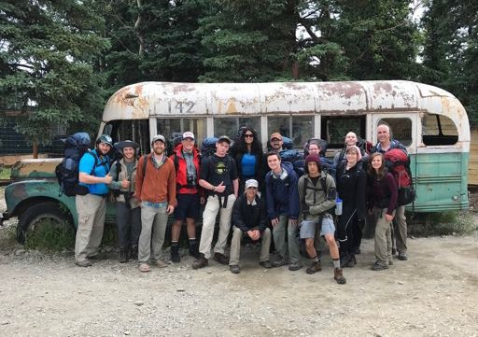
Left: Marco’s Film as Lit class in Alaska.

Below: “Challenge by choice” exemplified in Kauai.

Above: The DuPage storm chasing course. Right: Marco’s son Peter with a Wolf
The Dartmouth College assessment team identified several distinct competencies as outcomes of experiential learning, including increasing students’ confidence and ability to:

- Innovate and take risks
  - Self-efficacy: belief in one’s own ability to perform well in a variety of circumstances
  - Resolve: ability to act despite uncertainty of success
  - Creativity: ability to sample ideas and retrieve or form unconventional knowledge
- Solve complex problems
  - Complex reasoning: ability to extend and refine knowledge by comparing, contrasting, abstracting
  - Incorporating perspectives: capacity to understand where others’ ideas come from and negotiate/apply
perspectives
- Collaborate across differences
  - Communication skills: ability to effectively convey information to others
  - Cultural intelligence: ability to function effectively in culturally diverse contexts
  - Empathy: aptitude for understanding another person’s inner experiences and feelings
- Think critically and reflect on learning
  - Connecting theory to practice: competence in applying abstract ideas to connect situations
  - Reflection: capacity to intentionally explore and appraise experiences to create meaning for the benefit of
learning

https://dcal.dartmouth.edu/initiatives/experiential-learning/impact
Ideas for on-campus experiences:

    - Unusual scheduling to create blocks of time
    - Moving class for a day or two
    - Creating projects for students to do outside of class
    - Student experiences on their own or in groups
    - Field trip to your office
    - Creating on-campus conferences or events
    - Workplace site visits/tours
    - Finding internships and connecting students
    - Providing students with volunteer opportunities
- Traditional field trips

