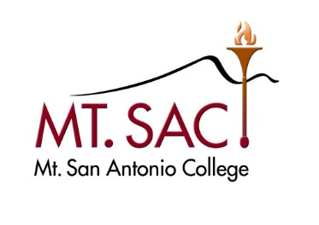
Unused Management Conference and Travel Funds Transfer Form

Per the Meet and Confer Agreement between the District and management employees approved by the Board of Trustees on September 13, 2017, management employees may transfer any unused portion of their conference and travel funds into a general management professional development account to support all management professional development, rolling over each year.

Manager Information:

Name Banner ID Title

Authorization:
In an effort to support and promote the professional development of all management employees, I hereby authorize the Fiscal Services Department to transfer from my manager conference and travel account, any unused funds at the end of the fiscal year, to the Professional and Organizational Development Department’s management professional development account.

Signature Date

Submit this form by June 30th to Professional and Organizational Development Building 6, Room 140.

Office Use Only:

Fiscal Year:

