
January 3-4, 2019
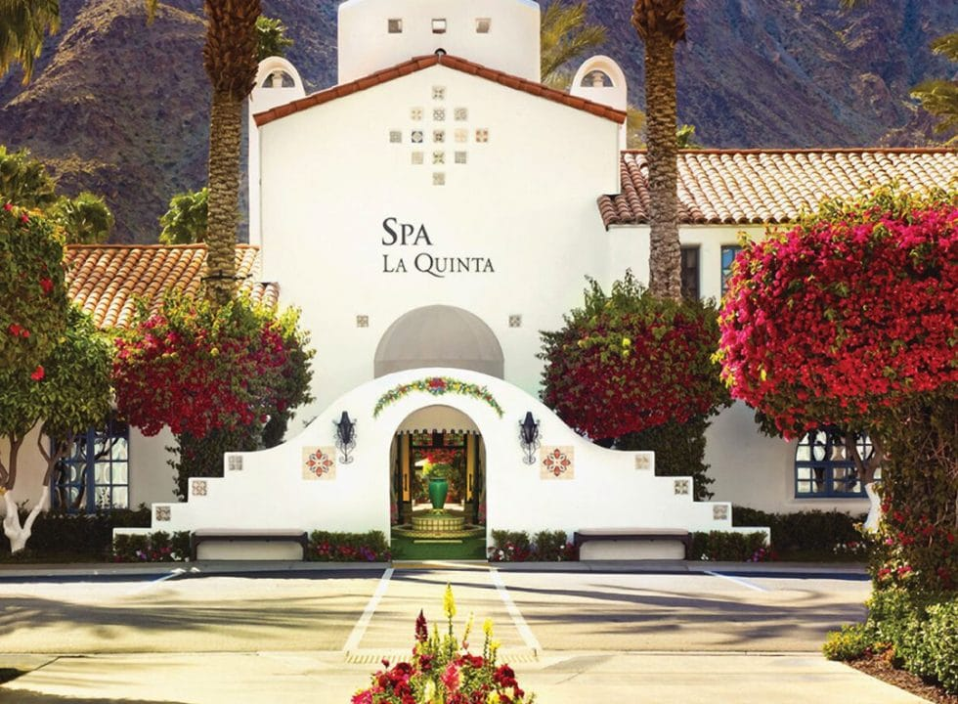
La Quinta Resort and Club, Palm Springs Area

TRANSPORTATION
Take the Bus! A charter bus will be provided for those who do not wish to drive. The bus will depart from Mt. SAC at 7:30 am on Thursday, January 3rd and return to campus on Friday, January 4th around 5 pm. Managers may also choose to drive their private vehicle if desired.

SCHEDULE
The retreat will begin at 10 am on Thursday, January 3th, and conclude at 3:00 pm on the 4th. If you would like to arrive early on January 3^{trd}, continental breakfast will be available beginning at 8:00 am.

RETREAT RSVP AND HOTEL ARRANGEMENTS
- Please RSVP online at the POD manager website for both hotel and bus transportation no later than Wednesday, November 21st.
- Mt. SAC will pay for your room & tax charges, parking, and all planned meals and activities over the program dates of January 3rd and 4th.
- For those who wish to extend their stay to include the night of January 2nd or the weekend following the retreat, the Mt. SAC discounted rate will be available to you at your personal cost. Extended stay information must be provided at the time of your RSVP.
- If you have any questions regarding the retreat, please contact Lianne Greenlee by email lgreenlee@mtsac.edu or phone at 909-274-6044.

CLIMATE & ATTIRE
- Expect lovely desert winter weather with cool mornings and evenings. January temperatures range from the mid to high 70s during the day and high 40s at night. The resort is nestled in the Santa Rosa Mountains, so please bring a jacket.
- Casual attire is appropriate for all retreat meetings.
- The resort sits on a large property, so comfortable walking shoes are recommended.
- Time will be provided in the afternoon and evening hours for you to enjoy the resort at your leisure. With 41 pools, tennis courts, bike rentals, and five championship golf courses, consider bringing active wear clothing.
- Dinner will be a “dine around”, with your choice of three restaurants, where casual attire is suggested.

HOTEL INFORMATION & AMENITIES
La Quinta Resort & Club, a Waldorf Astoria Resort, is a historic 92 year old desert hideaway frequented by Frank Capra and other Hollywood legends. This resort offers large renovated rooms, shopping, seven restaurants, a spa, numerous onsite activities, and mountain views.

