Keynote Speaker
Sophia Clarke Theater
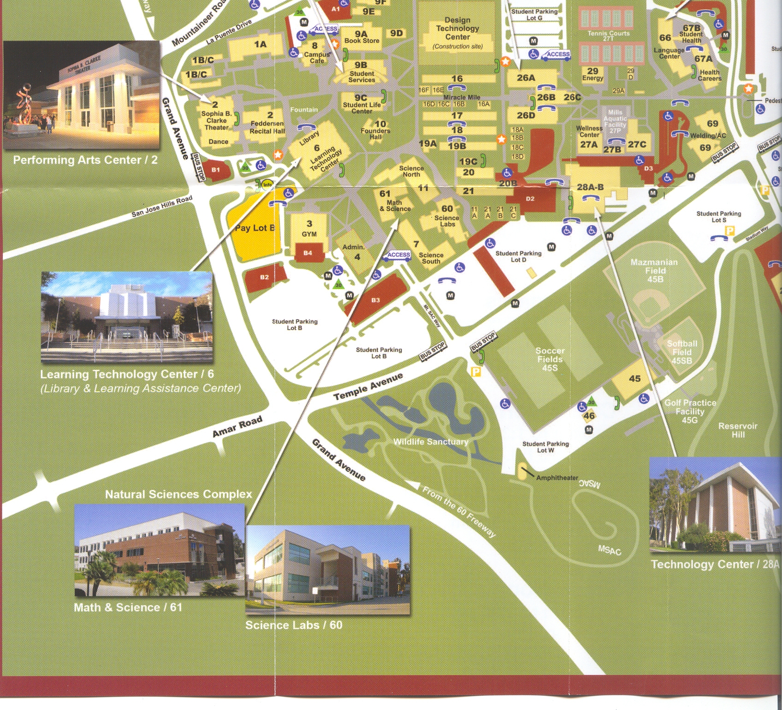
Planetarium

