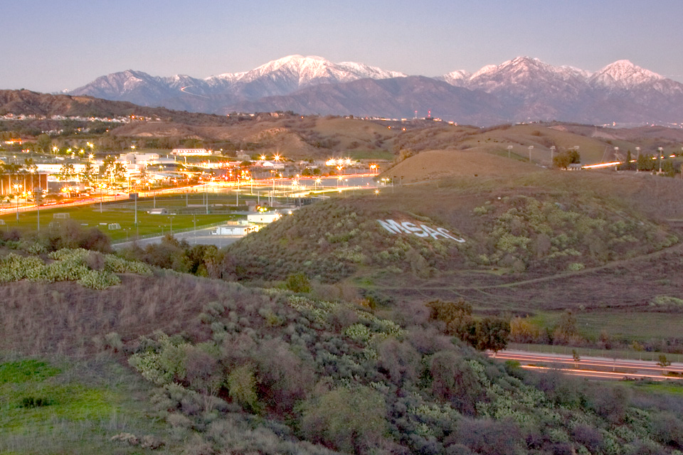
INTRODUCING
Marketing and Communication

Learn more at www.mtsac.edu/marketing

Introduction
At Mt. SAC, students can get the full-college experience without the full college debt. We give our students the support and excellent education they need to succeed in new careers, gain admission into top-tier universities, or advance in their current line of work. We have more than 260 degree and certificate programs, 25 support programs, and more than 50 student clubs and athletic programs.

Headings organize text
Mt. SAC is a Top Ten California Transfer College and ranks among the top degree-awarding community colleges in the nation. We also provide affordable career training education and accelerated bachelor's degree programs (often with reduced tuition) through partnerships with universities.
THIS IS A SUBHEAD THAT DRAWS ATTENTION
Many students think they can't afford college, but we make college a possibility for everyone. At just $46 a unit, Mt. SAC is 1/5 the cost of CSU schools, 1/10 the cost of UC schools, and 1/30 the cost of private universities. We have distributed more than $68.5 million in financial aid to our students.
THIS IS A SUBHEAD THAT DRAWS ATTENTION
Many students think they can't afford college, but we make college a possibility for everyone. At just $46 a unit, Mt. SAC is 1/5 the cost of CSU schools, 1/10 the cost of UC schools, and 1/30 the cost of private universities. We have distributed more than $68.5 million in financial aid to our students.

