SP34: Passive Voice
Student Name: _____________________________________ Student ID Number: ______________________
Instructor: _______________________________________ Class Level: ___________Date: ______________
For media links in this activity, visit the LLC Spanish Tutoring website. Find your DLA number to see all the resources to finish your DLA.

Learning Outcomes: You will be able to…
- Identify the subject, verb, and direct object of a sentence.
- Demonstrate comprehension of auxiliary verbs and past participles.
- Synthesize and articulate the passive voice in Spanish.

Section 1: Introduction
Let’s compare the active and passive voice:
The passive voice describes a sentence in which a given or anonymous subject receives an action. In the active voice, a subject performs an action unto a direct object. Both the active and passive voices use transitive verbs, verbs that describe a transactional relationship between the noun and direct object. For example, the following sentence is in the active voice:

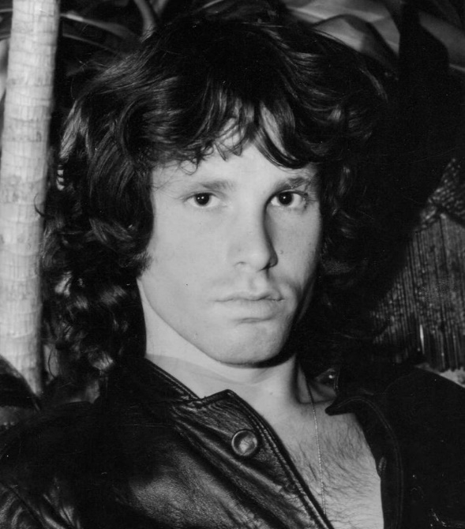
The Doors (S) recorded (V) an album (D.O).
“The Doors” is the subject that performs an action/verb -“recorded”- which is a transitive verb, so we ask ourselves, “recorded what?” to which we respond: “an album”, the direct object. But, in the passive voice:
An album (S) was (AUX) recorded (P.P) by The Doors (“by” phrase).
“An album” becomes the grammatical subject to which/whom something is done -“was recorded”. We can stop here - An album was recorded - but sometimes we can add the phrase “by”.

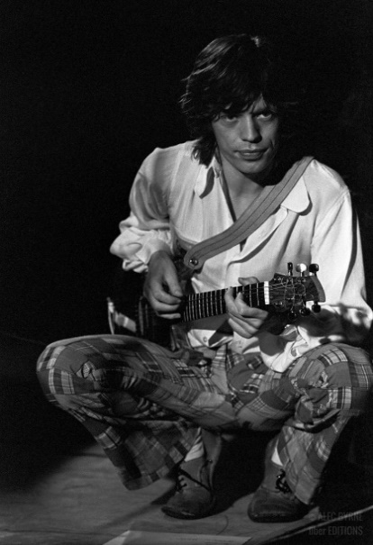
Consider this example in which there is no expressed doer or performer of the action:
The red door is painted black.
We do not know who painted the red door black, so the “by” phrase is unnecessary, but the Passive Voice is still valid.
So how does this look in Spanish?

En Español
Spanish too uses active and passive voice and generally follows the same rules as English.

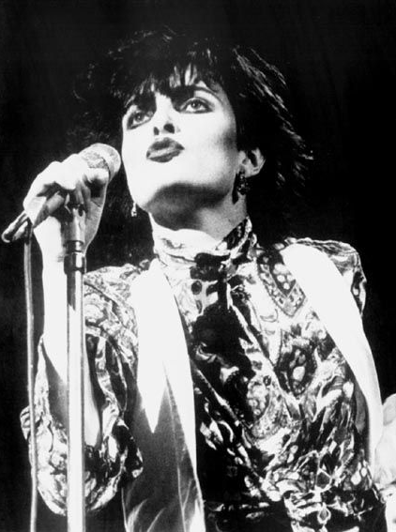
First, let us consider this sentence in the active voice in Spanish:
Siouxsie (S) canta (V) una canción (D.O).
In order to turn this into the passive voice in Spanish, first, take the Spanish auxiliary verb “to be” (ser) and conjugate it respectively, then add the past participle of the verb, in this case, (cantar), which, with regular verbs, is marked by the suffix -ado (-ar verbs) or -ido (-er/-ir verbs). In cases in which the “by” phrase is used, we use the Spanish equivalent “por”. Therefore:

Siouxsie canta una canción → Una canción es cantada por Siouxsie.
Remember, in Spanish, there needs to be an agreement between the gender of the noun and the past participle, which, in the example above, is feminine, denoted by the article “una” and thus the past participle is “cantada”.
An example with the masculine gender marker would be:
Siouxsie and the Banshees saca un album → Un album es sacado por Siouxsie and the Banshees.

Section 2: Practice
Change these from the active voice into the passive voice. Remember the subject/verb agreement!
Robert Smith toca la guitarra
________________________________________________________________________________
Siouxsie usa un micrófono
________________________________________________________________________________
Siouxsie compra una pandereta
________________________________________________________________________________
La banda firma un contrato de grabación
________________________________________________________________________________

Section 3: Practice with Tenses
Passive Voice can be constructed with any tense, so recall the conjugations for “ser”

Pronombres
Yo
Tú
Él/Ella/Ud.
Nosotros
Ellos/Ellas/Uds.
Presente
soy
eres
es
somos
son
Pretérito
fui
fuiste
fue
fuimos
fueron
Futuro
seré
serás
será
seremos
serán

Change these from the active voice into the passive voice. Pay attention to the verb tense and remember the subject/verb agreement!
Joy Division grabó un álbum.
________________________________________________________________________________
Peter Hook compró una guitarra.
________________________________________________________________________________
Stephen Morris tocó la batería.
________________________________________________________________________________
Peter llamó a Daniel.
________________________________________________________________________________
Los murciélagos mordieron a las personas.
________________________________________________________________________________
Tony Scott dirigió la película “The Hunger”.
________________________________________________________________________________
Los vampiros bebieron la sangre.
________________________________________________________________________________

Section 4: Subjects & Impersonal “Se”
Recall that with the first example in this worksheet: “An album was recorded by The Doors”, the additional “by” phrase was not technically necessary; it was only included because the subject/doer of the action was known. However, there are cases where there is no known subject. Consider this example in Spanish:
Los Cocteau Twins fueron firmados con el sello discográfico 4AD.
(The Cocteau Twins were signed to the record label 4AD).
There is a grammatical subject “Los Cocteau Twins”, the verb “to be” and the past participle (“fueron firmados”), but there is no known subject: Who signed them? They were signed to the label but by whom/what? Since it is unknown, there is no “by” phrase.
Write these sentences in the present tense. Conjugate the verbs appropriately.
Todas las ventanas (ser) (cerrar) (“Day of Lords” - Joy Division).
_________________________________________________________________________________
La fábrica de los sueños (ser) (destrozar) (“Nerves” - Bauhaus).
_________________________________________________________________________________
Las palabras pesadas (ser) (lanzar) tan ligeramente. (“What Difference Does It Make?” - The Smiths)
_________________________________________________________________________________
Instead of using the verb “to be” and the past participle, the Passive Voice in Spanish can also be expressed by using the third-person singular/plural reflexive pronoun “se” and the corresponding third-person singular/plural conjugation of the given verb.
For example:
La puerta roja se pinta negra/Las puertas rojas se pintan negras. (The red door(s) is/are painted black).
Write these song lyrics in passive voice using the “se” form (use present tense):
Un piano (tocarse) en un cuarto vacío (“The Hand That Rocks The Cradle” - The Smiths).
___________________________________________________________
Pienso que sus vidas (engañarse) (“A Day” - Clan of Xymox)
___________________________________________________________
Una fragancia (refinarse) (“Jasmine and Rose” - Clan of Xymox)
___________________________________________________________
Las promesas (hacerse) para la conveniencia (“Lie to Me” - Depeche Mode)
___________________________________________________________

Section 5: Watch a video
Go to the section 5 website. Watch the first few minutes of the video (you don’t have to watch the whole thing!) and make 8 sentences in the passive voice. You can use some of these verbs to get you started but make your own as well.

abrazar
morder
sorprender
golpear

__________________________________________________________________________________________________
__________________________________________________________________________________________________
__________________________________________________________________________________________________
__________________________________________________________________________________________________
__________________________________________________________________________________________________
__________________________________________________________________________________________________
__________________________________________________________________________________________________
__________________________________________________________________________________________________

Section 4: Practice with a Tutor
GOOD job! Now make an appointment for Spanish Tutoring on the LLC website.
Before your appointment, please fill out the sign-in sheet.
When it is time for your appointment, meet your tutor in the Virtual LLC.

Grading Rubric
Possible Points | Pass | Not Yet Pass
Completion | The student completed all of the sections of the DLA. | The student has not yet completed all of the section of the DLA.
Comprehension/  Metacognition | The student can effectively explain the concepts and skills learned in the DLA. | The student cannot yet effectively explain the concepts and skills learned in the DLA.
Course Connections | The student can explain the connections between their coursework and the DLA. | The student cannot yet explain a connection between their course and DLA.
Students must succeed in all criteria to pass this DLA.
Verification of completion: If you successfully complete this DLA with the tutor, you will receive a stamp on your digital passport. An updated copy of your passport will be emailed to you 1-2 business days after your tutoring appointment.

