SP33: The Subjunctive Mood (El subjuntivo)
Student Name: ____________________________________ Student ID Number: ______________________
Instructor: _______________________________________ Class Level: ___________Date: ______________
For media links in this activity, visit the LLC Spanish Tutoring website. Find your DLA number to see all the resources to finish your DLA.

Learning Outcomes: You will be able to…
- Identify what the subjunctive is.
- Name the triggers for the subjunctive.
- Conjugate the subjunctive.

Section 1: Meaning and Form
Within the Spanish Language, we have two different moods, the indicative and the subjunctive. However, what is a mood? A mood can be described as the way we look at reality. You may have heard the phrase “looking at the world through rose colored glasses”, and that means that the person wearing these glasses sees the world from a very optimistic point of view.
A mood is the way the speaker sees any given situation and because Spanish is such a polite language, it gives us a way to tell the listener that this may be my reality, but the speaker does not expect it to be the same for the listener.
For example, in English, if I want you to do something for me, I say it in such a way that makes it seem like it isn’t an option. Ex: “I want you to buy me a cup of coffee.”
In Spanish, I can say the exact same thing but I would use the subjunctive mood.
Ex: “Quiero que me compres un café.”
The feeling of this mood is that you buying a cup of coffee is my wish, but I realize it may not be your wish.

Conjugation
In order to conjugate verbs in the subjunctive, we have a pattern we follow. In order to find the stem of a verb in the subjunctive, it will first be conjugated in the first person singular (1S, “yo” form) of the present indicative. Then, we will remove the – o. Finally, we will add the opposite vowel endings to the stem.
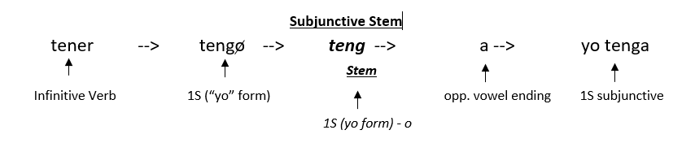
“Opposite vowel endings” simply means that for –ar verbs, you will use the endings we would normally use for –er verbs and for –er and –ir verbs, we will use the endings we would normally use for –ar verbs.
Subjunctive endings

-AR Verbs
1S -e
2S -es
3S -e
1P -emos
2P -éis
3P -en
-ER/-IR Verbs
1S -a
2S -as
3S -a
1P -amos
2P -áis
3P -an

Practice conjugating the verbs in the chart below. The first one has been done as an example.
Infinitive Verb Person/Number Stem (1S of present IND - o) Conjugation
TRABAJAR 3P Trabajo Trabaj Trabajen
DECIR 2S ____________________ ____________________
RECOMENDAR 3S ____________________ ____________________
ESCRIBIR 1P ____________________ ____________________
APRENDER 1S ____________________ ____________________
CAMINAR 3P ____________________ ____________________
COGER 2S ____________________ ____________________

Section 2: Use

When do we use the subjunctive?

Have you ever seen the movie “Alice In Wonderland”? If you haven’t, it’s about a young girl that follows a rabbit down a rabbit hole and she ends up falling underground. When she lands, she is in a world where everything is the opposite of the world she knows above ground. Rabbits can talk and throw tea parties, cats are magical and a deck of cards is an army for the Queen of Hearts! The subjunctive is a little like that, when certain phrases or expressions are used, they trigger a trap door, sending you into a reality that is the opposite of what you know. We’ll explore those triggers now.
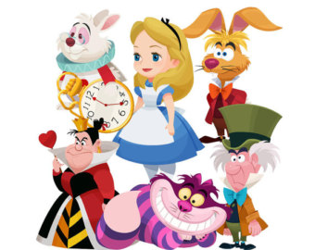

When we use verbs of will or influence, we’ll be triggered to the subjunctive, but why? If I’m expressing my will over someone else, it doesn’t necessarily mean that they will do what I want them to do. It’s a reality for me, but it isn’t for them.
For example:
Quiero [que me compres un café.]
Quiero (present indicative) que me compres (present subjunctive) un café.

To help understand the triggers of the subjunctive, remember that the subjunctive is a WEIRDO.
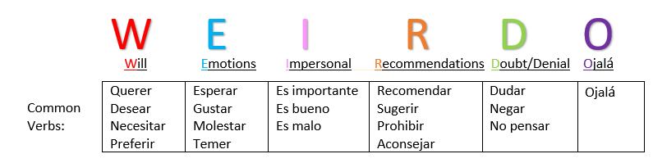

Using the triggers from the chart above, you can practice conjugating verbs in each sentence. Review the sentences with your tutor.
- Hay una nota que dice que Alice necesita beber lo que hay en una botella, no creo que _________________ (ser) una buena idea.
- Es ridículo que _________________ (haber) muchas cosas que Alice come y bebe sin pensar.
- Alice niega que el conejo _________________ (poder) hablar español.
- Es malo que la reina de corazones _________________ (castigar) a la gente de Wonderland.
- Al Sombrero Loco le gusta que Alice y el conejo _________________ (asistir) a la fiesta del té.

Section 3: Above or Below Ground?
Using what you now know about the subjunctive, you can practice selecting the correct verb in the sentences below. Check the box in front of the correct verb.
Is there will, emotion, doubt? If so, Alice is in Wonderland; if not, she’s above ground where rabbits don’t talk!
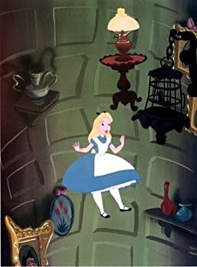

- Alice no cree que los animales pueden/ puedan hablar.
- Es una lástima que las flores piensan/ piensen que Alice es una hierba.
- El gato de Cheshire dice que ella necesita/ necesite ir a la derecha en lugar de la izquierda.
- Alice puede/ pueda hablar con los animales, eso es raro, ¿verdad?
- Le sorprende a Alice que todos los animales hablan/ hablen inicialmente.
- Me molesta que la reina de corazones es/ sea una mala mujer.
- El Sombrero Loco tiene/ tenga una fiesta donde Alice y otros beben mucho té.
- El conejo blanco corre/ corra rápidamente porque tiene prisa para una cita muy importante.

Section 4: ¿Qué hiciste ayer?
Follow the model below to create your own sentences. You will need to decide whether or not the sentence requires a subjunctive or will be in the indicative. Add any articles or pronouns necessary.
Mis padres / querer / que / yo / no ir / la playa / con amigos.
Mis padres quieren que yo no vaya a la playa con mis amigos.
    - Los profesores / sugerir / que / estudiantes / estudiar / cada día.
______________________________________________________________________________________
    - Tú / (yo) recomendar / que / no tener miedo de / perros.
______________________________________________________________________________________
    - Mis amigos / dudar / que / yo / completar / proyecto.
______________________________________________________________________________________
    - Los padres / Manuel / prohibir / que / él / no esperar / el último momento / terminar / tarea.
______________________________________________________________________________________
    - Yo / querer / viajar / España / próximo año.
______________________________________________________________________________________
    - Ellos / pensar / que / ir / fiesta / de amigo.
______________________________________________________________________________________
    - Ojalá / que / los profesores / no tener / clase / mañana.
______________________________________________________________________________________

Section 5: ¡Que suenen los tambores!
Identify the subjunctive verbs used in the poem. Make a list in the space below the poem.
“Que suenen los tambores” by Victor Manuelle
Que suenen suenen suenen!
Que suenen suenen suenen!
Eh!
Que suenen los tambores!
Ay no te desesperes y ten paciencia
Que todo en la vida viene
No se trata de velocidad, si no resistencia
Para lograr lo que se quiere
Por eso dale mueve, mueve las caderas
Vamos a gozar la vida y lo que la suerte llega
Por eso dale mueve, sacude los temores
No te quejes tanto y no me lloré
Y para que vengan tiempos mejores
Que suenen suenen suenen los tambores oye
Que cuando suenen se curen el alma y los corazones
Que suenen suenen suenen los tambores oye
Pa' que traigan alegría y se lleven los dolores
Se lleven los dolores
Se lleven los dolores
Se lleven los dolores
Dale rompe los tambores
Ay no te desesperes que no hay urgencia
Que llegue cuando llegue
Que la vida no es de rapidez, si no inteligencia
Y yo sé que tú puedes

Section 6: Practice with a Tutor
GOOD job! Now make an appointment for Spanish Tutoring on the LLC website.
Before your appointment, please fill out the sign-in sheet.
When it is time for your appointment, meet your tutor in the Virtual LLC.

Grading Rubric
Possible Points | Pass | Not Yet Pass
Completion | The student completed all of the sections of the DLA. | The student has not yet completed all of the section of the DLA.
Comprehension/  Metacognition | The student can effectively explain the concepts and skills learned in the DLA. | The student cannot yet effectively explain the concepts and skills learned in the DLA.
Course Connections | The student can explain the connections between their coursework and the DLA. | The student cannot yet explain a connection between their course and DLA.
Students must succeed in all criteria to pass this DLA.
Verification of completion: If you successfully complete this DLA with the tutor, you will receive a stamp on your digital passport. An updated copy of your passport will be emailed to you 1-2 business days after your tutoring appointment.

