SP09: Ser versus Estar
Student Name: _____________________________________ Student ID Number: ______________________
Instructor: _____________________________ Class Level: ______________ Date: _____________________
For media links in this activity, visit the LLC Spanish Tutoring website. Find your DLA number to see all the resources to finish your DLA.

Learning Outcomes: You will be able to…
- Use simple present forms of ser and estar
- Distinguish between temporary and permanent states
- Choose between ser and estar in sentences

Section 1: Form

ser – to be
yo soy nosotros somos
tú eres vosotros sois
él/ella/usted es ellos/ellas/ustedes son

estar – to be
yo estoy nosotros estamos
tú estás vosotros estáis
él/ella/usted está ellos/ellas/ustedes están

ser vs. estar
Both of these verbs mean “to be;” but they are used in two different ways: permanent and temporary. Ser refers to permanent states of being, and estar refers to temporary states of being. It’s that simple!

PERMANENT STATE
Él es alto. Él es bajo.
He is tall. He is short.
TEMPORARY STATE
Yo estoy enfermo.
I am sick.

What kind of situations are permanent and temporary?

Permanent States
ser
- The hour, day, and date
- Place of origin
- Occupation (job)
- Nationality
- Religious or political affiliation
- The material something is made of
- Possession
- Relationship of one person to another
- Where an event is taking place
- Physical traits
Temporary States
estar
- Geographic or physical location
- Weather
- State or condition (including health, feelings, and emotions)
- Progressive tenses (-ando/-iendo)
- Many idiomatic expressions

Section 2: Practice
For each picture, write the correct form of ser or estar. Then, write the number of the reason for using ser or estar (see the top part of this page).

Rodolfo _____________ ingeniero. # _____

Ellos _____________ corriendo. # _____
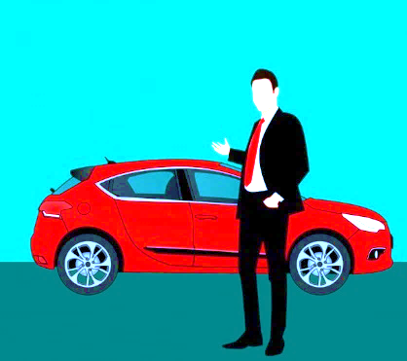

El carro nuevo _____________ de Enrique. # _____

Ella _____________ contenta. #_____

Section 3: Further Practice
For each sentence, write the correct form of ser or estar. Be prepared to discuss with the tutor why you chose ser or estar.
- Tu prima _________________________________ muy alta y simpática.
- Ulysses y yo _________________________________ de California.
- Mis amigos _________________________________ contentos.
- Mi profesora _________________________________ en el aula.
- El Language Learning Center _________________________________ en el edificio 77-1005.
- Ellos _________________________________ guatemaltecos.
- Ella _________________________________ abogada.
- Translate the sentence: It’s five in the afternoon. ____________________________________________.

Section 4: A Morning Routine
Go to the Section 4 Video on the LLC Spanish Tutoring website. Note that the video doesn’t have any sound—you will use it to create your own story below.
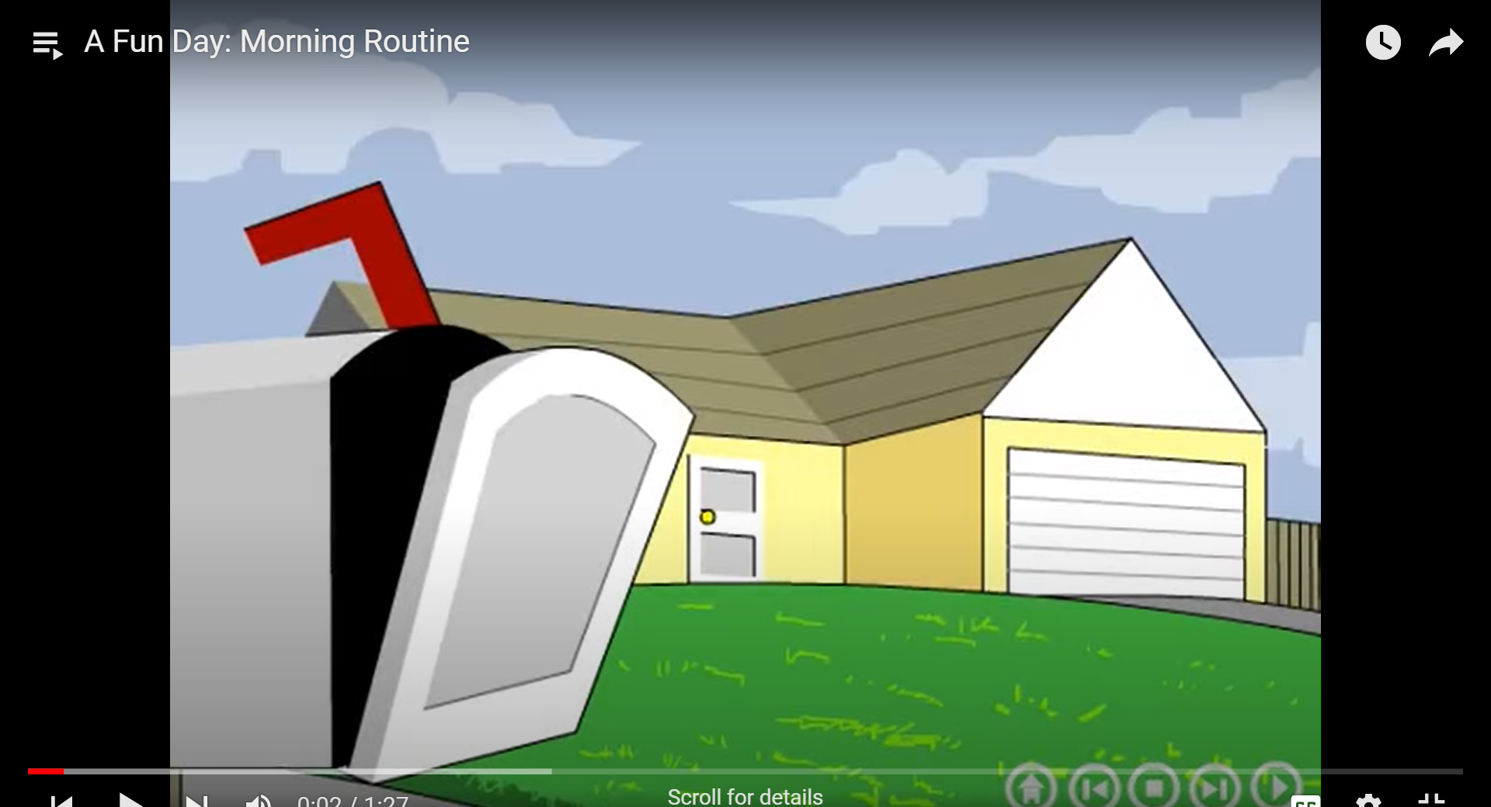
Have fun, use your imagination, and write 4 sentences about the video. Use a variety of ser and estar.
- _____________________________________________________________________
- _____________________________________________________________________
- _____________________________________________________________________
- _____________________________________________________________________

Section 5: Meanings
It’s important to understand the difference between ser and estar because it can change the meaning enough to confuse the listener!
Example:
Soy contento.
Estoy contento.
I am happy. (I am a happy person).
I am happy. (I am happy right now).

Your turn. Read the following sentence pairs aloud. Explain the difference between the two sentences to your tutor.
- aburrido
Soy aburrido.
Estoy aburrido.
- sana
Ella es sana.
Ella está sana.

- optimista
Tu eres optimista.
Tu estás optimista.

Section 6: Practice with a tutor!
GOOD job! Now make an appointment for Spanish Tutoring on the LLC website.
Before your appointment, please fill out the sign-in sheet.
When it is time for your appointment, meet your tutor in the Virtual LLC.

Grading Rubric
Possible Points | Pass | Not Yet Pass
Completion | The student completed all of the sections of the DLA. | The student has not yet completed all of the section of the DLA.
Comprehension/  Metacognition | The student can effectively explains the concepts and skills learned in the DLA. | The student cannot yet effectively explain the concepts and skills learned in the DLA.
Course Connections | The student can explain the connections between their coursework and the DLA. | The student cannot yet explain a connection between their course and DLA.
Students must succeed in all criteria to pass this DLA.
Verification of completion: If you successfully complete this DLA with the tutor, you will receive a stamp on your digital passport. An updated copy of your passport will be emailed to you 1-2 business days after your tutoring appointment.

