SP08: Estar
Student Name: _____________________________________ Student ID Number: ______________________
Instructor: _____________________________ Class Level: ______________ Date: _____________________
For media links in this activity, visit the LLC Spanish Tutoring website. Find your DLA number to see all the resources to finish your DLA.

Learning Outcomes: You will be able to…
- Use of estar in the simple present form.
- Distinguish in what situations to use estar
- Utilize estar in sentences and in conversation.

Section 1: Introduction/Presentation
Estar: To Be
Yo estoy Nosotros estamos
Tu estás Vosotros estaís
El/ Ella está Ellos/ Ellas están
Usted está

When do we use estar?
Estar in Spanish means “to be.” Estar indicates more temporary states whereas ser indicates more long term situations. Estar is typically irregular, so it is important that you understand its forms.

Why is it important?
The use of estar is important because it is used to describe how something is at the moment. It indicates temporary states such as; conditions, locations, emotions, and actions.
How something has always been. ≠ How something is.
(long term) (short term)
Scooby está confundido.
(Temporary State)
Shaggy y Scooby están listos.
(Temporary State)

Section 2: Reasons for Using Estar
Match each sentence to the reason for using estar. Write the letter of the reason in the space next to the sentence below.

Reasons to Use Estar:
- Geographic or physical location
- Weather
- State or condition (including health, feelings, and emotions)
- Progressive tenses (-ando/-iendo)
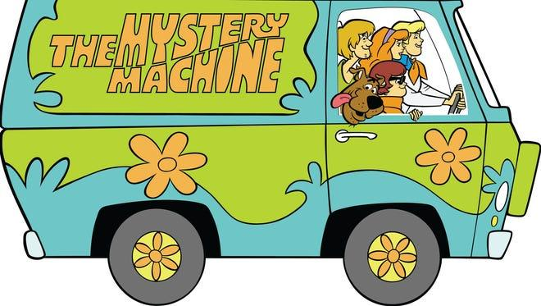

- Los amigos están en El Mystery Machine. (The friends are in the Mystery Machine).
- Shaggy y Velma están buscando la llave. (Shaggy and Velma are looking for the key.)
- Daphne está nerviosa. (Daphne is nervous.)
- Está nublado y oscuro, por lo que los amigos no pueden ver los fantasmas. (It’s cloudy and dark, so the friends can’t see the ghosts).

Section 3: Practice Using Estar
Fill in the blanks with the correct form of estar. Then, explain to the tutor why estar is used in each sentence.
- Shaggy y Velma _______ hablando sobre cómo van a resolver el misterio.
- Daphne no quiere ayudar con el misterio porque ella ______ más enfocada en comer pizza.
- ¿Scooby Dooby Doo, dónde _____?
- Este lugar ___ encantado.
- Zoinks! Shaggy y sus amigos deben tener cuidado porque este lugar _____ asqueroso.
- Ellos resolvieron el misterio, y ahora ______ listos para comer perros calientes con chocolate.

Section 4: One Minute Mysteries
Watch the One Minute Mysteries video on the LLC Spanish Tutoring website. Then, write at least 3 sentences with estar about the video. Have fun with it!
__________________________________________________________________________________________________________________________________________________________________________________________________________________________________________________________________________________________________________________________________________________________________________________________________________________________________________________________________

Section 5: Practice with a tutor!
GOOD job! Now make an appointment for Spanish Tutoring on the LLC website.
Before your appointment, please fill out the sign-in sheet.
When it is time for your appointment, meet your tutor in the Virtual LLC.

Grading Rubric
Possible Points | Pass | Not Yet Pass
Completion | The student completed all of the sections of the DLA. | The student has not yet completed all of the section of the DLA.
Comprehension/  Metacognition | The student can effectively explains the concepts and skills learned in the DLA. | The student cannot yet effectively explain the concepts and skills learned in the DLA.
Course Connections | The student can explain the connections between their coursework and the DLA. | The student cannot yet explain a connection between their course and DLA.
Students must succeed in all criteria to pass this DLA.
Verification of completion: If you successfully complete this DLA with the tutor, you will receive a stamp on your digital passport. An updated copy of your passport will be emailed to you 1-2 business days after your tutoring appointment.

