SP07: Gustar
Student Name: _____________________________________ Student ID Number: ______________________
Instructor: _____________________________ Class Level: ______________ Date: _____________________
For media links in this activity, visit the LLC Spanish Tutoring website. Find your DLA number to see all the resources to finish your DLA.

Learning Outcomes: You will be able to…
- Explain how gustar is different from regular verbs
- Use gustar for singular and plural subjects/nouns

Section 1: Form
Gustar is not like other verbs in that it doesn’t follow a standard conjugation pattern.
Gustar is not “to like.” Rather, gustar means something is pleasing to me, to us, to you, etc.
English: I like pizza.
Subject Verb Direct Object (DO)
Spanish: Pizza is pleasing to me.
Subject Verb Indirect Object Pronoun( IOP)
But there’s more! We need to place the indirect object at the beginning of the sentence and the subject at the end, like this:
Spanish: To me is pleasing pizza.
Indirect Object Pronoun( IOP) Verb Subject
So this is the formula:
IOP (who is being pleased?) + gustar + subject (thing that is pleasing)
What’s an IOP? Indirect object pronoun:
me - To me nos - To us
te - To you os - To you
le - To him/her les - To them
English: I like school.
Spanish: School is pleasing to me.
English: You like school.
Spanish: School is pleasing to me.
English: He likes school.
Spanish: School is pleasing to him/her.
One more thing! When the subject is singular or an infinitive verb, we use gusta. When the subject is plural, we must use gustan.

Me gusta estudiar. (singular subject)
Le gusta la escuela. (singular subject)
Me gustan las computadoras. (plural subject)
Te gustan los libros. (plural subject)

When we state the negative, we use “no” before the IOP:
No me gusta estudiar.
No te gusta la pizza.
No les gustan las clases de biología.

Section 2: Identify “Gustar” Forms
Fill in the blank with the correct form of gustar. Can you explain why it is the correct form to the tutor?

- Le _______________ la música de Los Beatles.
- Nos _______________ las fiestas.
- No les _______________ hacer la tarea juntos.
- Me _______________ la natación.
- Me _______________ las flores amarillas.
- No te _______________ bailar cumbias y salsa.
- Les _______________ los bebes.
- Le _______________ las gafas.
- No nos _______________ ir al cine.
- Te _______________ las canciones de regae.

Section 3: Write IOP & Gustar Form
Write in the correct indirect object pronoun (a clue may be found on the right) and the correct form of gustar.
ej.: A mis amigos y a mi nos gusta (gustar) hablar español.
My friends and I (we) like to speak Spanish.
- _______ __________________________ (gustar) la tele. (tú)
- A mis hermanos _______ __________________________ (gustar) nadar en el verano.
- _______ __________________________ (gustar) mucho ir de compras. (Yo)
- A los estudiantes _______ __________________________ (gustar) el español.
- A mis amigos _______ __________________________ (gustar) comer pizza.
- A Rafael _______ __________________________ (gustar) los autos.
- _______ __________________________ (gustar) leer libros. (Nos)

Section 4: Write Sentences
Write sentences about how you feel about the following items.
Ej.: No me gusta la soda Coke. Me gusta la soda Pepsi. (You write your sentence on the line for #1.)
1. ________________________________________________________________________________________________
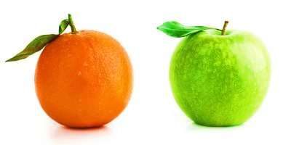
2. ________________________________________________________________________________________________
3. ________________________________________________________________________________________________
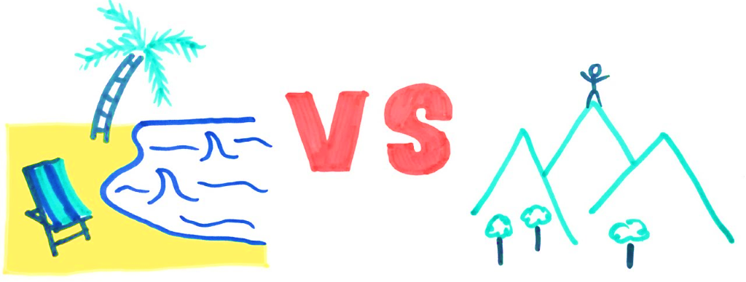
4. ________________________________________________________________________________________________
5. ________________________________________________________________________________________________

Section 5: Listening Practice
Listen to a woman talk about which sports she likes, on Section 5 on the LLC Spanish Tutoring website. Then, answer the following questions in English or Spanish:
- Which sport does she like the most? _____________________________________________________
- What is another sport that she likes? _____________________________________________________
- Besides sports, what other areas of interest does she have? ___________________________________
- Who does she like doing these activities with? ______________________________________________

Section 6: Practice with a tutor!
GOOD job! Now make an appointment for Spanish Tutoring on the LLC website.
Before your appointment, please fill out the sign-in sheet.
When it is time for your appointment, meet your tutor in the Virtual LLC.

Grading Rubric
Possible Points | Pass | Not Yet Pass
Completion | The student completed all of the sections of the DLA. | The student has not yet completed all of the section of the DLA.
Comprehension/  Metacognition | The student can effectively explains the concepts and skills learned in the DLA. | The student cannot yet effectively explain the concepts and skills learned in the DLA.
Course Connections | The student can explain the connections between their coursework and the DLA. | The student cannot yet explain a connection between their course and DLA.
Students must succeed in all criteria to pass this DLA.
Verification of completion: If you successfully complete this DLA with the tutor, you will receive a stamp on your digital passport. An updated copy of your passport will be emailed to you 1-2 business days after your tutoring appointment.

