SP04: Telling Time
Student Name: _____________________________________ Student ID Number: ______________________
Instructor: _______________________________________ Class Level: ___________Date: ______________
For media links in this activity, visit the LLC Spanish Tutoring website. Find your DLA number to see all the resources to finish your DLA.

Learning Outcomes: You will…
- Practice saying numbers in Spanish
- How to ask or how to answer when asked what time it is in Spanish
- How to say what time it is in Spanish by other means: half past, quarter past, half a quarter past, etc.

Section 1: Antes de empezar
Presta atención a las siguientes palabras y traduce cada término:
- Reloj: _________________________________________________
- Hora: _________________________________________________
- Alarma: _________________________________________________
- Mediodía: _________________________________________________
- Tarde: _________________________________________________

Section 2: Lección
In both English and Spanish, the verb to be (ser) and numbers are used to tell time.
Ser – to be
Subject – Verb
Yo soy
Tú eres
Él/Ella/Usted es
Vosotros sois
Nosotros/as somos
Ellos/Ellas/Ustedes son

To ask what time it is, use ¿Qué hora es? When telling time, use es + la only with una. The rest of the hours use son + las because they are in plural form.

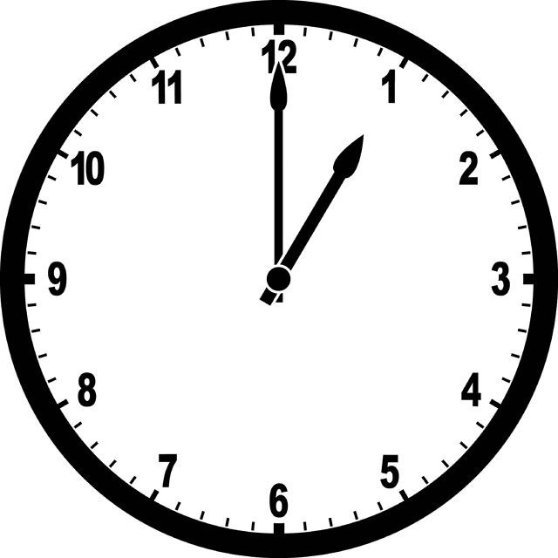
Es la una.
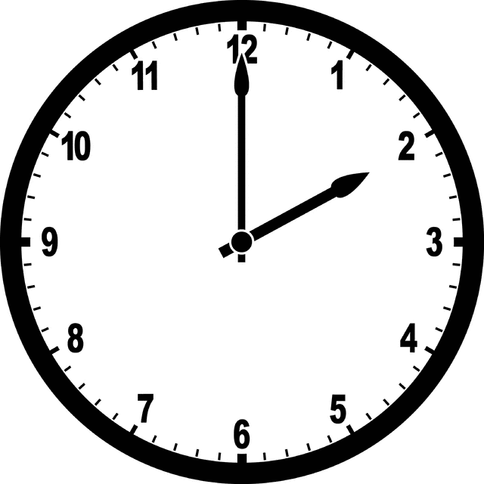
Son las dos.
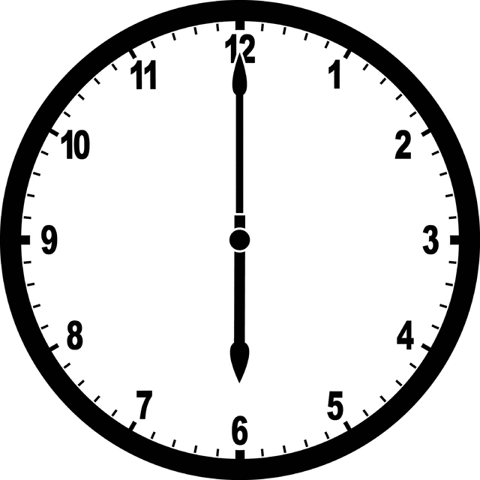
Son las seis.

As in English, you express time in Spanish from the hour to the half hour by adding minutes.

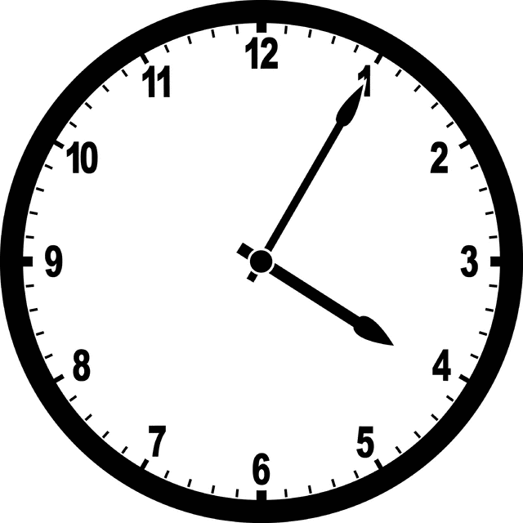
Son las cuatro y cinco.
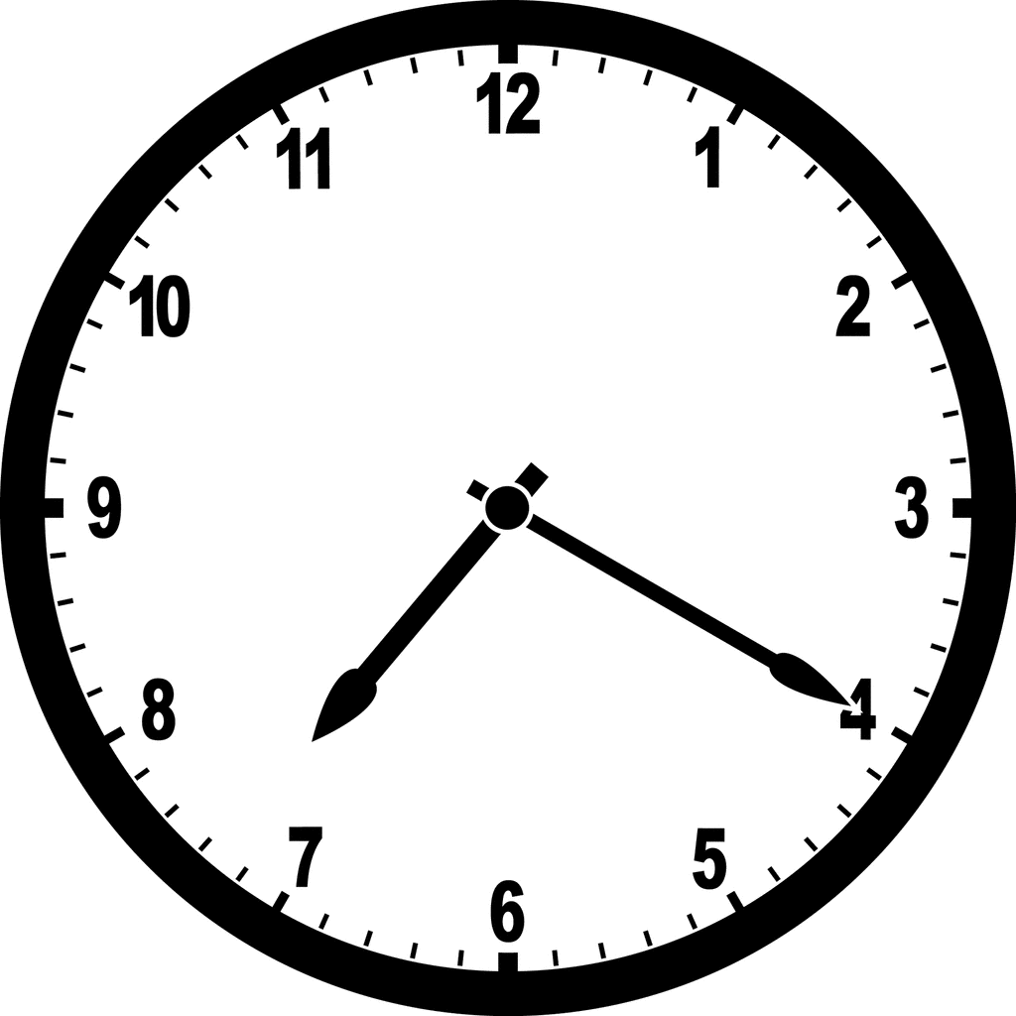
Son las siete y veinte.

You may use either y quince or y cuarto to express fifteen minutes or quarter past the hour. For thirty minutes or half past the hour, you may use either y media or y treinta.

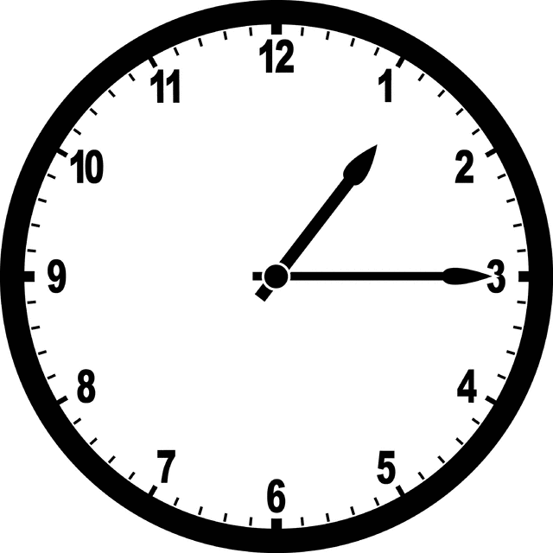
Es la una y cuarto.
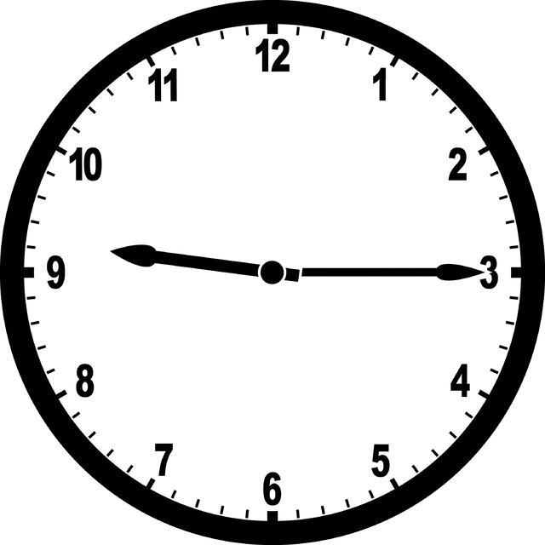
Son las nueve y quince.
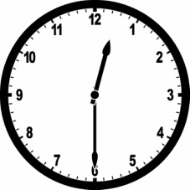
Son las doce y media.
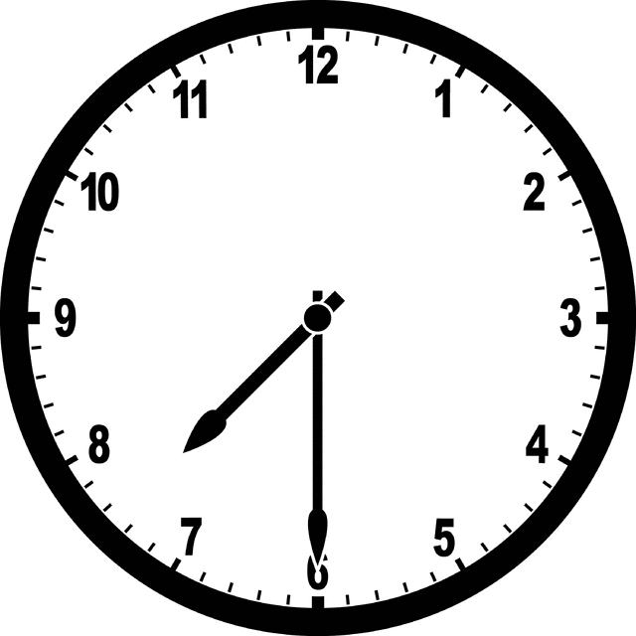
Son las siete y treinta.

Section 3: Conversación
When you need to have a conversation with someone related with time, use the phrase ¿A qué hora (…)?
Use the construction a la(s) + time.

¿A qué hora es la reunión?
(At) what time is the meeting?
La entrevista es a las cinco.
The interview is at 5 o’clock.
¿A qué hora vas a trabajar?
(At) what time are you working?
A las doce.
At twelve.

Additional words and phrases associated with time.

Vamos a correr al mediodía.
We are going to run at noon.
Son las siete de la mañana.
It’s 7 a.m./ in the morning.
El vuelo de María aterrizó a la medianoche.
Maria’s flight landed at midnight.
Son las once de la noche.
It’s 11 p.m./ at night.
Son las once en punto.
It is 11 o’clock on the dot.
Son las dos y media de la tarde.
It’s 2:30 p.m./ in the afternoon.

Section 4: ¡Inténtalo!
Write out the time given in Spanish and indicate whether it is in the morning or afternoon.
- 6 p.m. _________________________________________________
- 8:00 a.m. _________________________________________________
- 5 a.m. _________________________________________________
- 3 p.m. _________________________________________________
- 12:30 a.m. _________________________________________________
- 9:15 p.m. _________________________________________________
- 10:46 a.m. _________________________________________________

Section 5: ¡Inténtalo otra vez!
Write the times in parentheses. Use the construction a la(s) + time
Example: Fui al mandado a las siete de la mañana. (7:00 a.m.)
- Me fui de la casa al trabajo________________________________ (4:30 a.m.).
- Escuché al perro ladrar__________________________________ (9 a.m.) pero ya no lo escuché ___________________________ (1:00 p.m.).
- Terminaron de reparar el carro _______________________________ (2:00 p.m.).
- Mi mamá se va al trabajo todos los días _____________________________ (6:45 a.m.).

Section 6: A day in your life
Complete the first table with your daily activities. Then make sentences. Use the example as a reference.
Monday

Hora
7 am
_____________
_____________
_____________
_____________
Actividad
despertar
_____________
_____________
_____________
_____________

Ejemplo: Me despierto a las siete de la mañana.
_______________________________________________________________________________________
_______________________________________________________________________________________
_______________________________________________________________________________________
_______________________________________________________________________________________

Section 7: Watch a video
Watch the video on Section 7 on the LLC Spanish Tutoring website and answer the questions. Then, answer the questions about yourself.
¿Qué hora es, por favor? ______________________________________________
¿A qué hora tomas el desayuno? ______________________________________________
¿A qué hora te marchas de casa? ______________________________________________
¿Y tú?
¿A qué hora tomas el desayuno? ______________________________________________
¿A qué hora te marchas de casa para ir a la escuela? ____________________________________________

Section 8: Review with a tutor!
GOOD job! Now make an appointment for Spanish Tutoring on the LLC website.
Before your appointment, please fill out the sign-in sheet.
When it is time for your appointment, meet your tutor in the Virtual LLC.

Grading Rubric

Possible Points | Pass | Not Yet Pass
Completion | The student completed all of the sections of the DLA. | The student has not yet completed all of the section of the DLA.
Comprehension/  Metacognition | The student can effectively explain the concepts and skills learned in the DLA. | The student cannot yet effectively explain the concepts and skills learned in the DLA.
Course Connections | The student can explain the connections between their coursework and the DLA. | The student cannot yet explain a connection between their course and DLA.
Students must succeed in all criteria to pass this DLA.
Verification of completion: If you successfully complete this DLA with the tutor, you will receive a stamp on your digital passport. An updated copy of your passport will be emailed to you 1-2 business days after your tutoring appointment.

