# SW10. Academic Skills: Main Idea

Student Name: _________________________________ Student ID Number: ________________________

Instructor: _____________________________________ Level: ___________Date: ___________________

For media links in this activity, visit [the LLC ESL Tutoring website for Upper Level SDLAs](https://www.mtsac.edu/llc/passportrewards/llctutoring/upperlevels.html). Find your SDLA number to see all the resources to finish your SDLA.

## Section 1: Understanding the Main Idea and Supporting Details

**Has this ever happened to you?** There was a new movie you wanted to see, but your friend already saw it. You asked your friend what the movie was about, and your friend took *one hour* to explain the entire movie to you. That was way too long! Instead, your friend should’ve just told you what the **main idea** of the movie was. After all, the **main idea** is all you really need to know in order to decide if you want to see the movie. Recognizing **main ideas** is not only important in movies, but it is also important when reading stories.

When you’re reading, the main point of a story is called the main idea (or gist) because it is the most important piece of information an author wants you to know. Actually, most native English speakers read to understand the main idea first because it helps them organize the information in a story. Also, unlike your friend who took an hour to explain the main idea of the movie, you should be able to explain the main idea of a story in one or two sentences.

All of the other information that explains the main idea is called the **supporting details**. The **supporting details** are specific while the main idea is general. These **supporting details** provide *more information*or *examples* that help the reader understand the main idea more clearly. The picture of the stool can help you understand how the supporting details in a story support the main idea.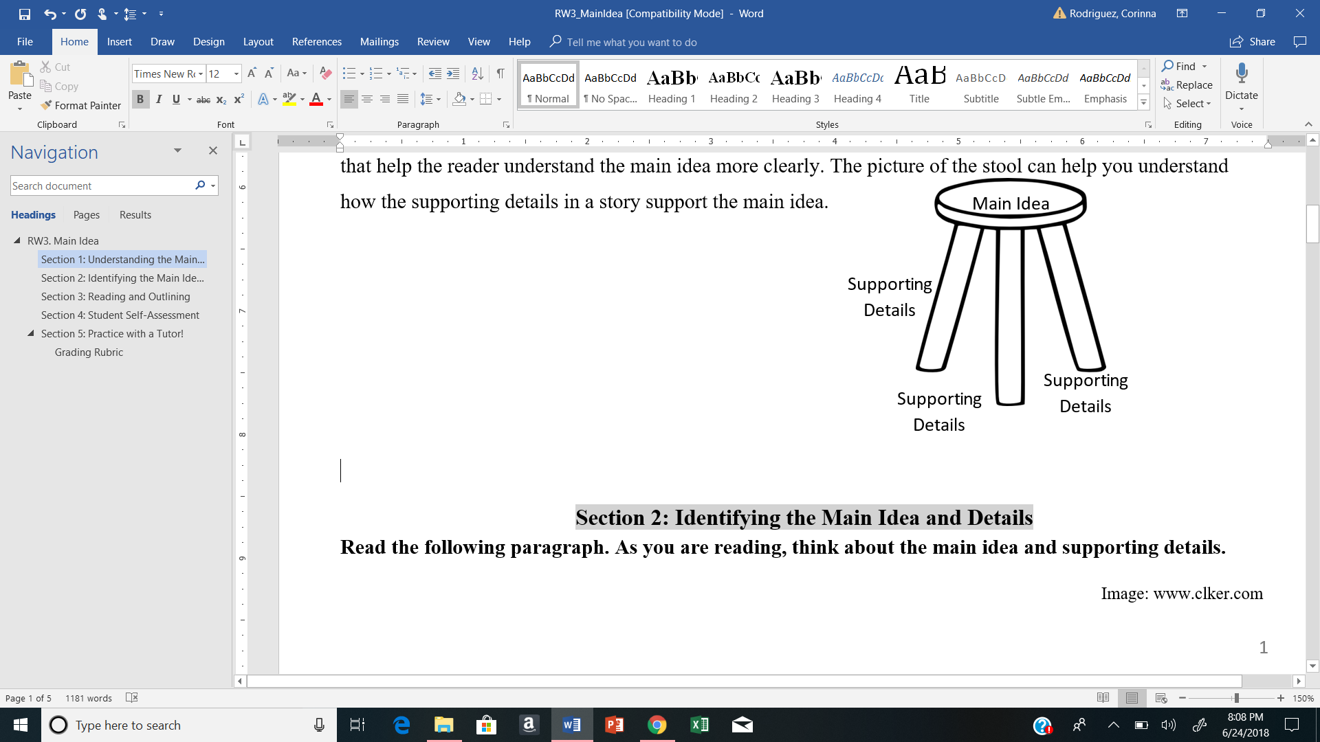

## Section 2: Identifying the Main Idea and Details

**Read the following paragraph. As you are reading, think about the main idea and supporting details.**

A penny for your thoughts? If it’s a 1943 copper penny, it could be worth as much as fifty thousand dollars. In 1943, most pennies were made out of steel since copper was needed for World War II. As a result, the 1943 copper penny is very rare. Another rarity is the 1955 double die penny. These pennies were mistakenly double stamped, so they have overlapping dates and letters. If it’s not being used, it could easily be worth $25,000 at an auction. Now that’s a pretty penny (ereadingworksheets.com).



**Think of the Main Idea as an Umbrella Idea:** *In this paragraph, there is 1 main idea and 2 supporting details. Below is a graphic organizer that shows the main idea and supporting details. Read the paragraph about pennies, and check the best answer to make the statements in the graphic organizer correct.*

**Main Idea:**

a.) Rare pennies can be worth a lot of money.

b.) Rare pennies are not worth a lot of money.

**Supporting Detail 1**

The 1943 copper penny could be worth:

A. $50,000.

B. $500,000.

**More Information 1**

These pennies were made of:

A. steel not copper.

B. copper not steel.

This makes them very rare.

**Supporting Detail 2**

The 1955 double die penny could be worth:

A. Two thousand five hundred dollars

B. Twenty-five thousand dollars

**More Information 2**

These pennies were stamped:

A. once with dates and letters.

B. twice with dates and letters.

This makes them very rare.

**How did you do? Check your answers on the last page:**

**Read the following paragraph. As you are reading, think about the main idea and supporting details. Fill out the graphic organizer below when you are finished.**

It is estimated that over 550 million pounds of candy is sold in the U.S. each year. About twenty million pounds of this is candy corn. Brach’s, the top manufacturer, sells enough candy corn to circle the earth 4.25 times. That’s a lot of candy corn, but that’s nothing compared to Tootsie Roll production. Over 64 million Tootsie Rolls are produced every day! But even Tootsie Rolls have got nothing on the candy industry’s staple product, chocolate. Confectioners manufacture over twenty billion pounds of chocolate in the United States each year. Now that’s a mouthful! (from ereadingworksheets.com)

Main Idea:

Supporting Detail 1:

More Information:

Supporting Detail 2:

More Information:

Supporting Detail 3:

More Information:

**\*Notice this paragraph has 1 main idea and 3 supporting details.**

## Section 3: Reading and Outlining

**A: Reading:** Go to the [website for Section 3](https://www.mtsac.edu/llc/passportrewards/llctutoring/upperlevels.html) to pick a story to read. Find the story you want to read and click on “reading comprehension.” You will read the story and fill out the main idea and supporting details in the graphic organizer below. For extra practice, you can answer the questions about the story on the website. The stories below are recommended based on your ESL Level, but you may choose any story that interests you.

**Recommended stories by level:**

Level 1

Level 2

Level 3

Level 4

Level 5

Level 6

A Special Christmas Present

Two Sisters and the Cat

Nasreddin’s and the Pot

Romulus and Remus

Tarzan of the Apes

The Wild Life

Main Idea:

Supporting Detail 1:

More Information:

Supporting Detail 2:

More Information:

Supporting Detail 3:

More Information:

*If you complete the chart above and want extra practice, you may choose another story to read.*

## Section 4: Student Self-Assessment

Complete this table BEFORE meeting with a tutor.

| Communication Skill | I can’t do this YET.  I can't do this yet. | I can do this WITH help.  I can do this WITH help. | I can do this WITHOUT help.  I can do this without help. | I can TEACH this to a classmate.  I can teach this to a classmate. |
| --- | --- | --- | --- | --- |
| I can identify the main idea of a story. |  |  |  |  |
| I can identify the supporting details of a story. |  |  |  |  |
| I can organize a story by its main idea and supporting details. |  |  |  |  |
| I can write about the main idea and supporting details of a story. |  |  |  |  |

**Here are some words/phrases I need to practice.**

***Good Job!***

**Now make an appointment**

**with a tutor on the LLC ESL Tutoring Website**

**(**[**www.mtsac.edu/llc/passportrewards/llctutoring**](http://www.mtsac.edu/llc/passportrewards/llctutoring)**).**

## Section 5: Practice with a Tutor!

After completing the self-assessment, meet with a tutor and give this completed SDLA to the tutor. The tutor will give you feedback.

### Grading Rubric

| **Possible Points** | **Need Practice**  Need practice  **(0-1 Point)** | **Good Job**  Good Job  **(2-3 Points)** | **Excellent Work**  Excellent work  **(4-5 Points)** |
| --- | --- | --- | --- |
| **Content** | Not enough information provided in responses and often does not use correct vocabulary. | Provides most important information in responses and some of the time uses correct vocabulary. | Provides all necessary information in responses and most of the time uses correct vocabulary. |
| **Skill: Speaking** | More than 6 mistakes saying words; needs guessing more than 3 times. | Not more than 5 mistakes saying words; needs guessing on 1-2 words or sentences. | Not more than 2 mistakes saying words; needs no guess about meaning. |
| **Oral Fluency** | Speaks mostly in phrases, individual words; many pauses. | Sometimes speaks in complete sentences; several pauses. | Speaks in complete sentences; a couple pauses okay. |

**\*Students must receive at least 10 points to move on Possible Points: ______ / 15**

**Tutor Comments:**

* **Congratulations! Keep going.**

You have successfully completed this SDLA and are ready to continue to the next.

* **Work on this more.**

You have not yet mastered this SDLA. It is recommended that you complete it again.

Tutor Signature: __________________________________________ Date: ___________________

Section 1 Answers

Main idea: A, Supporting detail 1: A, More information 1: B, Supporting detail 2:B, More information 2: B