# **SW09. Writing an Informal Email**

Student Name: _________________________________ Student ID Number: ________________________

Instructor: _____________________________________ Level: ___________Date: ___________________

For media links in this activity, visit [the LLC ESL Tutoring website for Upper Level SDLAs](https://www.mtsac.edu/llc/passportrewards/llctutoring/upperlevels.html). Find your SDLA number to see all the resources to finish your SDLA.

## Section 1: Email Vocabulary

Part 1: Use an online dictionary such as an ESL dictionary like [www.ldoceonline.com](http://www.ldoceonline.com) or the [Urban Dictionary](https://www.urbandictionary.com/) to look up the following words and pronunciation. Match the terms on the left with the correct definitions on the right.

1. spam ____
2. attachment ____
3. read receipt ____
4. emoji/emoticon ____
5. disclaimer ____
6. message thread ____
7. flame mail ____
8. correspondence ____
9. a combination of symbols, e.g. :) used in an email to express a particular emotion
10. a file, e.g. a document, photo, or computer program, which joined to an email is
11. a formal statement saying that you are not legally responsible for something
12. an angry email
13. confirmation that you have read something
14. the history of correspondence
15. unwanted emails, usually advertisements
16. writing letters or emails

Part 2: Based on the vocabulary above, identify examples of each. Write the number of the vocabulary word next to its example.

1. Abdel added a Word document file to the email he sent his boss.
2. I found Chun Hua crying in the bathroom because Abbie sent her an email saying mean things about Asians using all capital letters.
3. tacored pepper
4. My supervisor always knows if I have received and read her email or not.
5. I searched Google for tennis shoes and now I have tons of emails from companies trying to sell me shoes.
6. This quote does not imply entering into a contract.
7. 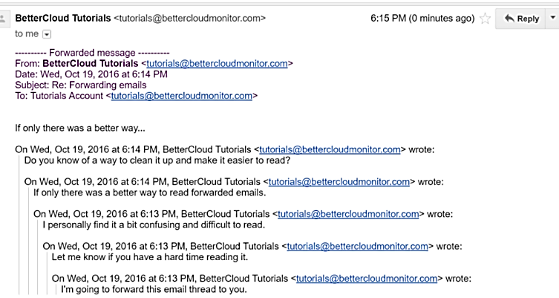

## Section 2: Example Informal Email

Fill in the blanks for the email below. Look up any words or phrases you don’t understand.

Use the following words to fill in the blanks.

**friend 6:00-ish gate get together reply BBQ**

**corner throwing Hey grilling**

### Email #1

### Two men in a backyard barbecuing hamburgers. Subject: Barbecue Party invite

____________ Jackson,

Let’s celebrate summer and _____________________ for some ______ . Wanda and I are ____________ a party in our backyard this Friday (the 11th); you should come. It starts at ____________ .

We are ____________ hamburgers and providing dessert. It is BYOD (bring your own drink), but remember my children will be there.

I’m sure you remember that we have the blue house on the ____________ of Main Street and Fourth Avenue. Go through the ____________ to the back of the house when you arrive.

Hit ____________ to let me know if you are coming and if you are bringing a ____________.Wyatt

## Section 3: Informal Email

[Watch the Section 3 Video about how to write an informal email](https://www.mtsac.edu/llc/passportrewards/llctutoring/upperlevels.html). Answer the following True or False questions based on the video. Write **T** or **F** in the space. Be prepared to explain your answer to the tutor.

1. _____ Subject lines are not necessary for informal emails.
2. _____ Informal emails are just like text messages.
3. _____ Informal emails should be long and detailed unlike Voice Mail.
4. _____ Informal greetings can use colons ( : ) or semi-colons ( ; ) at the end.
5. _____ You can close any informal email with “Hugs,” or “Love,”.
6. _____ Even in informal emails with multiple replies, you cannot skip the greeting, closing or signature.

## Section 4: Writing and Speaking

Part 1: Even with informal emails, there are expected ways of formatting it (how it looks). [Watch the Section 4 Video about how to format an email](https://www.mtsac.edu/llc/passportrewards/llctutoring/upperlevels.html) before you create your own email.

For each word or phrase below, add a note from the video to help you remember what it means.

* Subject: ____________________________________________________________________________________
* Salutation: __________________________________________________________________________________
* Body: ______________________________________________________________________________________
* Closing: ____________________________________________________________________________________
* Signature: __________________________________________________________________________________
* Signature Block: _____________________________________________________________________________
* Capitalization: _______________________________________________________________________________
* Empty Lines: ________________________________________________________________________________

Part 2: Time to practice writing an informal email. Imagine that you are having a party and inviting a friend to it. Make sure to include all the pieces from Part 1. It doesn’t need to be long.

## Section 5: What Did I Learn

Complete this table BEFORE meeting with a tutor.

| Communication Skill | I can’t do this YET.  I can't do this yet. | I can do this WITH help.  I can do this WITH help. | I can do this WITHOUT help.  I can do this without help. | I can TEACH this to a classmate.  I can teach this to a classmate. |
| --- | --- | --- | --- | --- |
| I can identify common email vocabulary. |  |  |  |  |
| I can recognize the parts of an informal email. |  |  |  |  |
| I can write a properly formatted informal email. |  |  |  |  |

**Here are some words/phrases I need to practice.**

**Good Job!**

**Now make an appointment**

**with a tutor on the LLC ESL Tutoring Website**

**(**[**www.mtsac.edu/llc/passportrewards/llctutoring**](http://www.mtsac.edu/llc/passportrewards/llctutoring)**).**

## Section 6: Practice with a Tutor!

Meet with a tutor and share this activity with the tutor. You will review this SDLA with the tutor. You may also ask the tutor any questions that you might have.

### Grading Rubric

| **Possible Points** | **Need Practice**  Need practice  **(0-1 Point)** | **Good Job**  Good Job  **(2-3 Points)** | **Excellent Work**  Excellent work  **(4-5 Points)** |
| --- | --- | --- | --- |
| **Content** | Not enough information provided in responses and often does not use correct vocabulary. | Provides most important information in responses and some of the time uses correct vocabulary. | Provides all necessary information in responses and most of the time uses correct vocabulary. |
| **Skill: Speaking** | More than 6 mistakes saying words; needs guessing more than 3 times. | Not more than 5 mistakes saying words; needs guessing on 1-2 words or sentences. | Not more than 2 mistakes saying words; needs no guess about meaning. |
| **Oral Fluency** | Speaks mostly in phrases, individual words; many pauses. | Sometimes speaks in complete sentences; several pauses. | Speaks in complete sentences; a couple pauses okay. |

**\*Students must receive at least 10 points to move on Possible Points: ______ / 15**

**Tutor Comments:**

* **Congratulations! Keep going.**

You have successfully completed this SDLA and are ready to continue to the next.

* **Work on this more.**

You have not yet mastered this SDLA. It is recommended that you complete it again.

Tutor Signature: __________________________________________ Date: ___________________