# SW07. Emailing Your Professor

Student Name: _________________________________ Student ID Number: ________________________

Instructor: _____________________________________ Level: ___________Date: ___________________

For media links in this activity, visit [the LLC ESL Tutoring website for Upper Level SDLAs](https://www.mtsac.edu/llc/passportrewards/llctutoring/upperlevels.html). Find your SDLA number to see all the resources to finish your SDLA.

## Section 1: Compare Informal and Professor Emails

Study the image about how to email a teacher. If you cannot see the image, refer to the text description on page 7.

How do you think informal emails **differ** from emailing your instructor? Make a list of your ideas below.

1. _______________________________________________________________________________________
2. _______________________________________________________________________________________
3. _______________________________________________________________________________________

Image shows that when emailing a teacher you need a short, clear subject line, you need a greeting, in the body explain why you are emailing, add a closing and type your first and last name.

If you cannot see this image, refer to the text description on page 7.

How do you think informal emails **are the same as** emailing your instructor? Make a list of your ideas below.

1. _______________________________________________________________________________________
2. _______________________________________________________________________________________
3. _______________________________________________________________________________________

## Section 2: Listening

[Watch the video “Make your Emails Count: How to Write to your Instructors”](https://www.mtsac.edu/llc/passportrewards/llctutoring/upperlevels.html) and answer the questions below

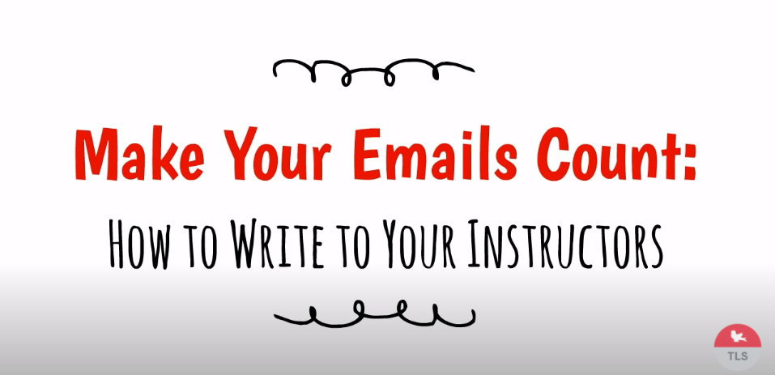

1. Why do you think the video starts by saying emailing your professor is not like sending a text? ________________________________________________________________________________________
2. Two features of emailing your professor are a) being polite and b) getting to the point. What does it mean to “get to the point”? Why would professors value that?

________________________________________________________________________________________

________________________________________________________________________________________

1. What are the three parts of an email given in the video?

________________________________________________________________________________________

1. Write an example of an informative subject line for one of your classes following the examples in the video.

________________________________________________________________________________________

1. Write a closing for an email using your personal information.

_________________________________________

_________________________________________

_________________________________________

1. Why does the video say to check the course outline (also called course syllabus) **before** emailing your professor? _________________________________________________________________________________________
   1. Bonus Question: Where else can you ask for information before emailing your teacher? _____________________________________________________________________________________
2. Before clicking “Send” on the email, you should always check what? NOTE: More information about these can be found in RW12: Writing an Informal Email.

_______________________________________

_______________________________________

_______________________________________

_______________________________________

1. Did you understand the following words in the video? In your words, describe what they mean.
   1. Concise ____________________________________________________________________________
   2. Accommodation _____________________________________________________________________
   3. Proofread __________________________________________________________________________

## Section 3: Bad Emails

Now you are going to [watch another video about email etiquette](https://www.mtsac.edu/llc/passportrewards/llctutoring/upperlevels.html). Etiquette means a series of rules for polite behavior. Here, etiquette is being applied to emailing your instructor.

After you watch, make a list of all the mistakes that the student made in the following email. If you cannot see the image below, please refer to the text description on page 7. Please note that this email is fictional; it is not real.

Screenshot of an email that has several problems

If you cannot see this image, refer to the text description on page 7.

### List of Mistakes in miff89 Email to the Professor:

1. _________________________________________________________________________________________
2. _________________________________________________________________________________________
3. _________________________________________________________________________________________
4. _________________________________________________________________________________________
5. _________________________________________________________________________________________
6. _________________________________________________________________________________________

**NOTE: You may find fewer mistakes or more mistakes depending upon interpretation. Your Tutor will discuss this with you.**

## Section 4: Writing

Imagine that you need to send an email to your Professor because you did not take a quiz on time. You are going to send an email to your Professor asking him/her for a makeup quiz. What details should you include in the email? Write an email with all the necessary information and pieces.

## Section 5: What Did I Learn

Complete this table BEFORE meeting with a tutor.

| Communication Skill | I can’t do this YET.  I can't do this yet. | I can do this WITH help.  I can do this WITH help. | I can do this WITHOUT help.  I can do this without help. | I can TEACH this to a classmate.  I can teach this to a classmate. |
| --- | --- | --- | --- | --- |
| I know the important pieces to include when I email my instructor. |  |  |  |  |
| I can identify what makes an email inappropriate to send to a professor. |  |  |  |  |
| I can write an appropriate email to my teacher. |  |  |  |  |

**Here are some words/phrases I need to practice.**

**Good Job!**

**Now make an appointment**

**with a tutor on the LLC ESL Tutoring Website**

**(**[**www.mtsac.edu/llc/passportrewards/llctutoring**](http://www.mtsac.edu/llc/passportrewards/llctutoring)**).**

## Section 6: Practice with a Tutor!

Meet with a tutor and share this activity with the tutor. You will review this SDLA with the tutor. You may also ask the tutor any questions that you might have.

### Grading Rubric

| **Possible Points** | **Need Practice**  Need practice  **(0-1 Point)** | **Good Job**  Good Job  **(2-3 Points)** | **Excellent Work**  Excellent work  **(4-5 Points)** |
| --- | --- | --- | --- |
| **Content** | Not enough information provided in responses and often does not use correct vocabulary. | Provides most important information in responses and some of the time uses correct vocabulary. | Provides all necessary information in responses and most of the time uses correct vocabulary. |
| **Skill: Speaking** | More than 6 mistakes saying words; needs guessing more than 3 times. | Not more than 5 mistakes saying words; needs guessing on 1-2 words or sentences. | Not more than 2 mistakes saying words; needs no guess about meaning. |
| **Oral Fluency** | Speaks mostly in phrases, individual words; many pauses. | Sometimes speaks in complete sentences; several pauses. | Speaks in complete sentences; a couple pauses okay. |

**\*Students must receive at least 10 points to move on Possible Points: ______ / 15**

**Tutor Comments:**

* **Congratulations! Keep going.**

You have successfully completed this SDLA and are ready to continue to the next.

* **Work on this more.**

You have not yet mastered this SDLA. It is recommended that you complete it again.

Tutor Signature: __________________________________________ Date: ___________________

## Text Description of Section 1 Image

### How to Email a Teacher

1. Subject Line
   * 2-5 word summary of the email
     + Missing Grade
     + Homework Question
     + Late Work
2. Begin with a Greeting
   * This is in the body of the email
     + Good morning
     + Hello
     + Good afternoon
3. Body of the Email
   * I am writing because…
   * I need help with…
   * I am confused by…
4. Closing
   * Thank you!
   * Have a nice day!
5. Sign Your Name!

General Tips

* Be sure to use proper capitalization and punctuation.
* Always use proper grammar.
* Plz spell out ur words.
  + Please spell out your words.

## Text Description of Section 3 Image

From: miff89@yahoo.com

To: professor@mtsac.edu

Subject: Hello Pro

Oct. 3 at 2:33am

How r u

Yesterday @ 5:00pm, I sent you email. You have not replied. You must tell me when Assignment 1 is due. i cannot start the assignment until I hear from you.