# SW06. Job Interview

Student Name: _________________________________ Student ID Number: ________________________

Instructor: _____________________________________ Level: ___________Date: ___________________

For media links in this activity, visit [the LLC ESL Tutoring website for Upper Level SDLAs.](https://www.mtsac.edu/llc/passportrewards/llctutoring/upperlevels.html#sl) Find your SDLA number to see all the resources to finish your SDLA.

## Section 1: Introduction

An interview is a meeting of people to determine if an applicant is the right person for the job. During an interview, an applicant should act professionally and be prepared to answer questions. [Watch the Section 1 YouTube video](https://www.mtsac.edu/llc/passportrewards/llctutoring/upperlevels.html#sl) and decide if this applicant is the right person for the job.

**[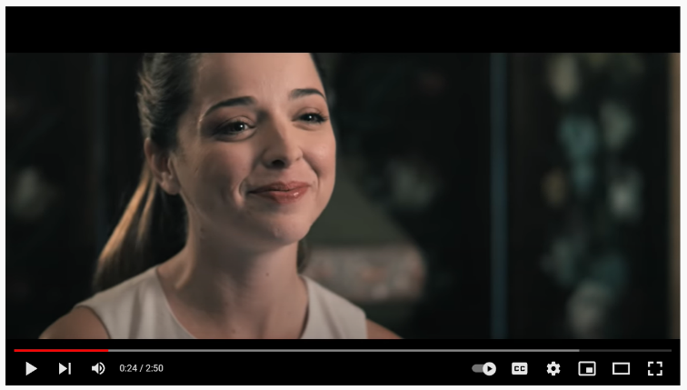](https://www.mtsac.edu/llc/passportrewards/llctutoring/upperlevels.html#sl)Is this applicant right for the job?**

Mark one: **❑ Yes or ❑ No**

Write **5** reasons or examples that explain your answer.

1. _______________________________________
2. _______________________________________
3. _______________________________________
4. _______________________________________
5. _______________________________________

**If you marked NO, you are correct! This applicant is probably not the best person for the job.**

## Section 2: Helpful Interview Tips

Job interviews are extremely important, and therefore, they make many of us extremely nervous. It is important that you are prepared before your job interview and that you have all the knowledge you need to answer the questions successfully. Not all job interviews are the same, but there are **four** important tips that can help you succeed in any interview.

### Tip 1: Do Your Research:

Before each job interview, it is very important that you research the employer and the position you are applying for. When you show the interviewer you know this information, it shows that you are prepared and really want the position. The more you know about the company, the better you will look.

**Below is some important information you should find before an interview:**

* The services and/or products the company provides or produces.
* The age of the company and how it has grown/is growing.
* Articles about the company in magazines, newspapers, or on the Internet
* The size and location of the company.
* What the career opportunities are for the position you are applying for.

**You Try:** Research the above information about **Costco**, a membership warehouse club. You can use [the Costco.com website](http://www.costco.com/) to help you complete the chart below.

**Services/Products**

(List **5** services/products)

**Location**

(List **5** states that have a Costco)

**Career Opportunities**

(List **5** job opportunities)

### Tip 2: Give Detailed Answers:

When you respond to questions during a job interview, you want to give a lot of useful and relevant information. Three things you should keep in mind when responding to an interview question include:

* *Give specific examples:* It is a good idea to include specific examples from your previous work or education experiences that show your accomplishments or describe how you handled a difficult situation.
* *Highlight your skills:* You want to make sure that you show the interviewer your qualifications and skills that make you perfect for this position in each question that you answer.
* *Be clear and concise:* You don’t want to just give a one sentence response, but you also don’t want your answer to be too long with unnecessary information. Make sure you directly answer the question and only include relevant information.

**You Try:** Below is a sample interview response. What part of the response includes a specific example and highlights the applicant’s skills?

**Question:** How would people you have worked with describe you?

**Sample Response:** *My managers would describe me as someone who would rather solve a problem on my own than ask them for immediate help. I make my managers’ lives easier in this way. For example, when I first started working at Costco, I was asked to figure out ways to lower costs. Instead of asking my manager for help, I decided to look at the reports and see what the company was spending money on in each department. After seeing where we could lower costs, I took the information to my manager, who was thankful I did the work on my own.*

### Tip 3: Ask questions:

At the end of an interview, employers will ask if you have any questions. You should always respond with a few questions of your own. Questions can be about job expectations to why the interviewer enjoys working for the company. Asking questions shows that you are interested and did your research. In addition, by asking thoughtful and insightful questions, you can not only get important information but also stand out from other applicants.

**You Try:** Imagine you are interviewing for a manager position at Costco. What are **3** questions you could ask your employer? You can use the research you did in **Tip 1** to help you.

1. *____________________________________________________________________________________*
2. *____________________________________________________________________________________*
3. *____________________________________________________________________________________*

### Tip 4: Thank You Note:

Having good manners is always a desirable quality in any employee. One way you can show your employer that you have good manners is to send a thank you note within 24 hours of completing your interview. Today, most thank you notes are sent by email, but a card or letter is fine also. Writing a thank you note is very important. Without it, employers may think you don't pay attention to details, you don't have any manners, or maybe you don't even want the job. On the next page, there is an example of a thank you note:

Dear Mr. Moody:

Thanks for meeting with me about the manager position yesterday. The job seems like a very good match for my skills and interests. The strategies you outlined are just my style and I know I would hit the ground running.

In addition to my 8 years of experience in the merchandise/sales industry, I will bring strong communication and leadership skills as well as a ton of energy to your team. I've also got solid organizational skills and know I could contribute to the areas you mentioned.

I am very interested in working for your company and look forward to hearing from you soon.

Sincerely,

John Smith

Adapted from: *Interview thank you notes. (2014).* http://www.thank-you-note-samples.com/interview-thank-you.html

## Section 3: Interview Example

Read the questions below. [Listen to an interview](https://www.mtsac.edu/llc/passportrewards/llctutoring/upperlevels.html#sl) for a manager position at Costco. You may listen to the interview as many times as needed. After you listen, write down the answers to the questions below.

**Did the applicant research the company? Explain.**

**Did the applicant give detailed answers? Explain.**

**What questions did the job applicant ask?**

**Should the employer hire the applicant? Explain.**

## Section 4: Student Self-Assessment

Complete this table BEFORE meeting with a tutor.

| Communication Skill | I can’t do this YET.  I can't do this yet. | I can do this WITH help.  I can do this WITH help. | I can do this WITHOUT help.  I can do this without help. | I can TEACH this to a classmate.  I can teach this to a classmate. |
| --- | --- | --- | --- | --- |
| I can recognize the reasons why a job interview is ineffective. |  |  |  |  |
| I can explain tips for having a good job interview. |  |  |  |  |
| I can identify the reasons why a job interview is effective. |  |  |  |  |

**Here are some words/phrases I need to practice.**

**Good Job!**

**Now make an appointment**

**with a tutor on the LLC ESL Tutoring Website**

**(**[**www.mtsac.edu/llc/passportrewards/llctutoring**](http://www.mtsac.edu/llc/passportrewards/llctutoring)**).**

## Section 5: Practice with a Tutor!

Meet with a tutor, and share this activity with the tutor. You will talk about the interviews in this SDLA. Be prepared to explain why you think the employer should or should not hire the applicant in Section 3. You may also ask the tutor any questions that you might have.

### Grading Rubric

| **Possible Points** | **Need Practice**  **Need practice**  **(0-1 Point)** | **Good Job**  **Good Job**  **(2-3 Points)** | **Excellent Work**  **Excellent work**  **(4-5 Points)** |
| --- | --- | --- | --- |
| **Content** | Not enough information provided in responses and often does not use correct vocabulary. | Provides most important information in responses and some of the time uses correct vocabulary. | Provides all necessary information in responses and most of the time uses correct vocabulary. |
| **Skill: Speaking** | More than 6 mistakes saying words; needs guessing more than 3 times. | Not more than 5 mistakes saying words; needs guessing on 1-2 words or sentences. | Not more than 2 mistakes saying words; needs no guess about meaning. |
| **Oral Fluency** | Speaks mostly in phrases, individual words; many pauses. | Sometimes speaks in complete sentences; several pauses. | Speaks in complete sentences; a couple pauses okay. |

**\*Students must receive at least 10 points to move on Possible Points: ______ / 15**

**Tutor Comments:**

 **Congratulations! Keep going.**

You have successfully completed this SDLA and are ready to continue to the next.

 **Work on this more.**

You have not yet mastered this SDLA. It is recommended that you complete it again.

Tutor Signature: __________________________________________ Date: ___________________